“It’s all about the questions.”

Questions from Lab 1.

1. How to use Excel to convert Fahrenheit to Celsius
   1. If you know the formula: C = (F-32)\*5/9

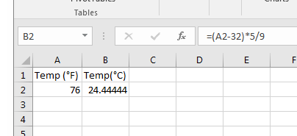

Cell A2 contains the number 76 (numbers in Excel are typically right justified). Cell B2 contains a formula seen in the formula bar (seen in the gray area above). Note that

* + 1. Formulas start with an equal sign
    2. Multiplication is indicated by \* (an asterisk)
    3. To perform the subtraction before the multiplication, parentheses are used; since in normal “order of operations” (precedence) multiplication would be done before addition
  1. If you don’t know the formula

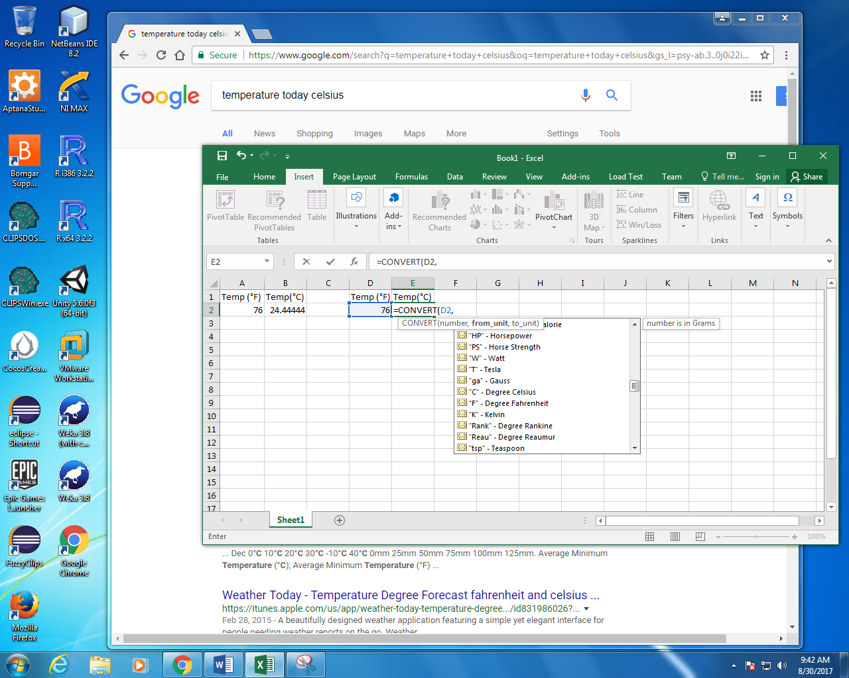

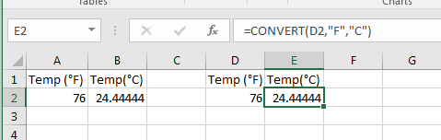

If you don’t know the conversion, Excel has a CONVERT function, it takes three “arguments”.

* + 1. Argument 1 is the number to be converted – I used the reference to the cell D2 instead of the explicit number 76.
    2. Argument 2 is the unit you are converting from; I found it using the long drop-down list. Note the “F” is in quotes
    3. Argument 3 is the unit you are converting to; I again used the drop-down list but it was shorter (since Excel now knew I was dealing with temperatures).

For a one-time conversion, it is probably easier to use Google. However, if you have a lot of data it is convenient to know how to perform the conversion in Excel.

1. How to use Excel when interpolating (or extrapolating)

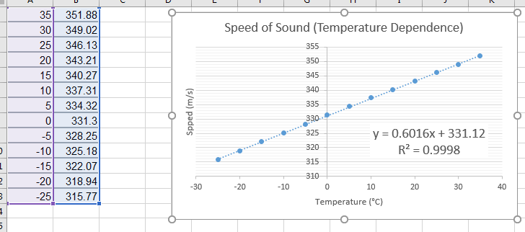

* 1. Enter the formula seen on the graph.

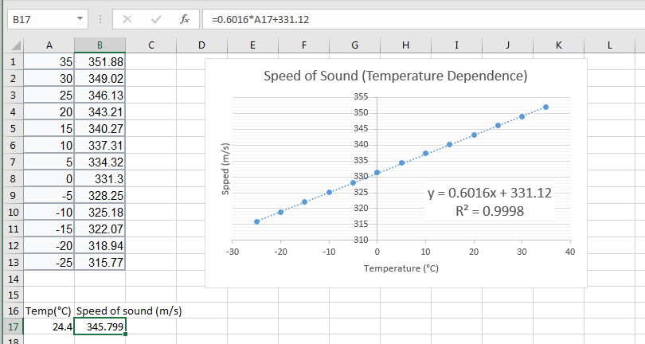

Enter the desired temperature in a cell (A17 above) and a formula from the graph (B17 above) – see formula bar at top. Note that the x in the formula corresponds to what is plotted on the x axis of the graph, temperature in this case; and the y in the formula corresponds to what is plotted on the y axis of the graph, speed of sound in this case.

* 1. You can obtain the slope and intercept from the data without making a graph.

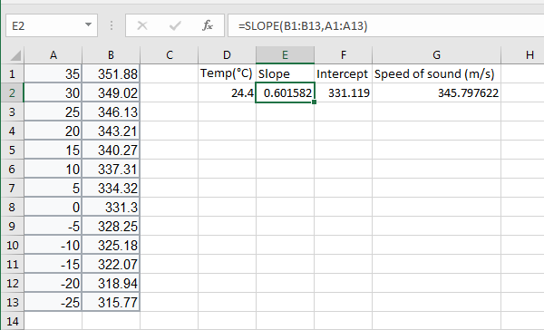

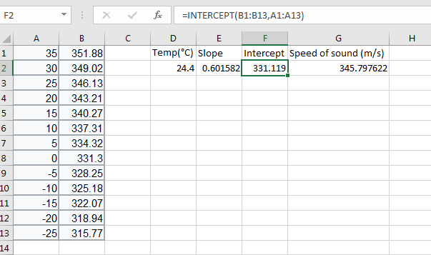

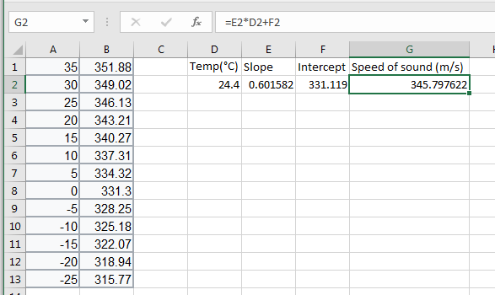

1. How to move y axis labels to the front (instead of toward the middle at Temperature =0).

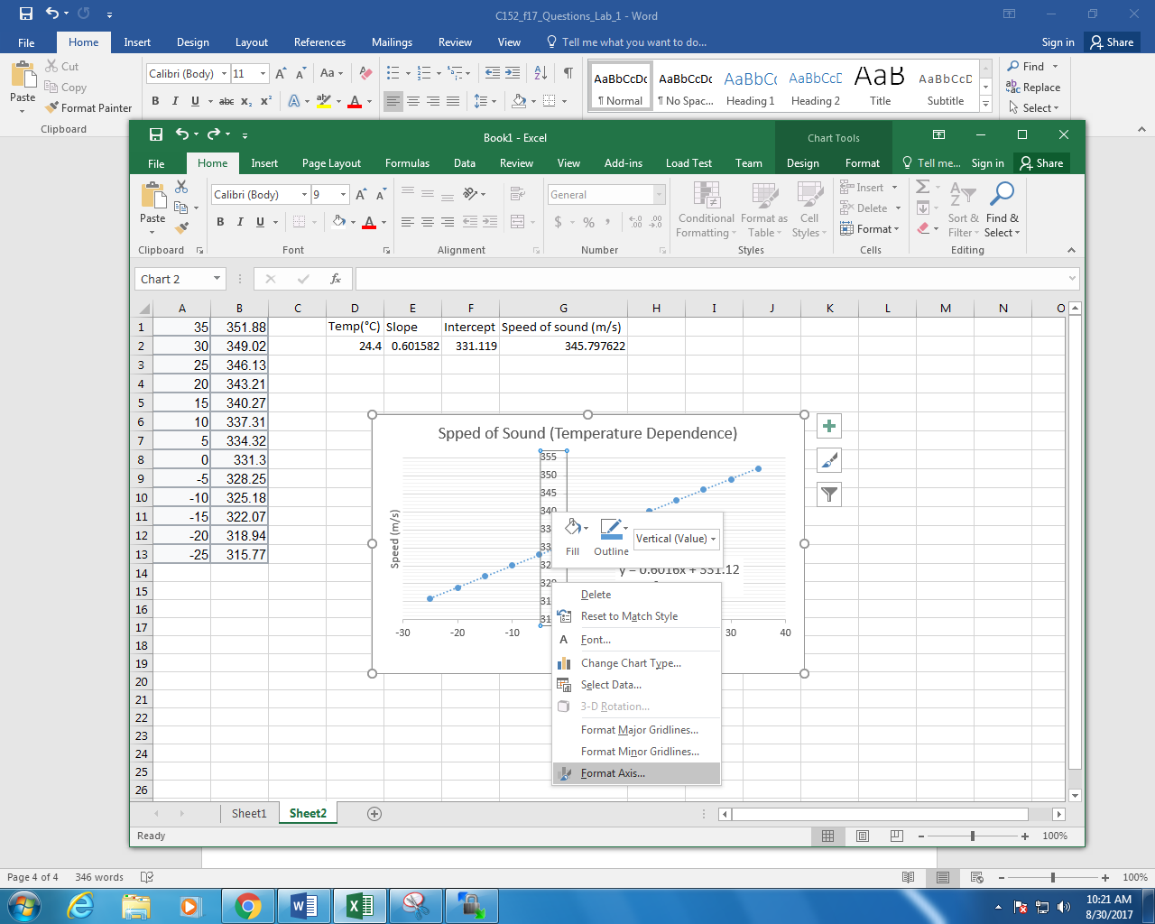

* 1. Right click on the axes and choose Format Axis.
  2. Scroll down on the Format Axis tab and change Label Position to Low.

