You can use the Add Trendline feature of Excel to fit data to linear, logarithmic, polynomial, power or exponential functions. However, sometimes you want to fit your data to a more complicated function. The data in the example shown below does not fit to any of these simple functions.
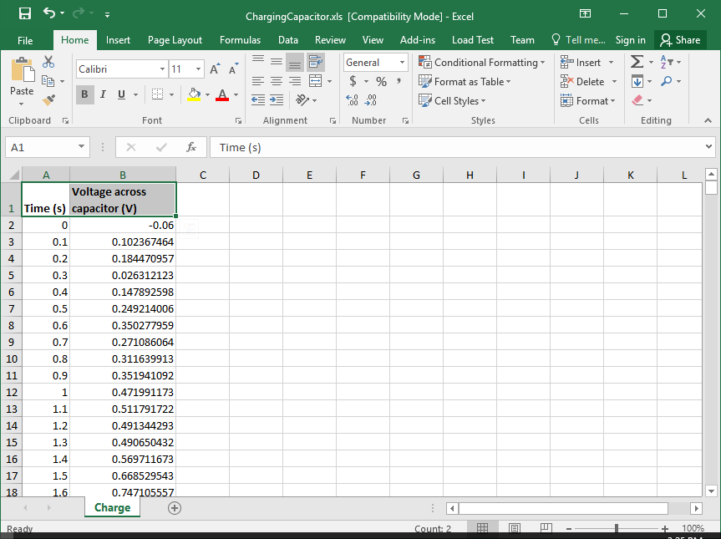
The appropriate formula for this data is
v ( t ) = V_{sat} ( 1 - e^{-t/T})
where V_sat is the saturation voltage and T is the “time constant” (whereas t is the time variable). Insert three rows above, place numerical guesses for V_sat and T into cell B1 and B2. I just put in values of 1 to start and I will improve my guesses later.
Enter the formula "=$B$1*(1-EXP(-A5/$B$2))" in cell C5. Note we have replaced
- the parameter V with the cell reference $B$1, using absolute addressing (the dollar signs)
- the variable t with the cell reference A5 (no dollar signs because this input varies)
- the parameter T with the cell reference $B$2, again using absolute addressing
Also notice that the exponential function e^{x} is written out as EXP(x).
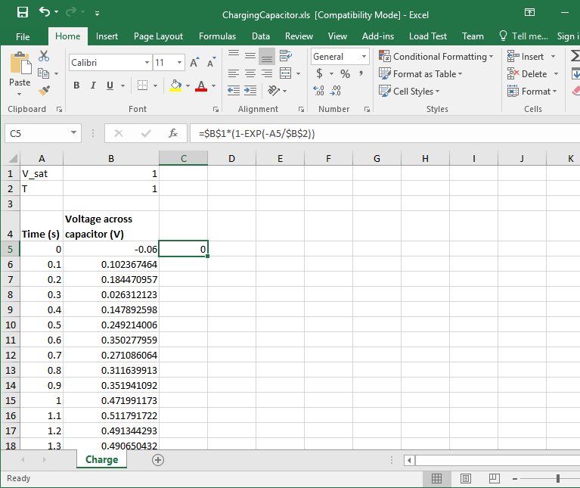
Next we copy the formula in cell C5 down into the rest of column C, highlight the three columns, and proceed with the steps for XY plotting.
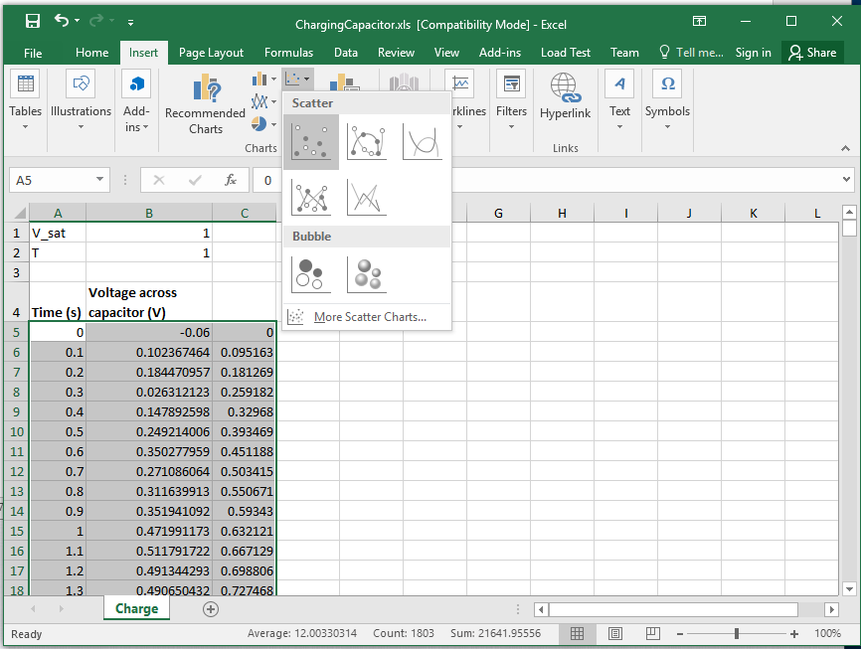
The resulting plot is shown below. The idea of "a fit" is to make the two curves look as much alike as possible. We will accomplish this by adjusting the parameters V and T.
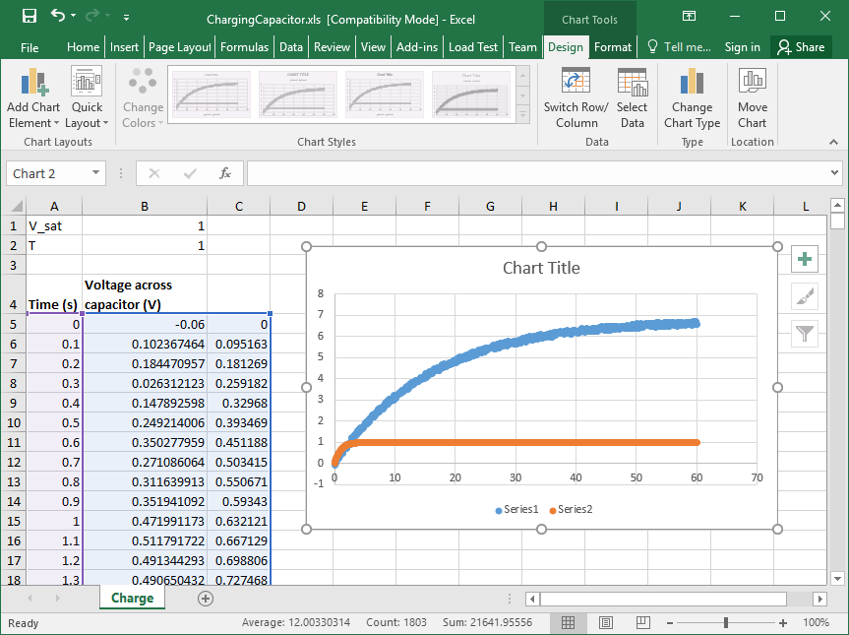
In this particular example, the parameter V determines the saturation value, the value at large times. Looking at the plot we see that the data (the blue curve) approaches 7 (??) at large times. Thus we change the value in cell B1 to 7. When we do this the formulas in column C which refer to cell B1 and the plot are automatically updated.
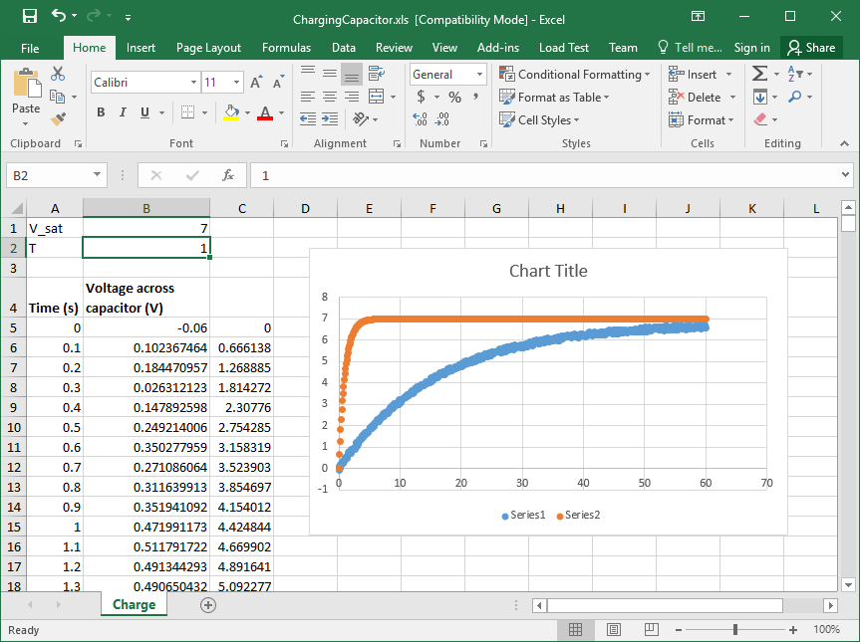
The parameter T determines how long it takes to reach the saturation value. We adjust the value in cell B2 until the two curves look as much alike as possible. A value of 17 produced the result shown below.
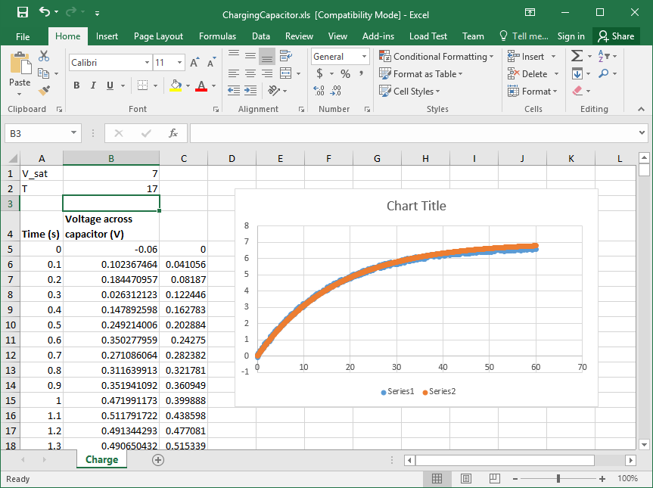
To change what the legend reads, right click of the data and choose Select Data
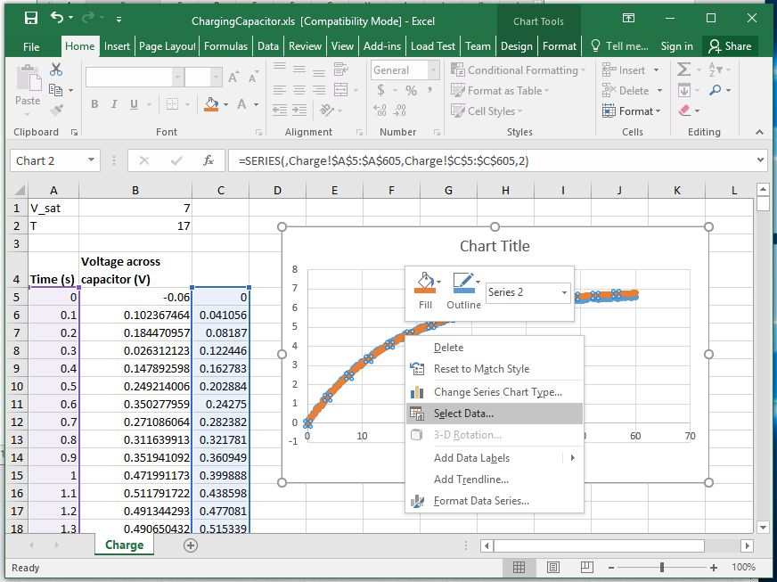
Highlight Series 1 and then click Edit.
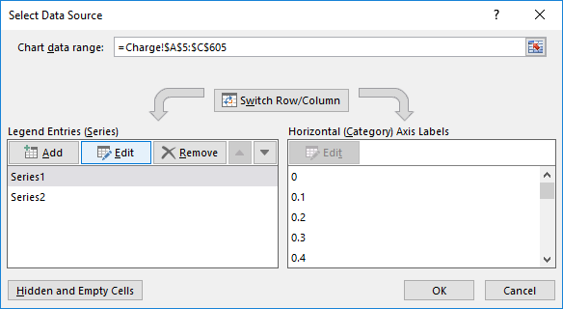
Enter a Series name.
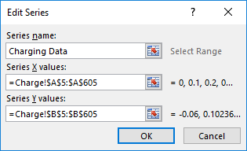
Repeat for Series 2 which is the fit.
Proceed as normal to provide a title and axis labels. (I will often use Layout #9 and then delete the trendline.)
