Cosines
A sinusoidal wave (a sine or a cosine) is characterized by three parameters – its amplitude, its frequency and its phase
- A: the amplitude, determines the size the oscillations, i.e. the maximum displacement from the equilibrium position
- f: the frequency, determines how many cycles go by within one time unit which is typically one second
- φ: the phase constant, determines the part of the cycle at the beginning, when t=0.
Make a spreadsheet to compare two cosine plots which differ by one parameter at a time. Have two columns with the three parameters with only the amplitudes different to start.
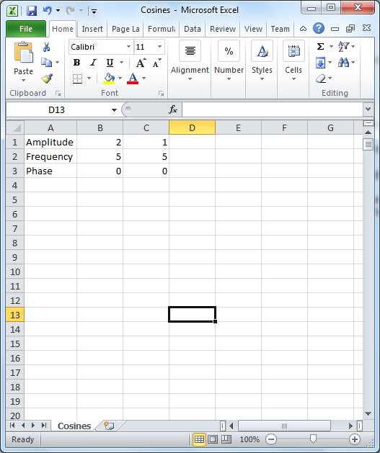

Make a column for the times. Generate times starting at zero going up to 1 with a separation between consecutive values (an increment) of 0.001. Refer to the previous exercise Plotting Mathematical functions if you have forgotten how to set this up.

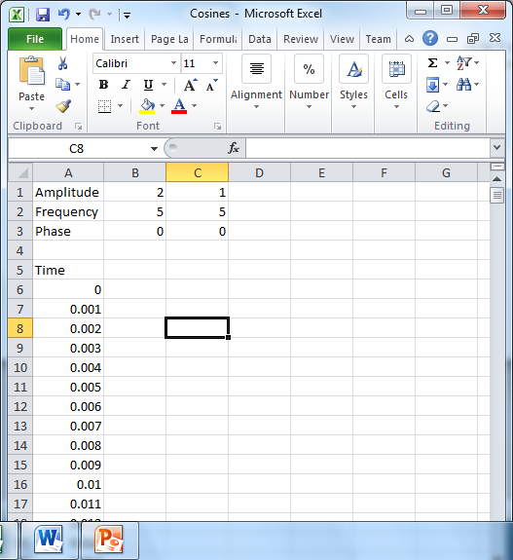

Enter formulas like =B$1*COS(2*PI()*B$2*$A6+B$3) for the two cosine functions. Note the use of absolute addressing ($’s). The PI() part just supplies the number 3.14159265358979323…
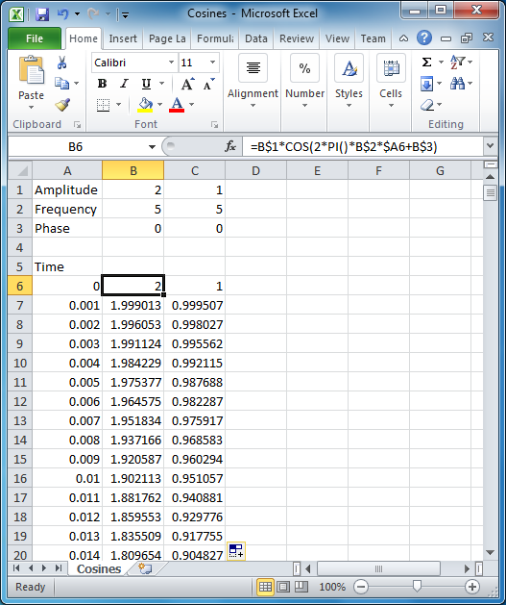

Recall that a dollar sign in front of the number means that the number does not change when the formula is copied to other cells and that a dollar sign in front of a letter means that the letter does not change when it is copied to other cells.

- Make a plot of two cosine functions that have different amplitudes (but frequency and phase the same) and paste it below.

- Make a plot of two cosine functions that have different frequencies (but amplitude and phase the same) and paste it below.

- Make a plot of two cosine functions that have different phases (but amplitude and frequency the same) and paste it below.

Next we will look briefly at the phenomenon of beats.
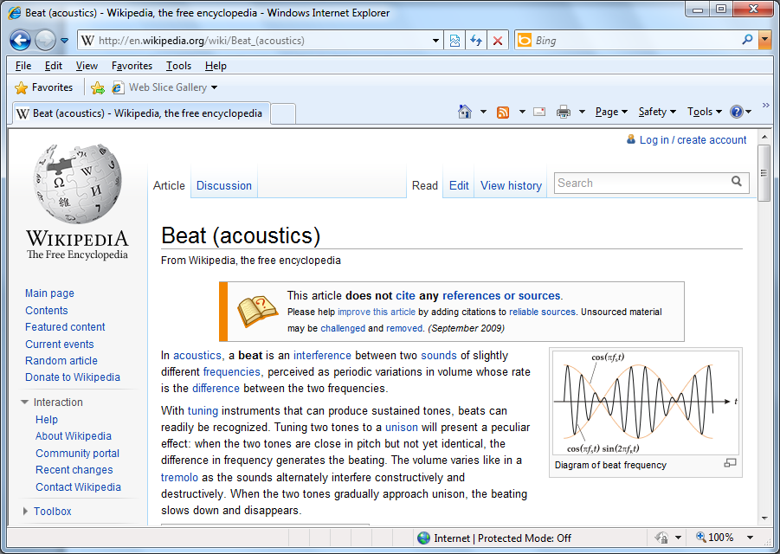

Extend your domain for the times which previously went from 0 to 1 making it go now from 0 to 10. Copy your cosine formulas down as well.
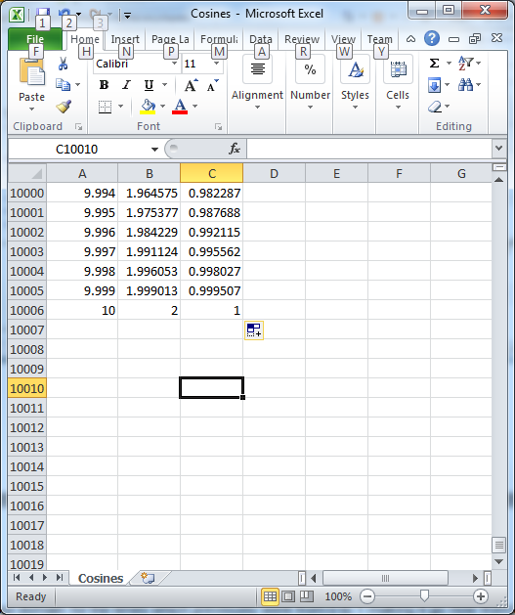

In the next column enter a formula to add the two cosine functions. Copy in down – after entering the formula. Place your mouse over the cell, move toward the lower right hand corner. When the cursor changes to a thin cross, then double click.
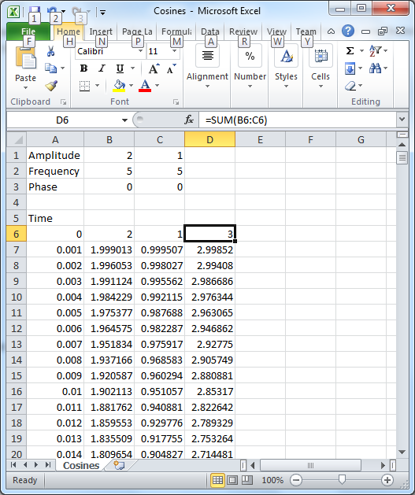

Highlight the time and sum columns. Make an XY Scatter graph. Replace my graph (which has frequencies of 3 and 3.5, amplitudes both 1 and phases both 0) with yours. Some of your parameters should be different from mine.
