Information Entropy

We are going to count the frequency of letter occurrence in English. Start by making a conjecture about what you expect the six most frequent and six least frequent letters to be.

Conjecture of most frequent:

Conjecture of least frequent:

Claude Shannon introduced the notion of entropy to the field of Information Science (also known as Communication Theory). Information entropy measures the rate at which information is transmitted. Using an alphabet of 26 letters suggests at first that one conveys log₂(26)= 4.7 bits per letter (ignoring spaces and punctuation). However, the calculation of entropy suggests that the alphabet’s capacity to convey information is not actually met because some letters are used frequently and some quite infrequently. In this lab you will calculate the entropy of two texts and compare their so-called frequency analyses and entropy calculations. (It might be interesting to compare two languages or text from two different centuries, etc.)

Open a new Word document and paste in some text (at least a long paragraph). The longer it is, the better the statistics. Open an Excel spreadsheet and in the first column place the header “Letters” followed by each letter as shown below.

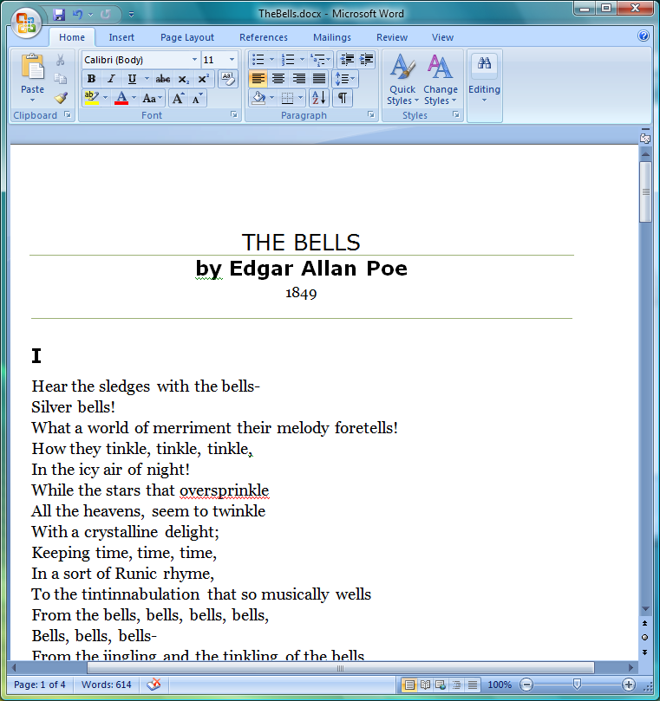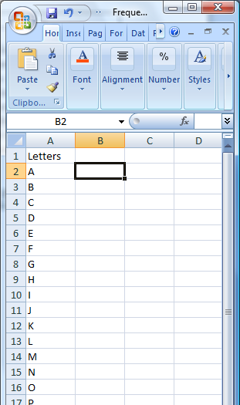

Use Word’s Find and Replace dialog box found under Edit/Replace. Enter an “a” in the Find What textbox and enter nothing in the Replace with textbox. Click on the Replace All button and enter the number of replacement reported into your Excel spreadsheet next to the letter a (Cell B2).

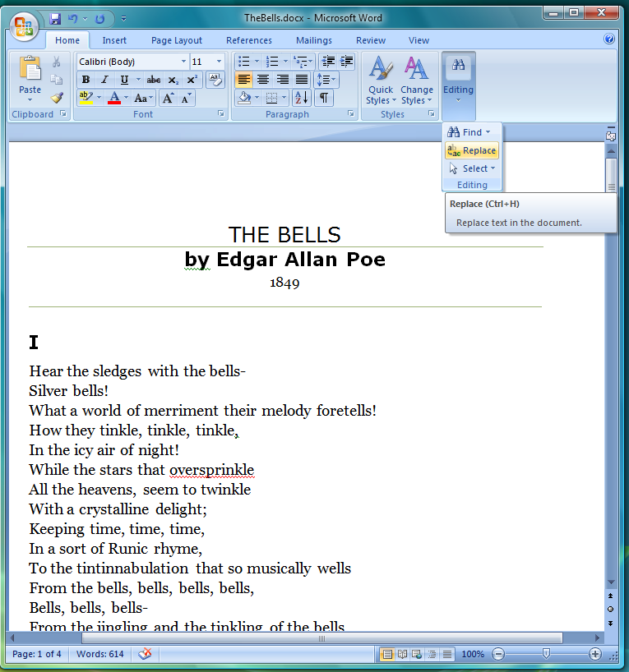

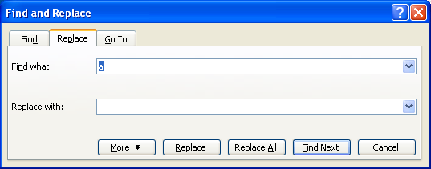

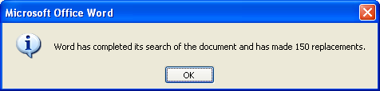

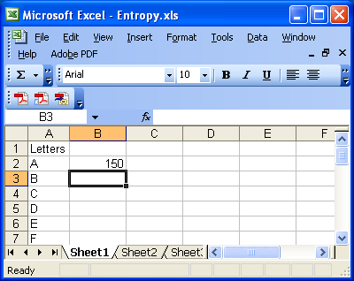

Continue with the other letters.

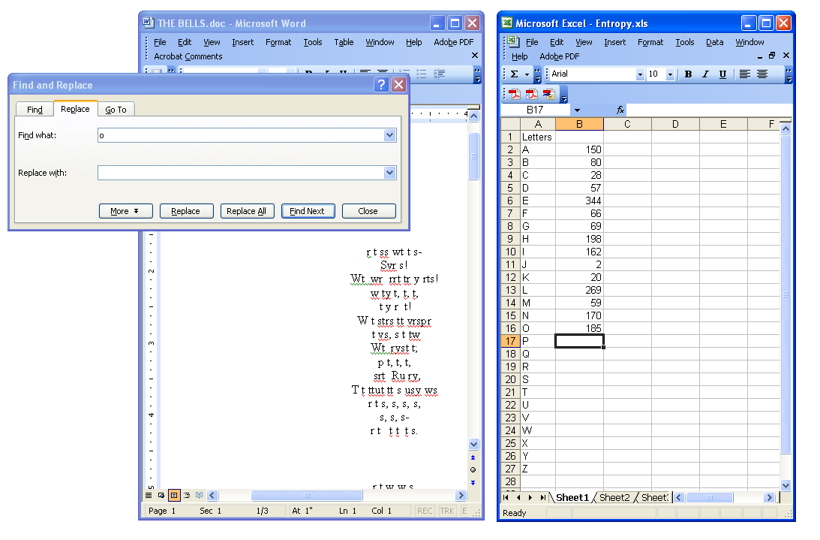

Strictly speaking we should count the spaces and various punctuation marks as well, but we will stop with the letters. Place a header “Frequencies” at the top of this column and then take the sum of the frequencies (highlight the cell at the bottom, B28 and either double click the Σ button or enter the formula =SUM(B2:B27).)

Place a header “Probabilities” in the third column. Calculate the probabilities by dividing the frequency by the sum. For example, enter in C2 the formula =B2/B$28. (You can check your calculations by summing this column; you should get 1.)

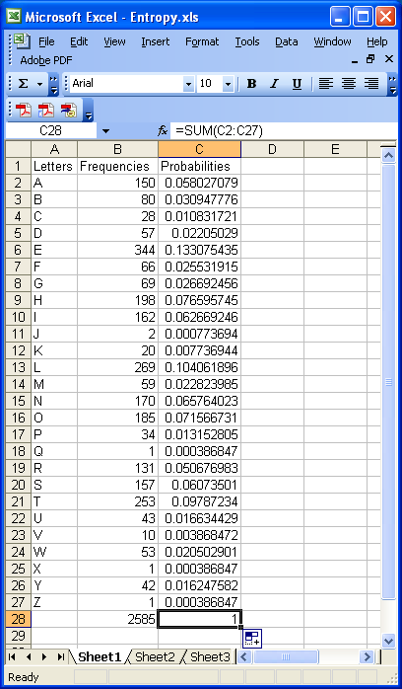

Make a histogram (column chart) of the letters and their probabilities. Right click on a column; choose Format Data Series; then on the Options tab, set the Gap Width to 0.

Because the frequency distribution shown above is based on the poem The Bells, the letters “b” and “l” have larger than usual probabilities. Frequency analysis is used to decrypt the messages hidden in cryptograms, such as that shown below.

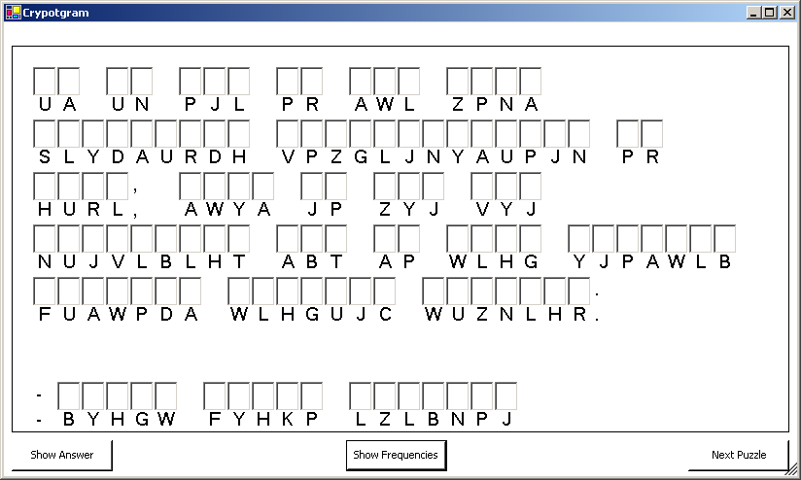

The 9th Century mathematician Al-Kindi did some of the early work on such techniques. It may seem odd that the uneven use of letters that allows one to discover the cryptogram’s hidden message also implies that it conveys less information than it could.

Frequency analysis is also used in file compression. It allows one to better match the size of a file with the actual amount of information contained therein. Next, we will calculate the entropy from the frequency distribution. In a column labeled “Entropy”, enter the formula = - C2*LOG(C2,2). If you have any frequencies that are zero, you may want to enter the more complicated formula =IF(C2=0, 0, -C2*LOG(C2,2)). Finally sum the entropy column to determine the entropy per letter as shown below.

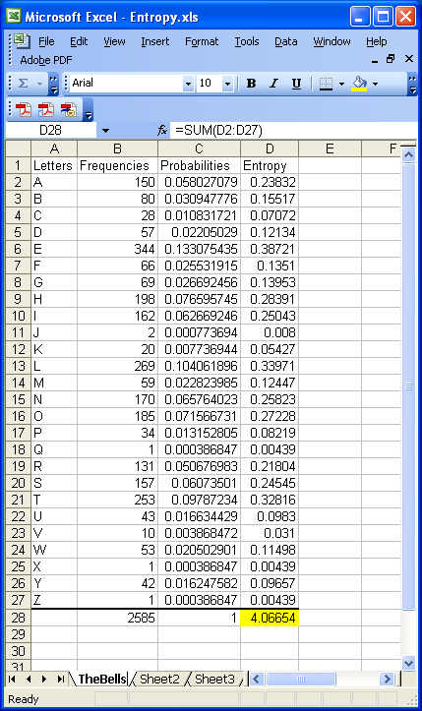

This calculation suggests that the poem The Bells by Edgar Allen Poe contains a little over 4 bits of information per letter. A standard encoding scheme for letters known as ASCII uses 8 bits per character. Thus one can see that such an encoding would not be efficient using almost twice as many bits as there is actual information in the text. Unlike ASCII which uses 8 bits for each character, efficient encoding methods use short codes for frequently occurring letters and long codes for infrequently occurring letters making for a shorter encoded message (on average). Morse code is an example of such a system – using a dot to represent the most common letter E and dash-dash-dot-dash to represent the infrequent Q.

Perform the frequency analysis and entropy calculation for your two texts. Compare these to a third distribution in which you make all of the frequencies the same. Having all of the frequencies the same should maximize the entropy and provide what we call the information capacity.

Name of Text 1:

Paste Letter Frequency Distribution for Text 1 here.

Information per letter for Text 1:

Name of Text 2:

Paste Letter Frequency Distribution for Text 2 here.

Information per letter for Text 2:

Make a comment on how your hypothesis compared to the experimental results.

Reference: http://en.wikipedia.org/wiki/ETAOIN_SHRDLU

