Information Entropy

We are going to count the frequency of letter occurrence in English. Claude Shannon introduced the notion of entropy to the field of Information Science (also known as Communication Theory). Information entropy measures the rate at which information is transmitted. Using an alphabet of 26 letters suggests at first that one conveys log₂(26)= 4.7 bits per letter (ignoring spaces and punctuation). However, the calculation of entropy suggests that the alphabet’s capacity to convey information is not actually met because some letters are used frequently and some quite infrequently. In this lab you will calculate the entropy of a text and perform a frequency analyses and do an entropy calculation.

Open a new Word document and paste in some text (at least a long paragraph). The longer it is, the better the statistics. Open an Excel spreadsheet and in the first column place the header “Letters” followed by each letter as shown below.

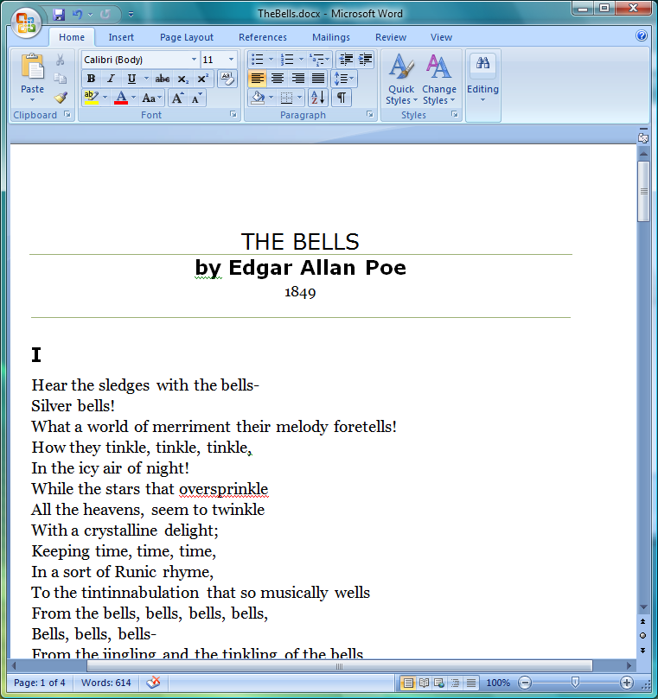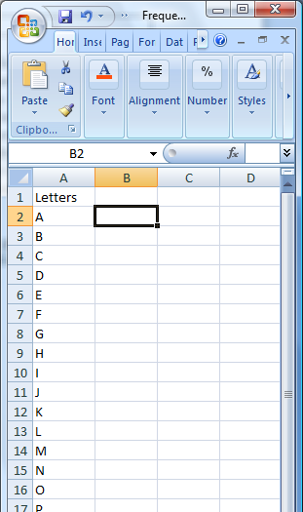

Use Word’s Find and Replace dialog box found under Edit/Replace. Enter an “a” in the Find What textbox and enter nothing in the Replace with textbox. Click on the Replace All button and enter the number of replacement reported into your Excel spreadsheet next to the letter a (Cell B2).

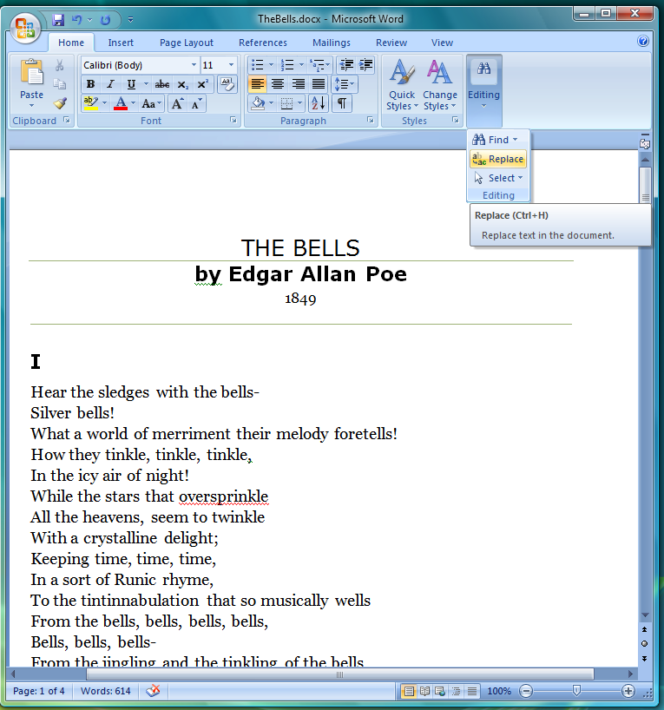

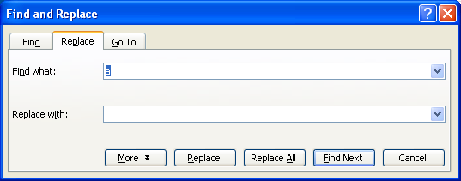

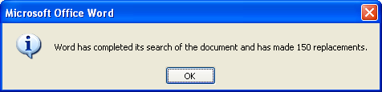

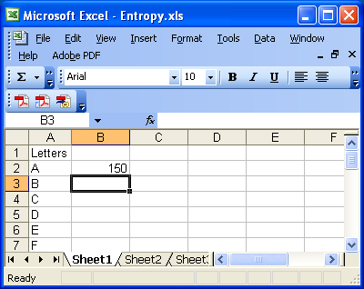

Continue with the other letters.

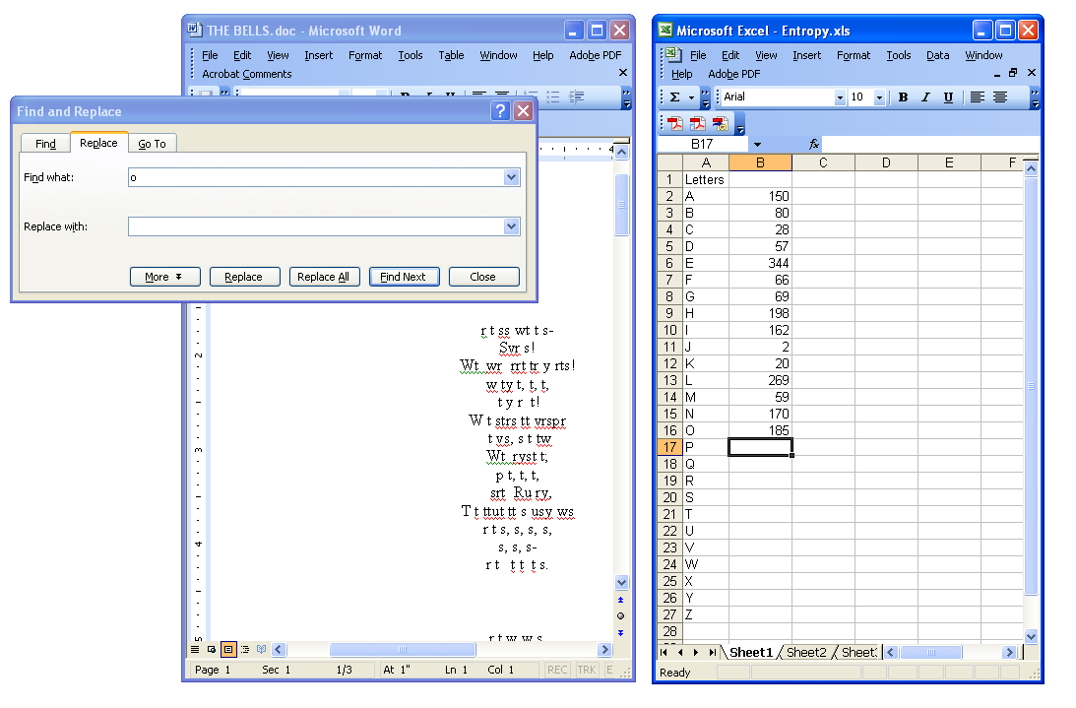

Strictly speaking we should count the spaces and various punctuation marks as well, but we will stop with the letters. Place a header “Frequencies” at the top of this column and then take the sum of the frequencies (highlight the cell at the bottom, B28 and either double click the Σ button or enter the formula =SUM(B2:B27).)

Place a header “Probabilities” in the third column. Calculate the probabilities by dividing the frequency by the sum. For example, enter in C2 the formula =B2/B$28. (You can check your calculations by summing this column; you should get 1.)

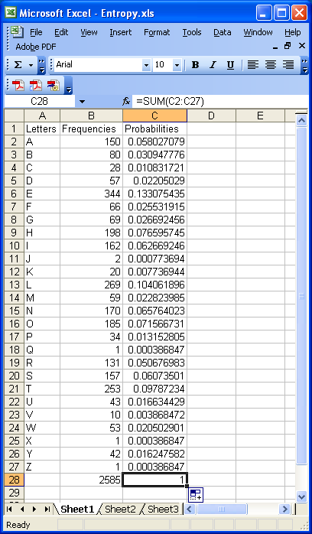

Make a histogram (column chart) of the letters and their probabilities. Right click on a column; choose Format Data Series; then on the Options tab, set the Gap Width to 0.

Next, we will calculate the entropy from the frequency distribution. In a column labeled “Entropy”, enter the formula = - C2*LOG(C2,2). If you have any frequencies that are zero, you may want to enter the more complicated formula =IF(C2=0, 0, -C2*LOG(C2,2)). Finally sum the entropy column to determine the entropy per letter as shown below.

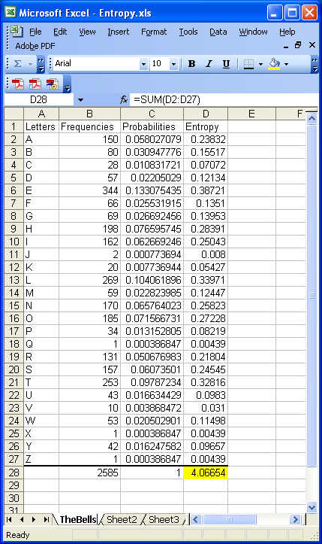

Name of Your Text:

Paste Letter Frequency Distribution for Your Text here.

Information per letter for Your Text :

