Excel IF function

Example

In the game of Yahtzee, a player rolls dice and scores them in various ways. The “upper section” of the game has six ways to score. In the first scoring category, you add up the number of dice that are 1’s in a designated round; in the second scoring category, you add up the number of dice that are 2’s in a designated round, etc. By the end of the game each scoring category must be used once and only once. If the sum, of a player’s score in the upper section is 63 or higher, then that player receives a bonus of 35 points. (http://en.wikipedia.org/wiki/Yahtzee)

Suppose you used Excel to keep score, the upper section might look like

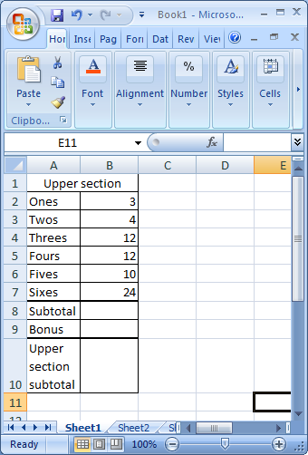

You can obtain the first subtotal by using the SUM function.

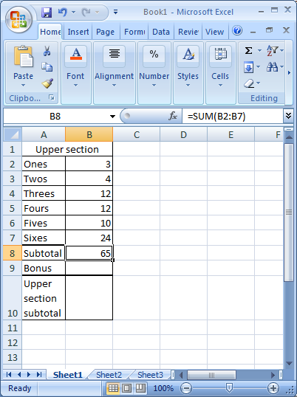

The bonus requires an IF function. An IF function has three parts. In the first part, an IF function tests a condition (here the condition is whether or not the subtotal is 63 or higher). The result of testing a condition can be true or false. The second part of an IF provides the result for cases when the condition is true, and the third part of an IF provides the result for cases when the condition is false.

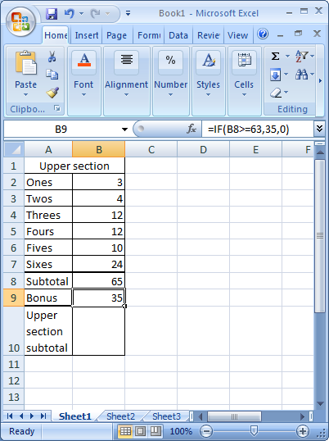

The formula **=IF(B8>=63,35,0)** tests whether the subtotal result in cell B8 is greater than or equal to 63, if it is it outputs 35, if it is not it outputs 0. Here the condition compared a cell to a number and output a number in either case. However, the IF function can also involve functions as its ***arguments***. Another version of the Yahtzee calculation is

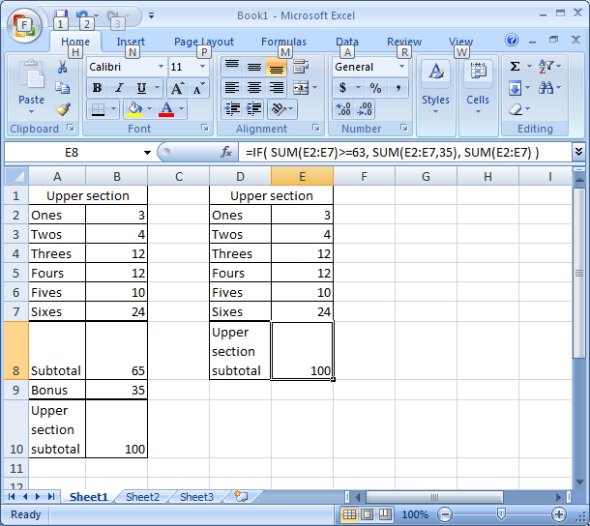

The formula **=IF( SUM(E2:E7)>=63, SUM(E2:E7,35), SUM(E2:E7) )** tests the condition about the sum of the cells in the range E2:E7, if the condition holds (is true), then the output is the sum of those numbers and the bonus of 35; if the condition is not true then the output is just the sum of the numbers.