Fluorescence Intensity data
Data from https://www.chem.utoronto.ca/coursenotes/analsci/stats/LinPortion.html
Copy the data below over to Excel
Concentration pg/ml | Intensity
0 | 2.1
2 | 5
4 | 9
6 | 12.6
8 | 17.3
10 | 21
12 | 24.7
14 | 28.4
16 | 31
18 | 32.9
20 | 33.9

Add a column in between and place there the squares of the concentrations.
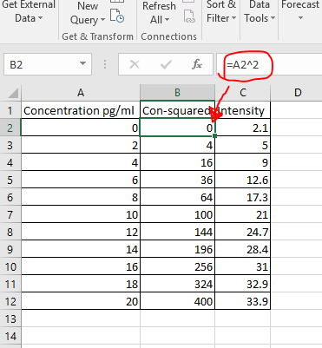
Highlight Columns A and C without Column B highlighted (use control), make an XY-Scatter graph and fit it to a polynomial of order 2. Paste below
Paste graph here
Next go to Data/Data Analysis, and choose Regression. In the dialog box, choose Column C for the y’s (include the label), choose columns A and B for the x’s, and check the labels checkbox.
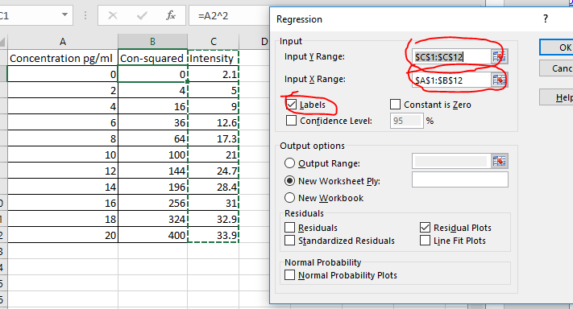

How do the coefficients that results from this analysis compare to the polynomial displayed on your graph?

Fill in the p-values below.
Intercept p-value
Concentration p-value
Con-squared p-value

