Images, Screen Captures, and Drawing
If you find an image you want on the web, right click on it, and choose Save Picture As (or Save Image As) and use the dialog box to know the name and location of the image file.
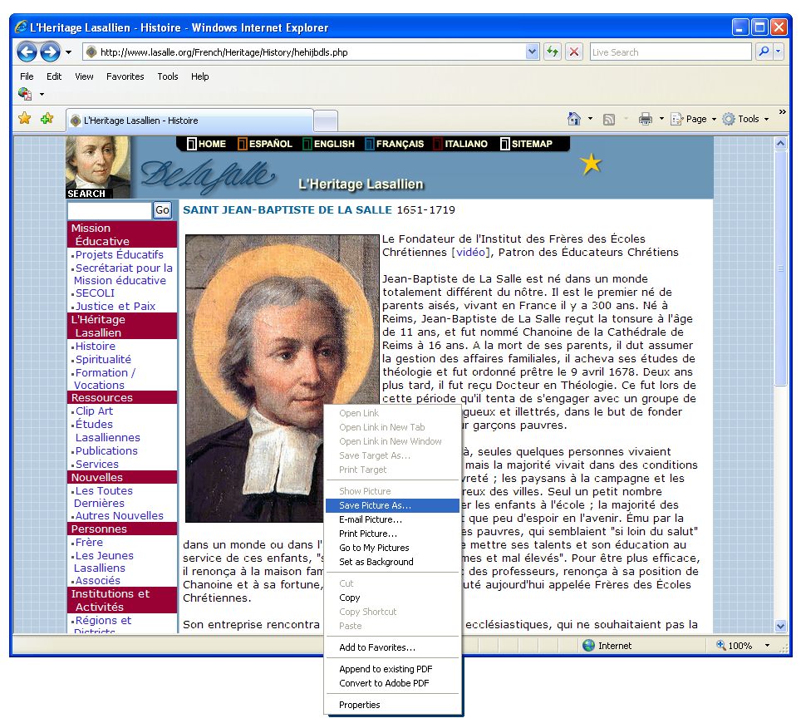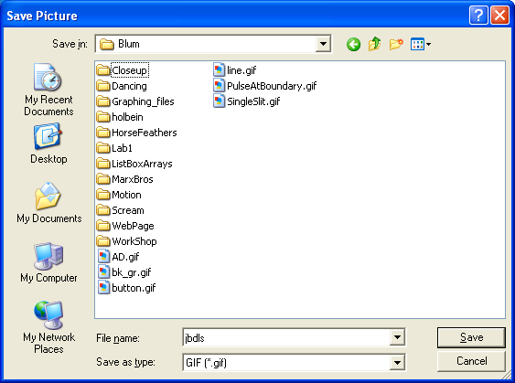
It can then be used in a Word document by going to Insert/Picture
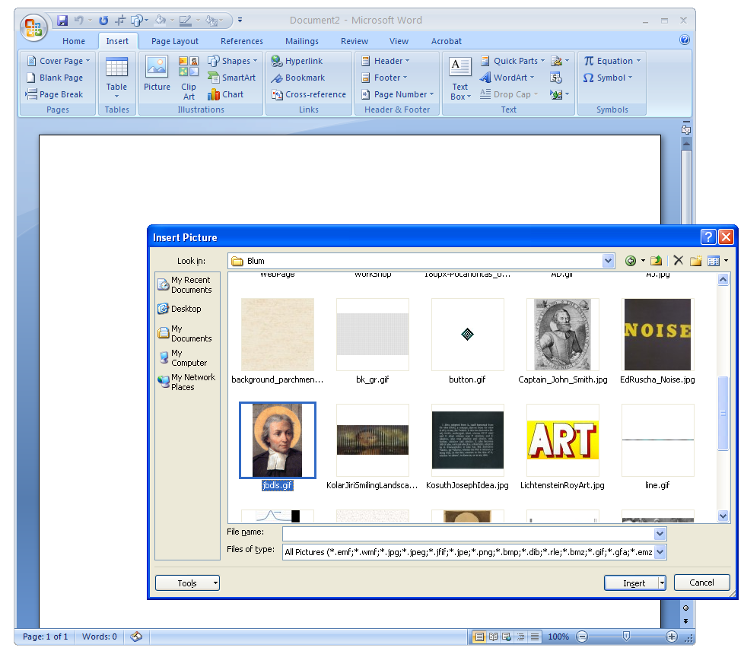
After you have inserted an image there are a number of effects that one can apply under Picture Tools Format.
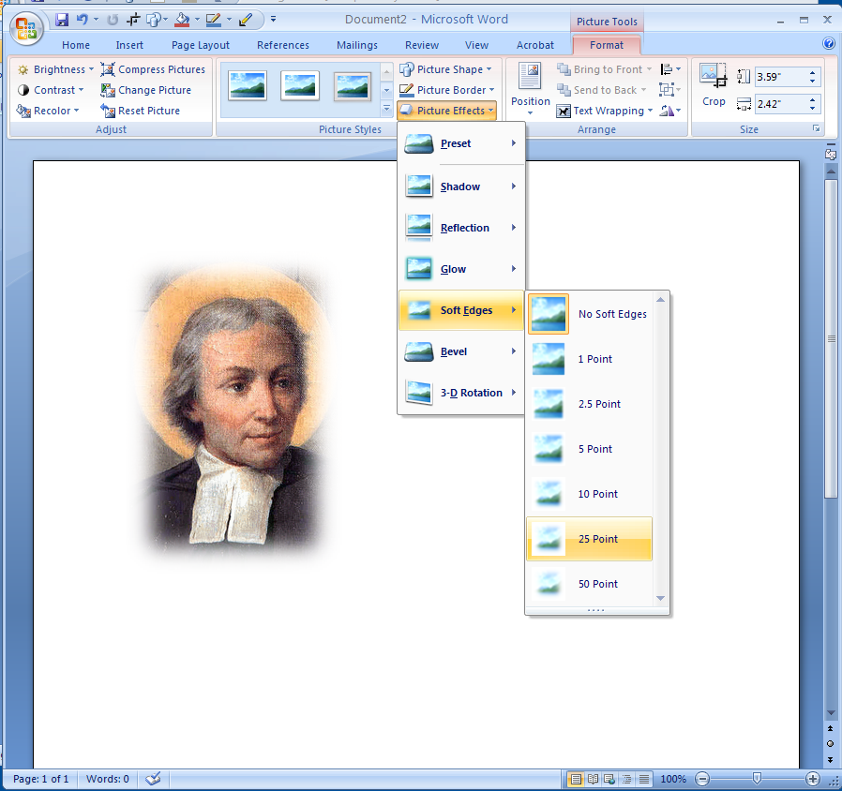
If the image that you want is of your computer’s desktop, you can use the Print Screen button on the keyboard which places an image of your screen on the clipboard, which can then be pasted into a Word document or PowerPoint presentation.
If you want just the highlighted object, press Alt-Print Screen.
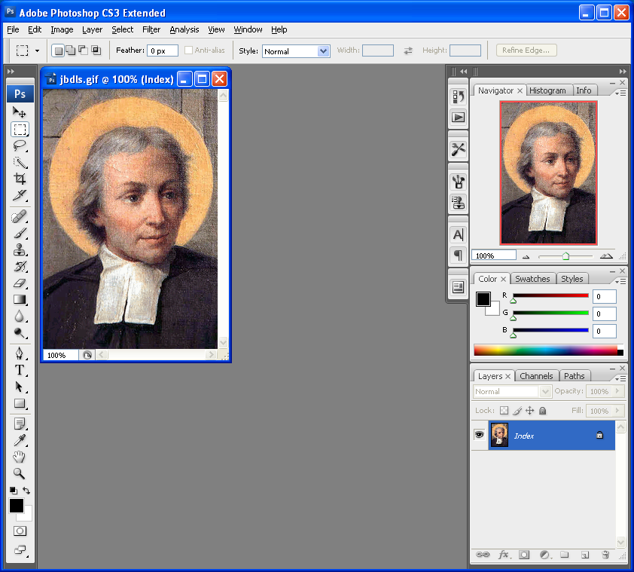
If you want the entire desktop, press just Print Screen. (This is useful for showing menus or error messages.)
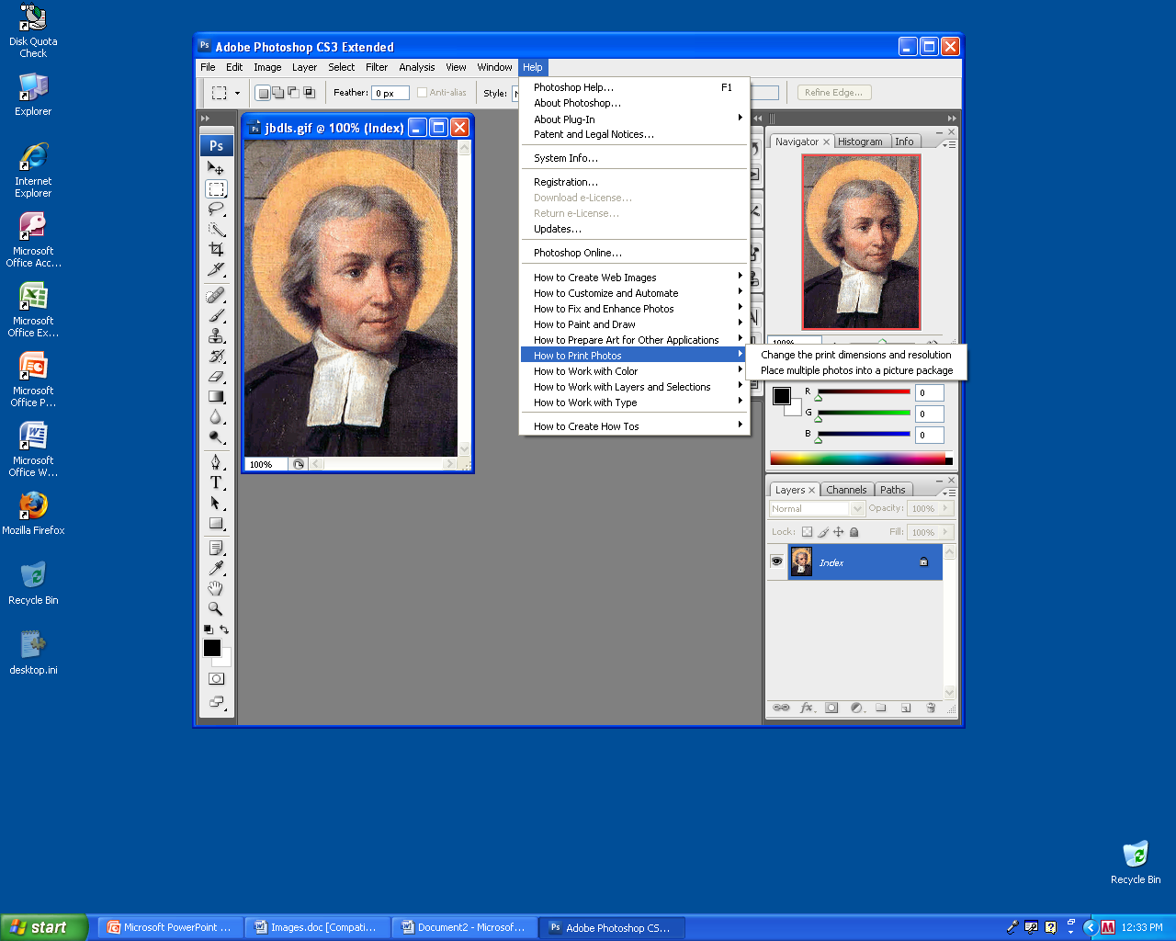
One of the Picture Tools allows you to crop the image. Place the crop tool near the middle of a side (you will see an indicator there) and drag to crop (take away parts of) the image.
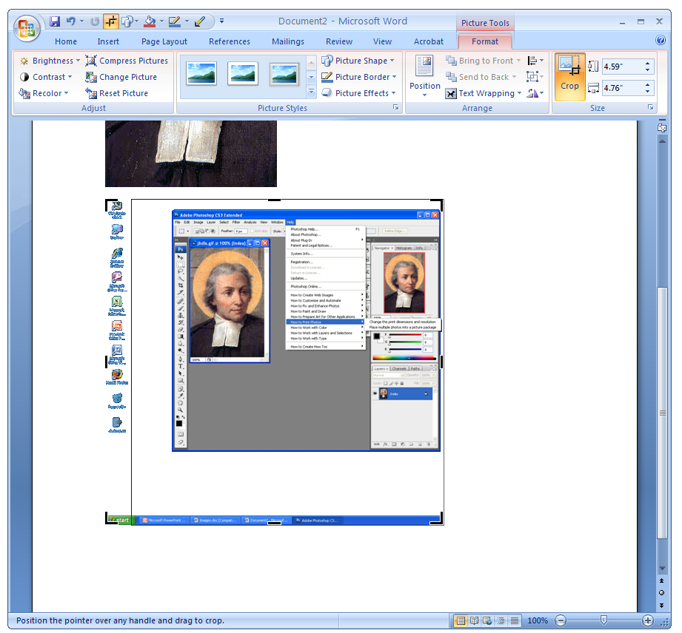
Another tool I find useful is the Set Transparency Color tool which can make a solid background transparent.
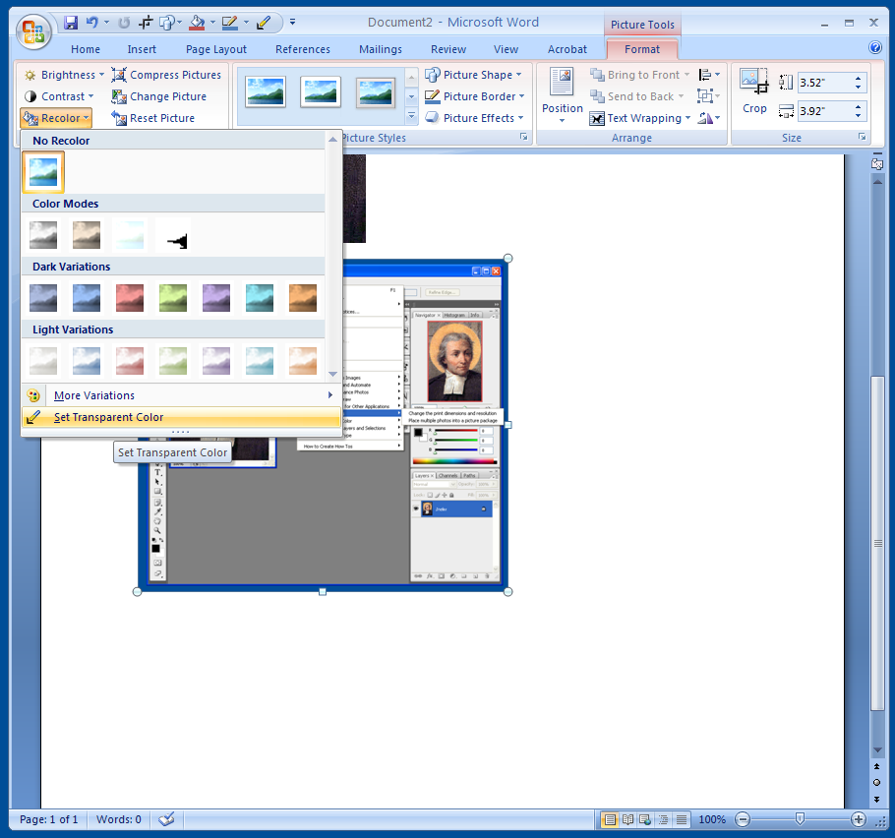

If you want to draw one the image, go to the Insert/Shapes
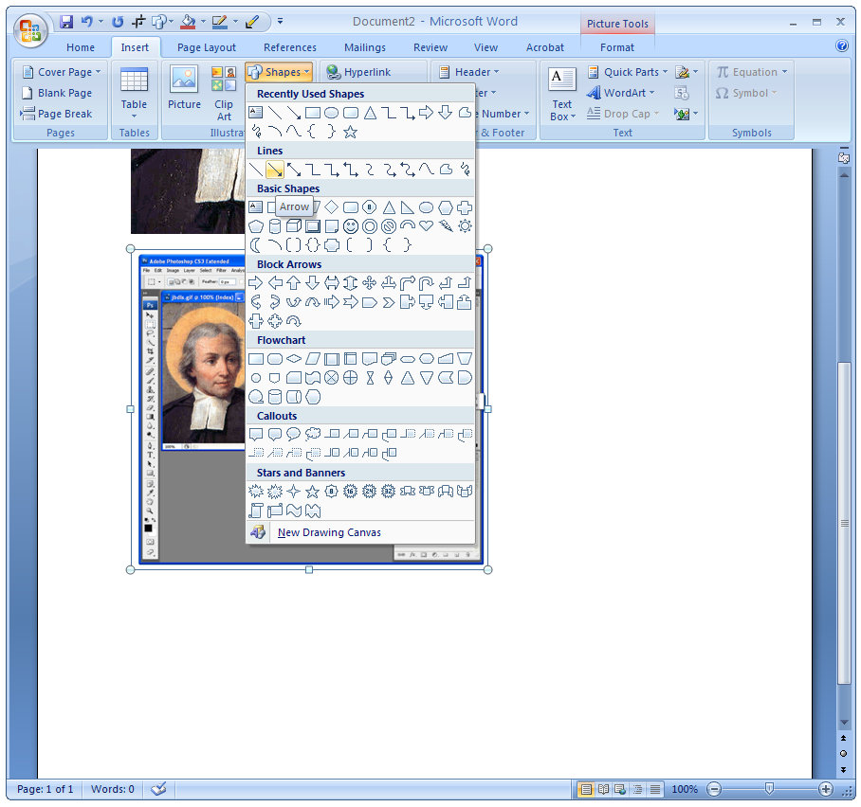
After selecting an arrow and dragging it onto the image, one can change its color, weight, etc.
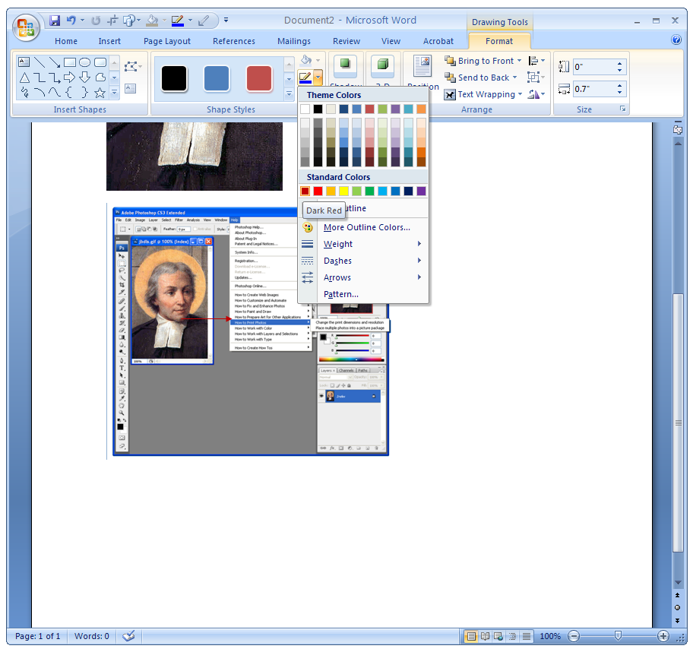
One can do all the same things in PowerPoint, but PowerPoint allows one to save the edited image as a new image. First drag across the screen to make a box around everything that should be included.
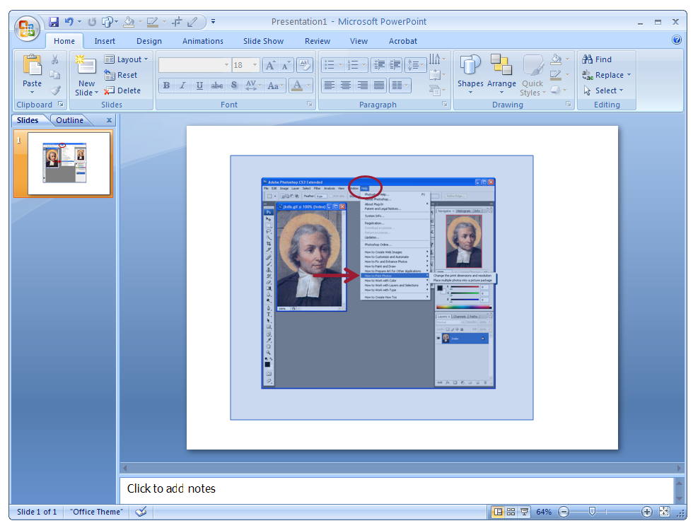
That selects a set of objects which can be grouped into one object by right clicking and choosing Group.
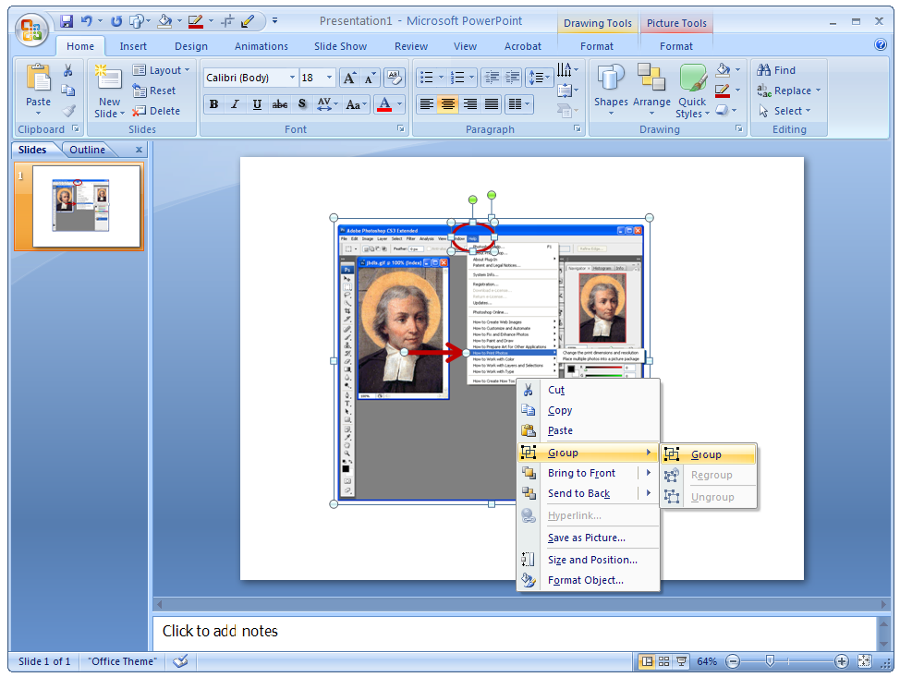

Right click again and choose Save As Picture.
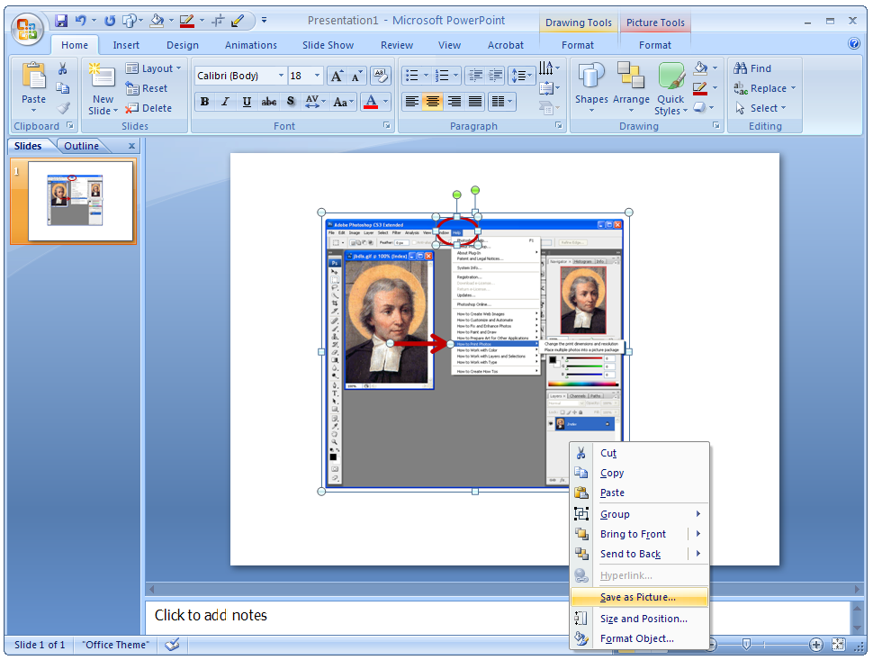
Use the dialog box, to select a name, location and type of image file.
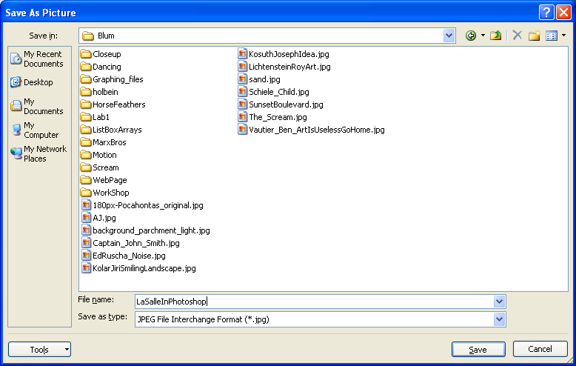

Suppose you find yourself often adjusting the brightness of images then you add the Brightness tool to the Quick Access Toolbar near the top of the application by right clicking on the tool and choosing Add to Quick Access Toolbar.
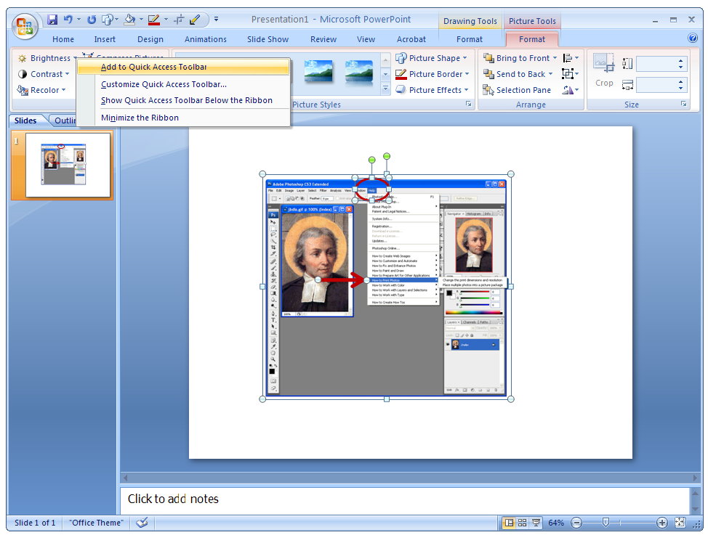

Assignment:
Part A. In Word make a table with at least six cells. Place the same image in each cell and then apply various effects to them.
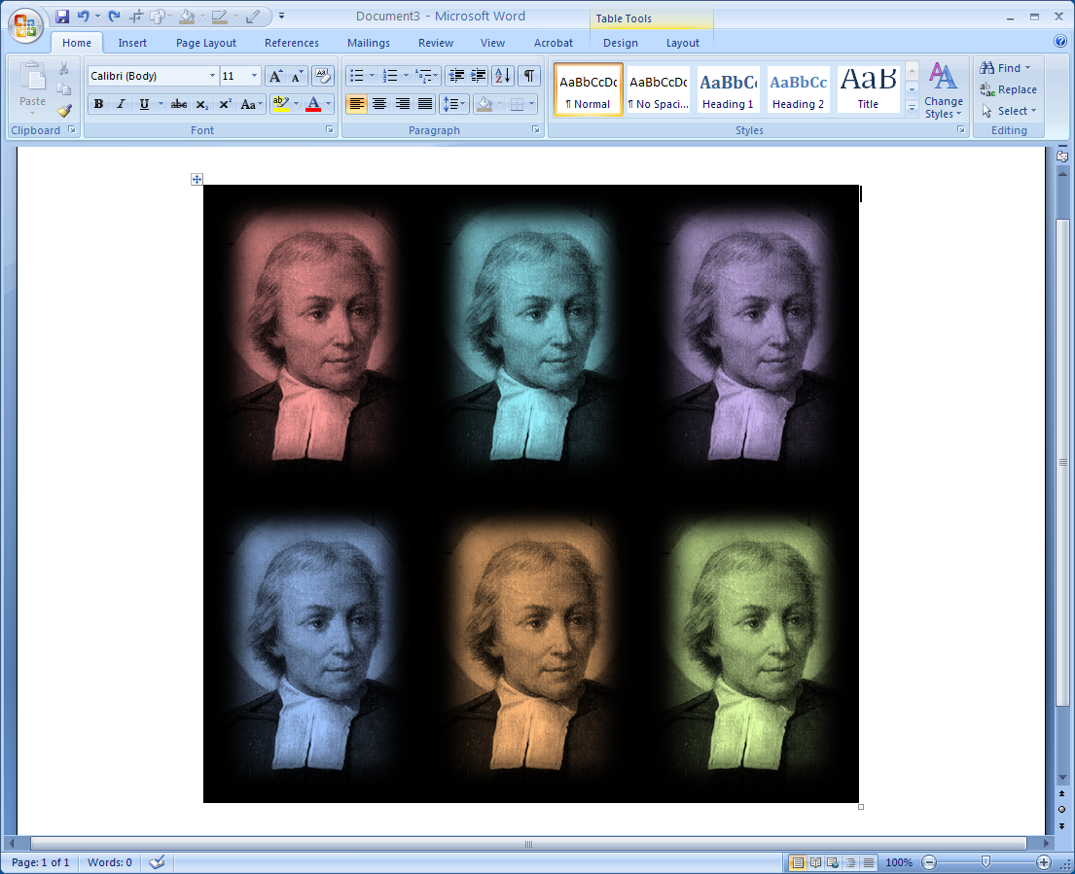
Part B. Use PowerPoint to draw on top of an image. And then same a new image that includes the image and your drawing on top of it.
