**Ohm’s law and combinations of resistors**

The voltage (or potential difference) is a push that charges experience. The potential difference is measured in volts, a unit named after Alessandro Volta. This force may result in charges moving – otherwise known as a current. The current is measured in amperes or amps, a unit named after André-Marie Ampère. Actually an ampere is a fairly large current and we will see currents measured in mA (milliamps). There is a class of materials and devices made from those materials in which the current in the material is directly proportional to the voltage applied to the material; so that if one doubled the voltage, one would double the resulting current; if one tripled the voltage, one would triple the resulting current; and so on. This relationship is expressed as

V = I R

and is called Ohm’s law. Furthermore, the proportionality constant R is called the resistance; resistance is measured in ohms, a unit named afterGeorg Simon Ohm. Actually an ohm is a fairly small resistance and we will see resistances measured in kΩ (kilo-ohms).

|  |  |
| --- | --- |
| Resistor | |
| **Voltage (V)** | **Current (mA)** |
| 1.0 | 0.29 |
| 2.0 | 0.61 |
| 3.0 | 0.88 |
| 4.0 | 1.19 |
| 5.0 | 1.53 |

Make a plot of current versus voltage. Add a fit to a straight line. Force that line to go through the origin.

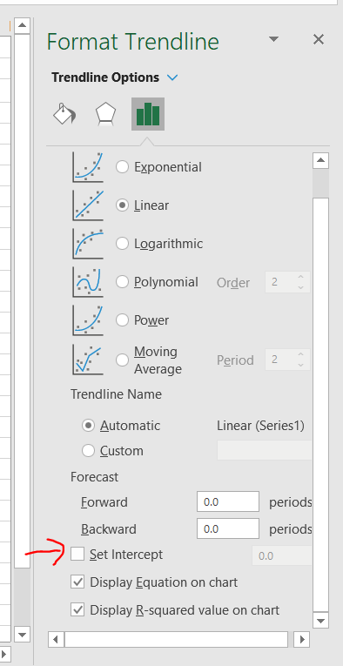

Paste the plot below.

***Paste plot here.***

Since the data has current on the Y axis, solve Ohm’s law for current I. Type the result below.

***Ohm’s Law solved for I***

According to the above result what is the interpretation of the slope of your fit equation?

***Slope Interpretation:***

Finally determine the resistance from your graph (don’t forget the unit).

***Resistance:***