Name: _______________________

Levers: an example of plotting to something other than a straight line.

A way to “see” the dependence of the variables is to plot them against one another. Make an XY-Scatter graph in Excel with Weight (the independent variable) on the x-axis and Lever Arm (the dependent variable) on the y-axis.

  - Open Excel and enter the weight and lever-arm data in two columns. In Excel the x-axis data (which is conventionally the independent variable) goes in the first column while the y-axis data (conventionally the dependent variable) goes in the second column.

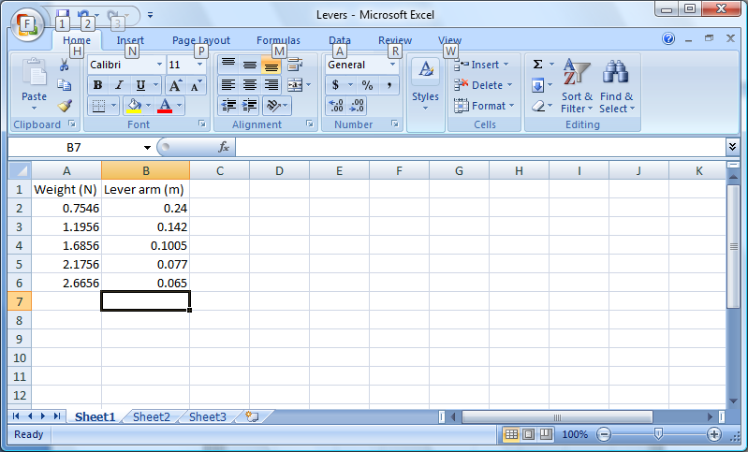

  - Highlight the data in the two columns. Then click on the Insert tab. Click on Scatter under the Chart region and choose the version which has data points only.

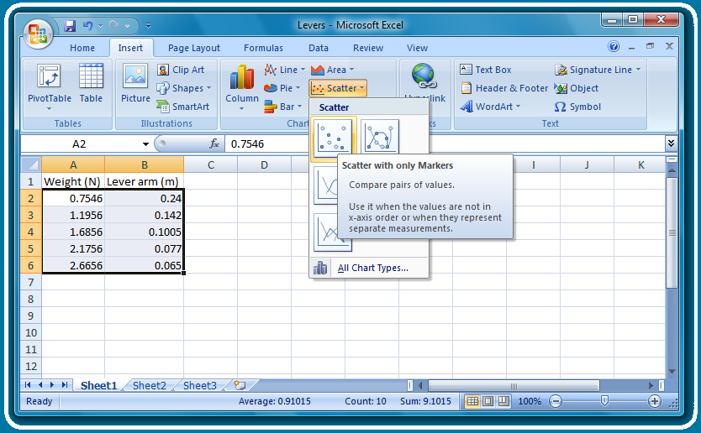
  - With the chart highlighted, click on the Design tab under Chart Tools. Then click on the drop-down arrow next to Quick Layout and choose Layout 9.

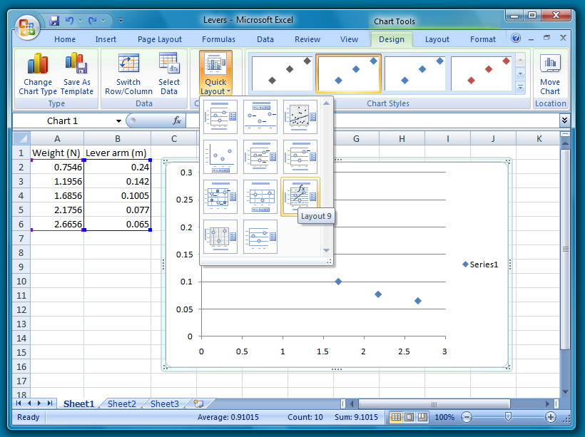

  - Click on the x-axis label and enter “Weight (N)”. Then click on the y-axis label and enter “Lever arm (m)”. Next click on the title and enter a title.

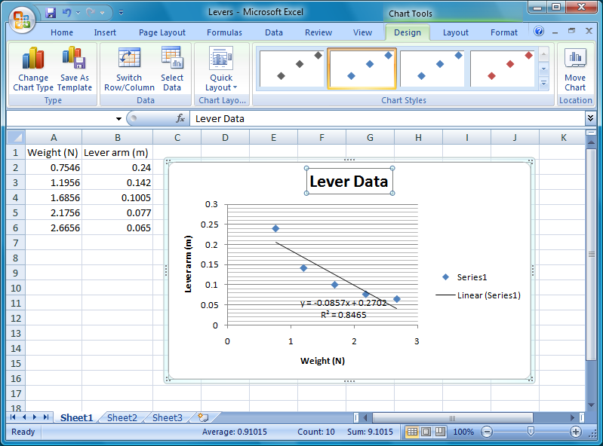

  - Right click on the legend and choose delete.

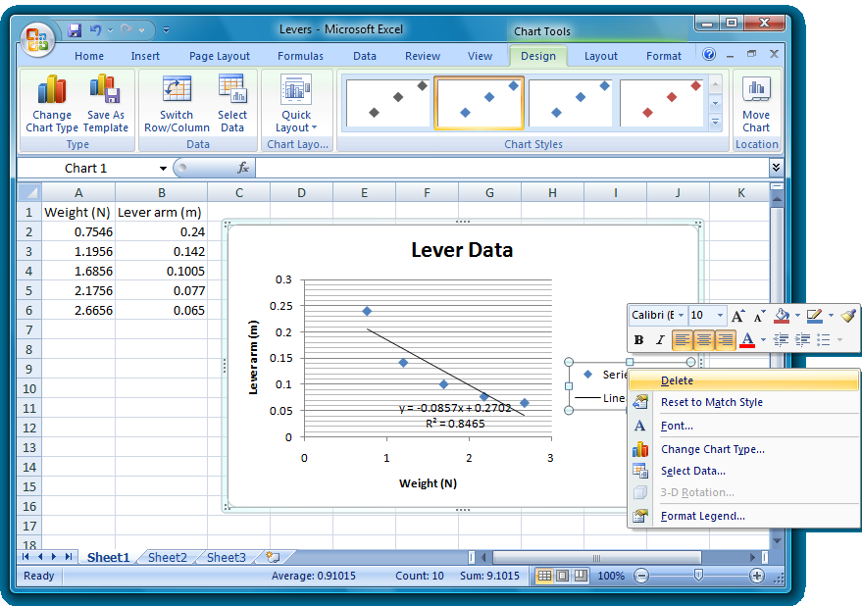

  - Right click on the line (known as a Trendline or a fit) and choose Format Trendline.

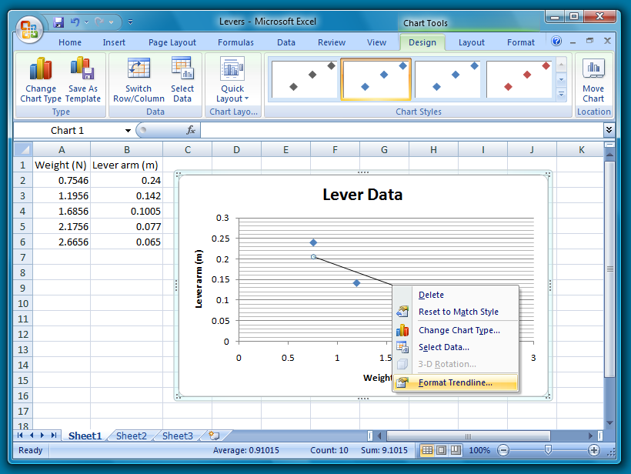

  - The mathematics that we expect our data to conform to is called a Power law, so select that option. Also make sure that the checkboxes for Display Equation and display R-squared value are checked. (The R-squared value is a statistical measure of how well the data and the mathematical function agree.)

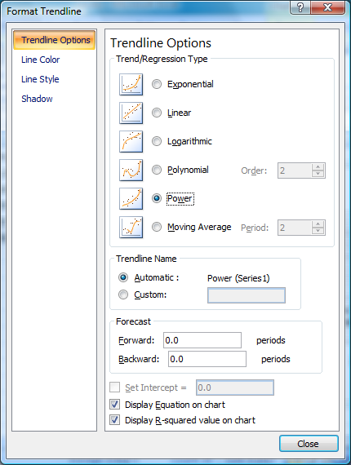

  - Drag the equation to a better position, then highlight it and go to the Home tab and change the Font size.

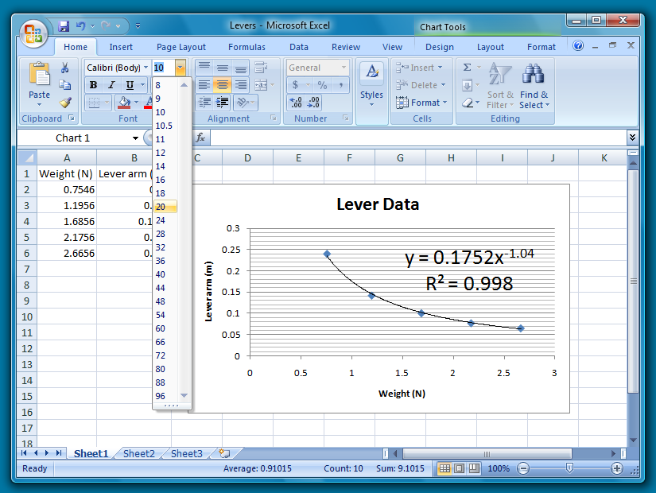

If the Chart is highlighted, it can be copied and pasted into another file, for example a Word document. Thus you will be able to add your graph to this document. Change the color of the Chart Area and/or the Plot Area and paste your graph below.

Paste your version here

The “fit” was to a so-called “Power Law” which has a coefficient (0.1752 in the sample above) and a power (-1.04 in the sample above). The power from the fit is very close to –1, which is known as an “inverse” or “reciprocal” relationship. An inverse law says more than “when quantity A goes up, quantity B goes down,” but more specifically says that “when quantity A is doubled, quantity B is halved; when quantity A is quadrupled, quantity B is quartered; and so on.” A mathematical relationship such as this allows one to imagine what the results would be for dependent variables that were not actually studied in the experiment using the processes of interpolation and extrapolation. Archimedes’ famous extrapolation of the lever results: Give me a lever long enough and a fulcrum on which to place it, and I shall move the world.

