More conditional formatting
Use the data for the Weather for Philadelphia in August 2018
date | high | low | Precip | Snow | Ave high | Ave low
8/1/2018 | 89 | 73 | 0.41 | 0 | 87 | 69
8/2/2018 | 89 | 74 | 0.08 | 0 | 87 | 69
8/3/2018 | 86 | 72 | 0.51 | 0 | 87 | 69
8/4/2018 | 87 | 72 | 0.1 | 0 | 87 | 69
8/5/2018 | 92 | 73 | 0 | 0 | 87 | 69
8/6/2018 | 92 | 75 | 0 | 0 | 86 | 69
8/7/2018 | 92 | 75 | 0.05 | 0 | 86 | 69
8/8/2018 | 92 | 73 | 0.02 | 0 | 86 | 69
8/9/2018 | 89 | 74 | 0.04 | 0 | 86 | 69
8/10/2018 | 91 | 72 | 0 | 0 | 86 | 69
8/11/2018 | 85 | 70 | 0.79 | 0 | 86 | 69
8/12/2018 | 86 | 71 | 0 | 0 | 86 | 69
8/13/2018 | 84 | 71 | 0.52 | 0 | 86 | 69
8/14/2018 | 83 | 68 | 0.73 | 0 | 86 | 68
8/15/2018 | 89 | 72 | 0 | 0 | 86 | 68
8/16/2018 | 89 | 73 | 0 | 0 | 86 | 68
8/17/2018 | 93 | 74 | 0 | 0 | 85 | 68
8/18/2018 | 88 | 73 | 0.34 | 0 | 85 | 68
8/19/2018 | 74 | 66 | 0.34 | 0 | 85 | 68
8/20/2018 | 78 | 66 | 0 | 0 | 85 | 68
8/21/2018 | 81 | 69 | 0.02 | 0 | 85 | 68
8/22/2018 | 84 | 71 | 0.05 | 0 | 85 | 67
8/23/2018 | 79 | 67 | 0 | 0 | 85 | 67
8/24/2018 | 83 | 63 | 0 | 0 | 84 | 67
8/25/2018 | 81 | 63 | 0 | 0 | 84 | 67
8/26/2018 | 86 | 65 | 0 | 0 | 84 | 67
8/27/2018 | 90 | 73 | 0 | 0 | 84 | 66
8/28/2018 | 94 | 75 | 0 | 0 | 84 | 66
8/29/2018 | 95 | 76 | 0 | 0 | 84 | 66
8/30/2018 | 90 | 78 | 0 | 0 | 83 | 66
8/31/2018 | 79 | 69 | 0.11 | 0 | 83 | 66

We want to visually pick out those days on which the high temperature for the day was higher than the average high for that day. Place your cursor in the high temperature for 8/1/2018. Click on Conditional Formatting/ Highlight Cell Rules/Greater Than …
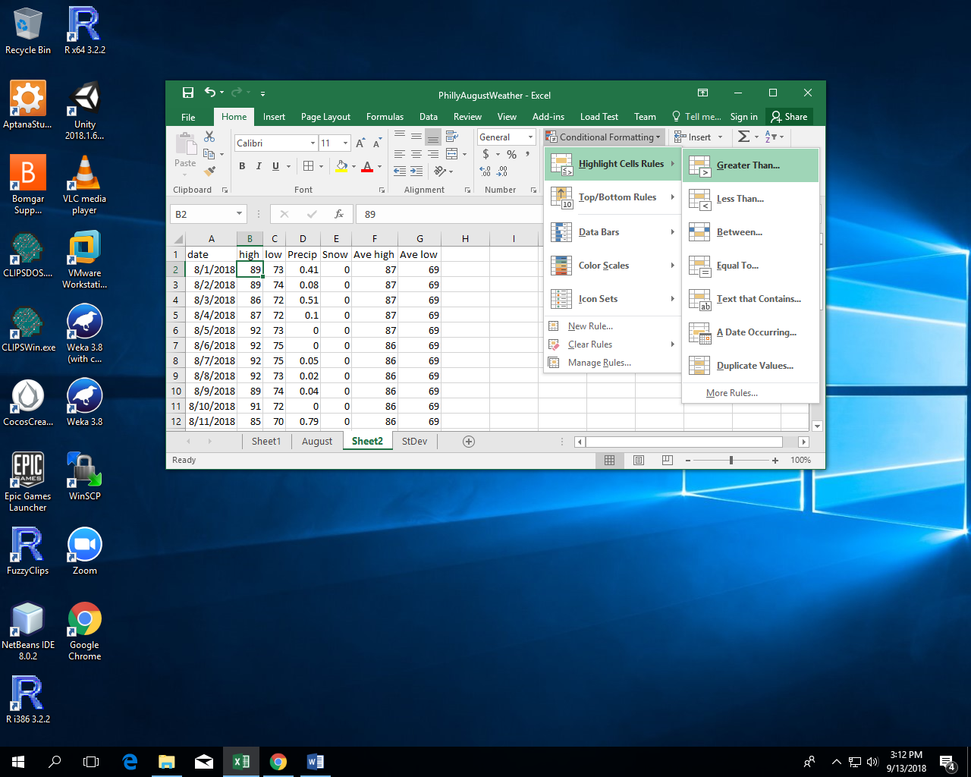

Click on the cell with the average high temperature for 8/1/2018. Eliminate the $ before the 2. (We will be copying the formatting and we want it to change from row-to-row.) Click OK.
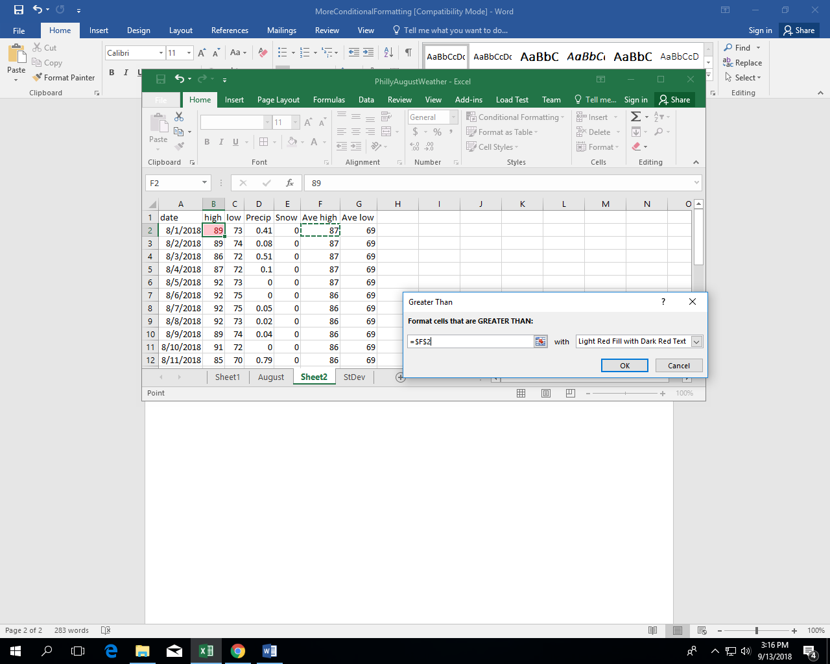
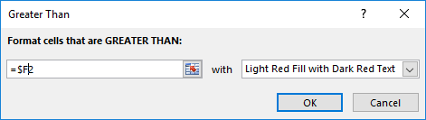
With cursor in the one formatted cell (B2) go to the “Format Painter” in the upper left.
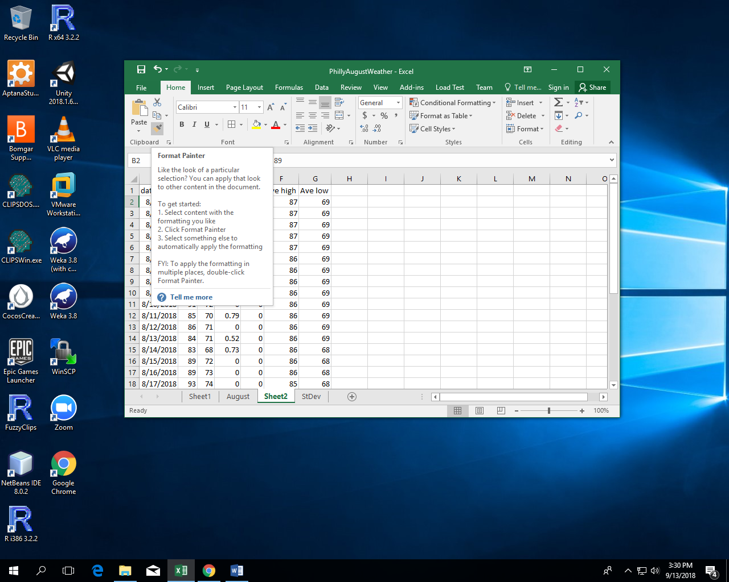
Click on the Format Painter, then drag the “paint brush” icon over the cells you want to copy the formatting to. When you release the mouse from the drag the cells should have the copied formatting.
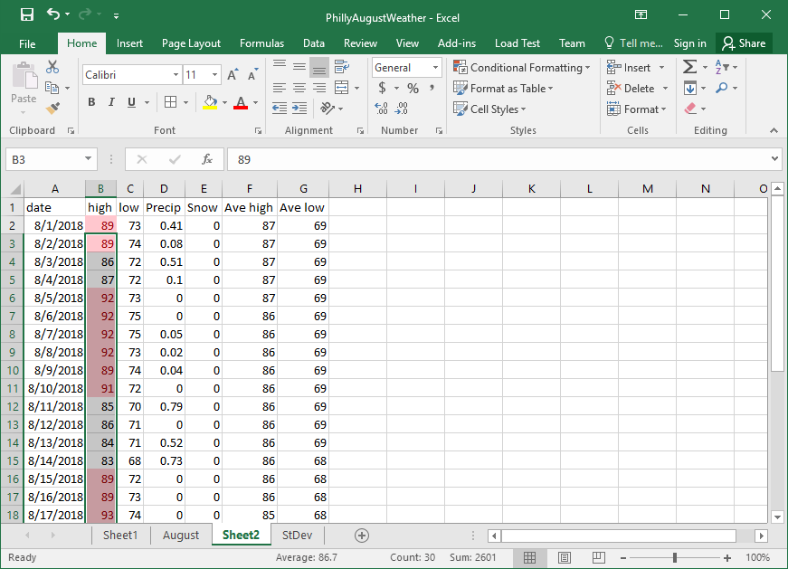
Similarly format the low temperatures that are lower than the average low for that day.
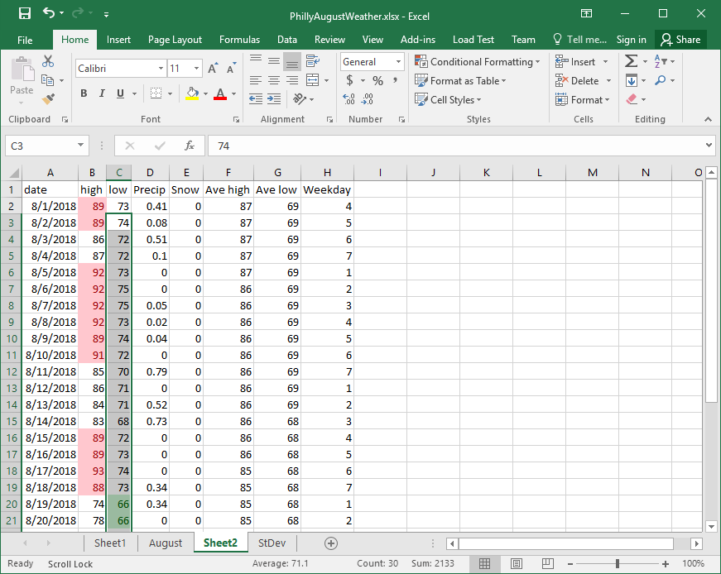
To view any conditional formatting rules applied to a cell, place the cursor in that cell, co to Conditional Formatting/Manage Rules ….
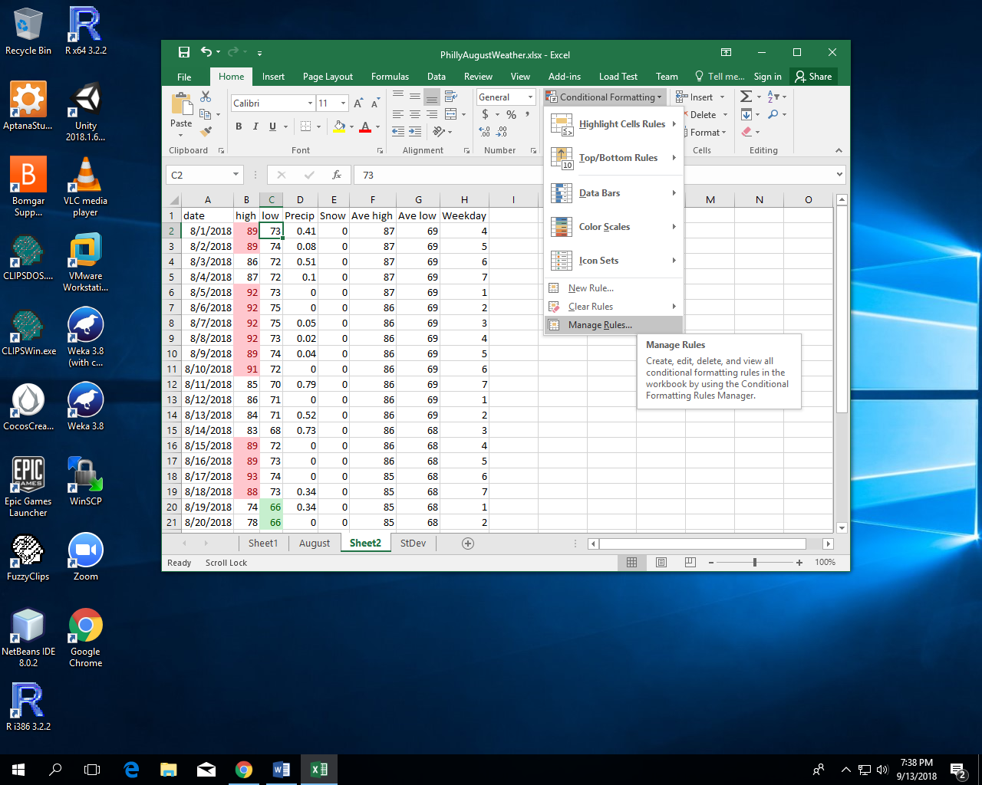
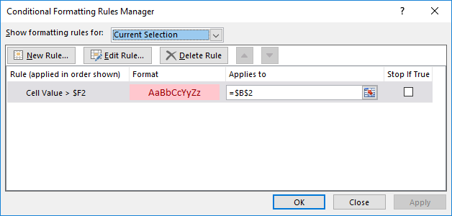

Rainy Days and Mondays (maybe that should be Rainy Days OR Mondays)
https://www.azlyrics.com/lyrics/carpenters/rainydaysandmondays.html
The WEEKDAY formula acts on a date and gives a number depending on the day of the week that date falls on. Mondays are 2 for the basic function.
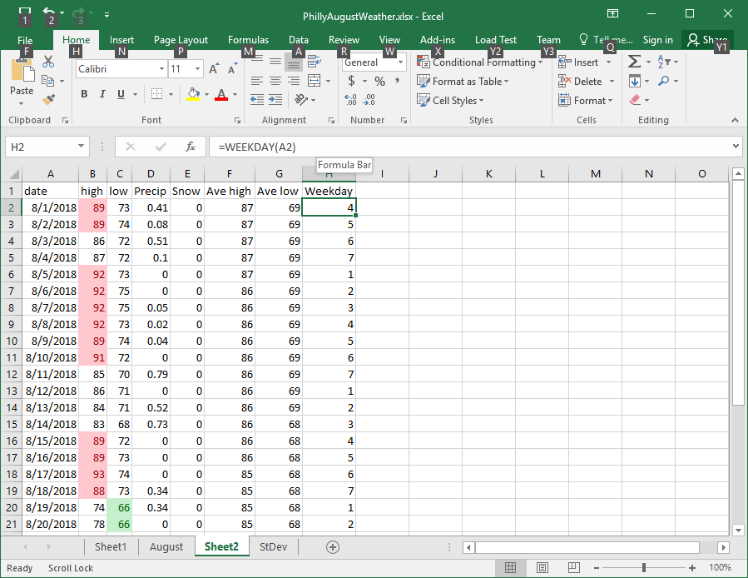

The Excel function AND allows one to combine two conditions. The AND produces a result of TRUE only if both individual conditions are true. Thus
=IF(AND(D2>0,H2=2), "Down", "OK")
Will only say “Down” if it rained on a Monday. D2>0 means there was some precipitation (in August rain) and H2=2 means it was Monday.
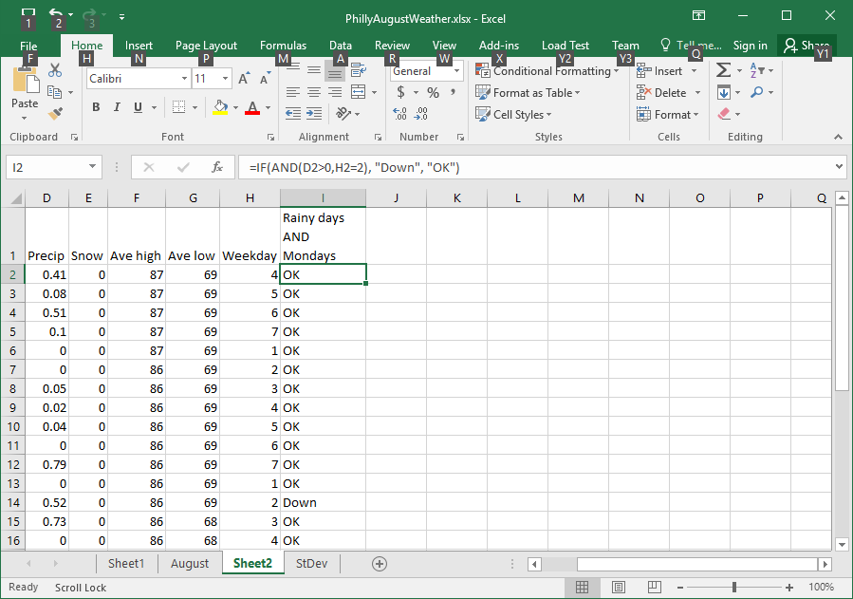

On the other hand, the function OR takes multiple conditions and gives if true if one or more of the individual cinditions is true. Hence the formula
=IF(OR(D2>0,H2=2),"Down", "OK")
Shows “Down” if it rained on the day or if it was a Monday.
