Instructions to accompany evolution_2000.doc
- Run the spell checker. Go to Review/Spelling and Grammar.
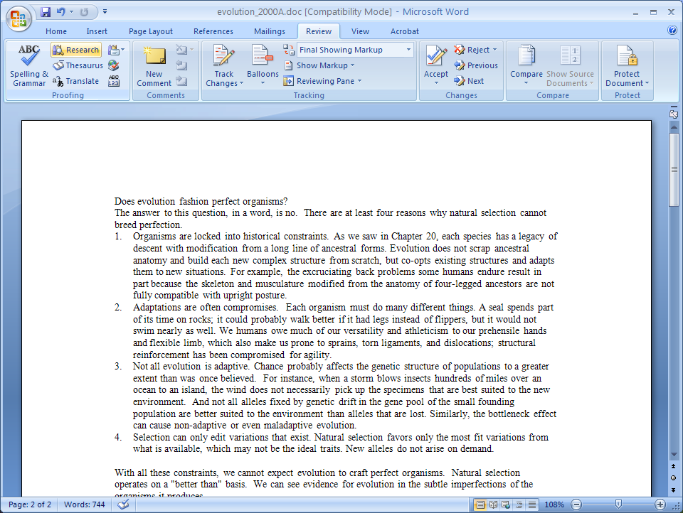

- Italicize subject lines of numbered paragraphs (under Home/Italics).
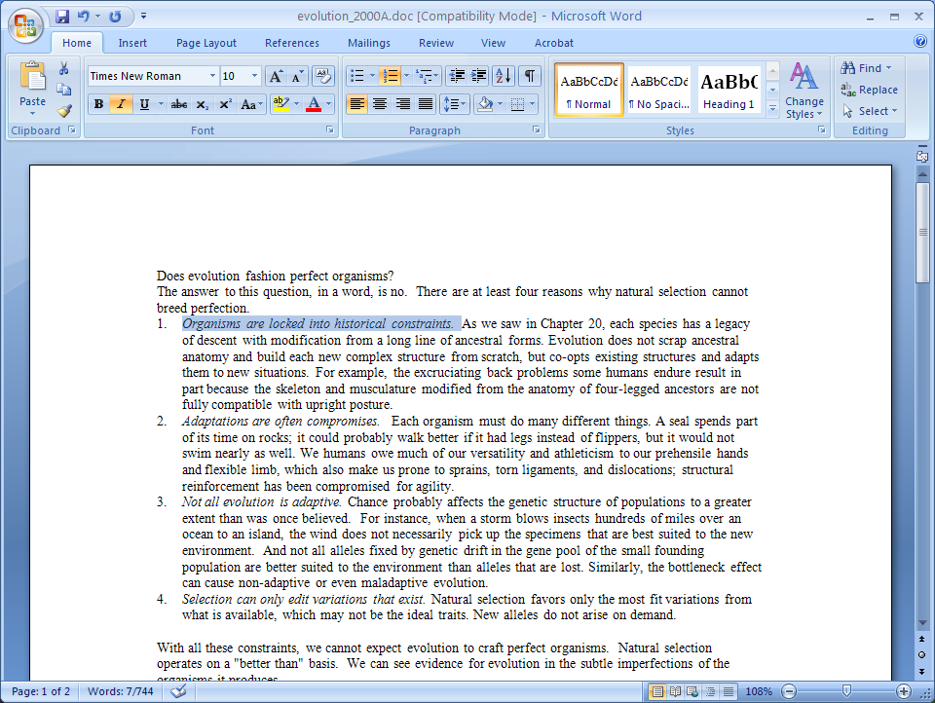

- Set margins. See Page Layout/Margins/Custom Margins/. Top: 0.5", Bottom 0.8", Left: 0.8", Right: 0.8".
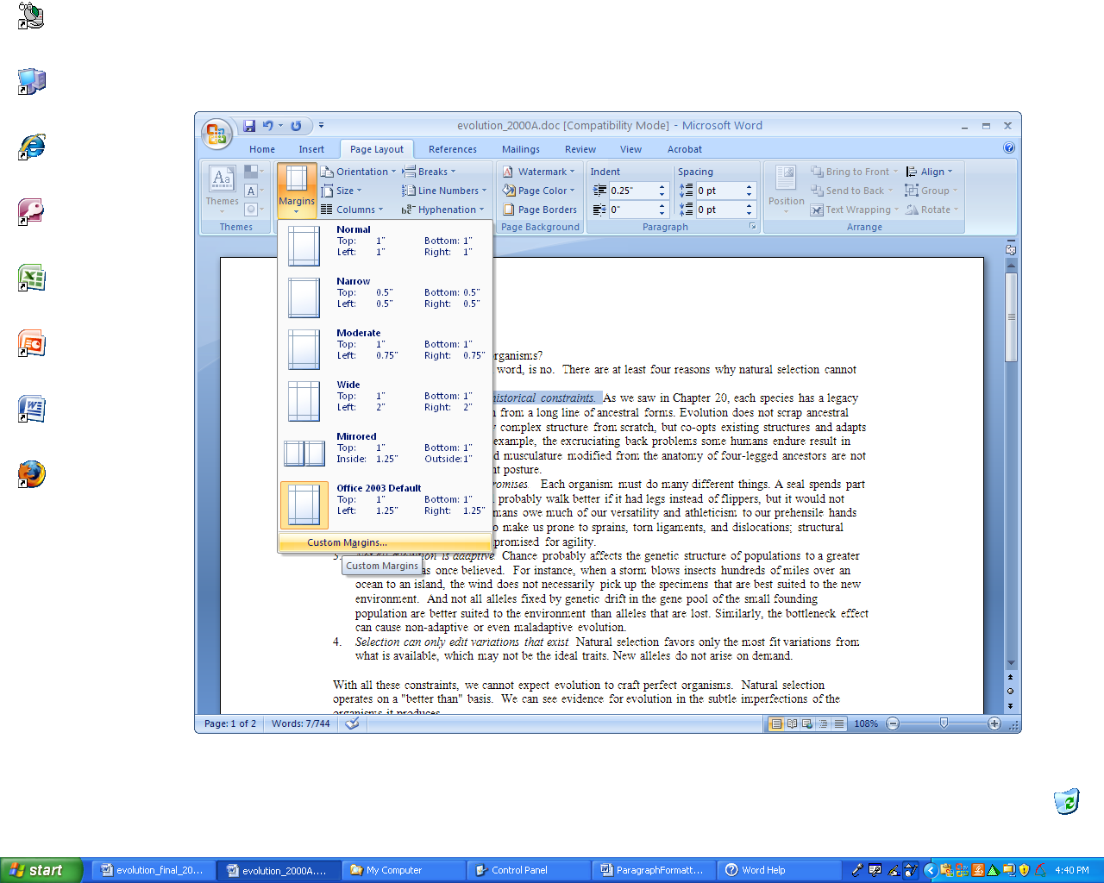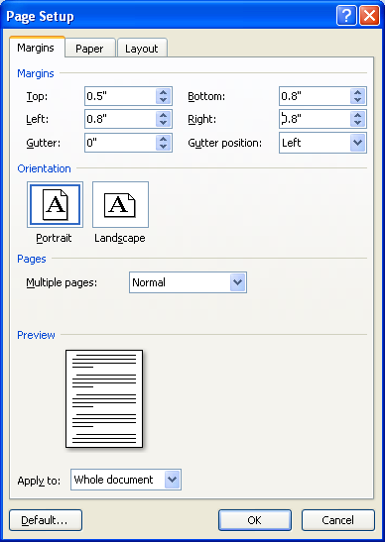

- Insert section breaks before and after REVIEW OF KEY CONCEPTS. Go to Page Layout/Break/Continuous.
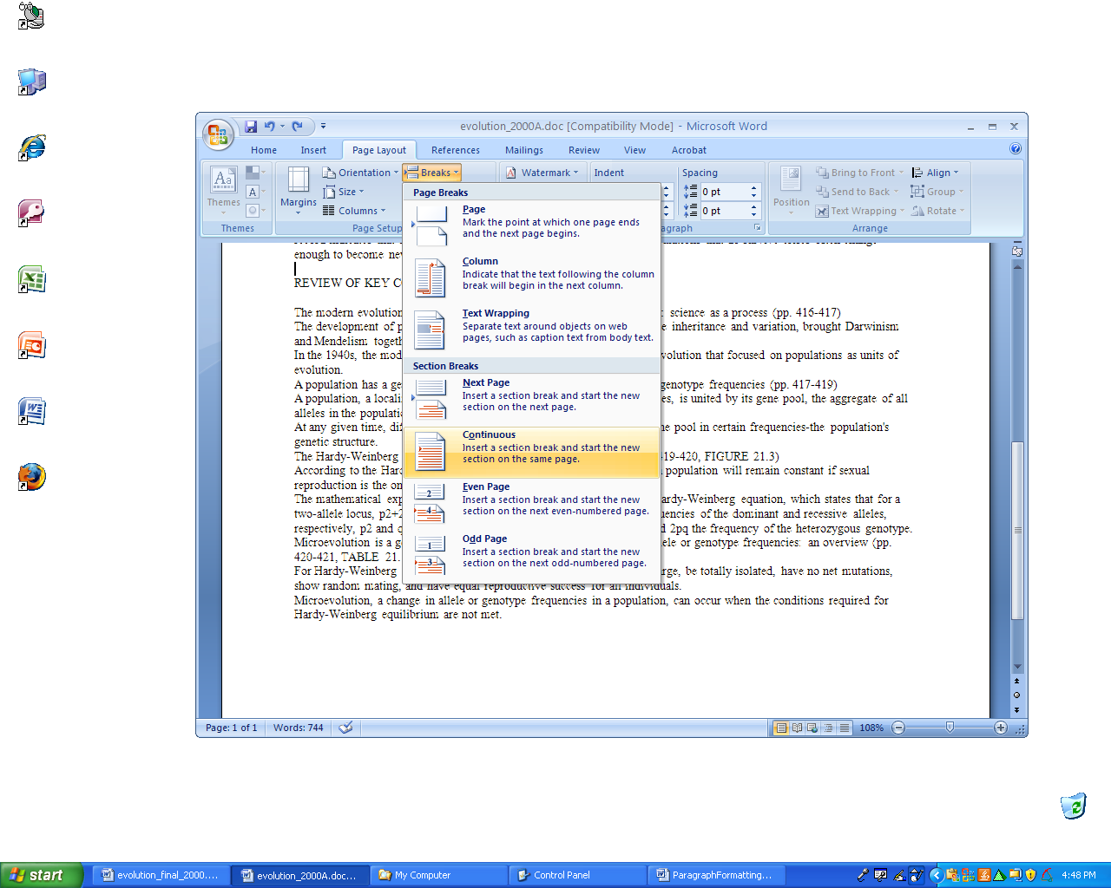

- To display formatting marks, go the Office Button (circle), click on Word Options. Then choose Display, Show all formatting marks, and OK.
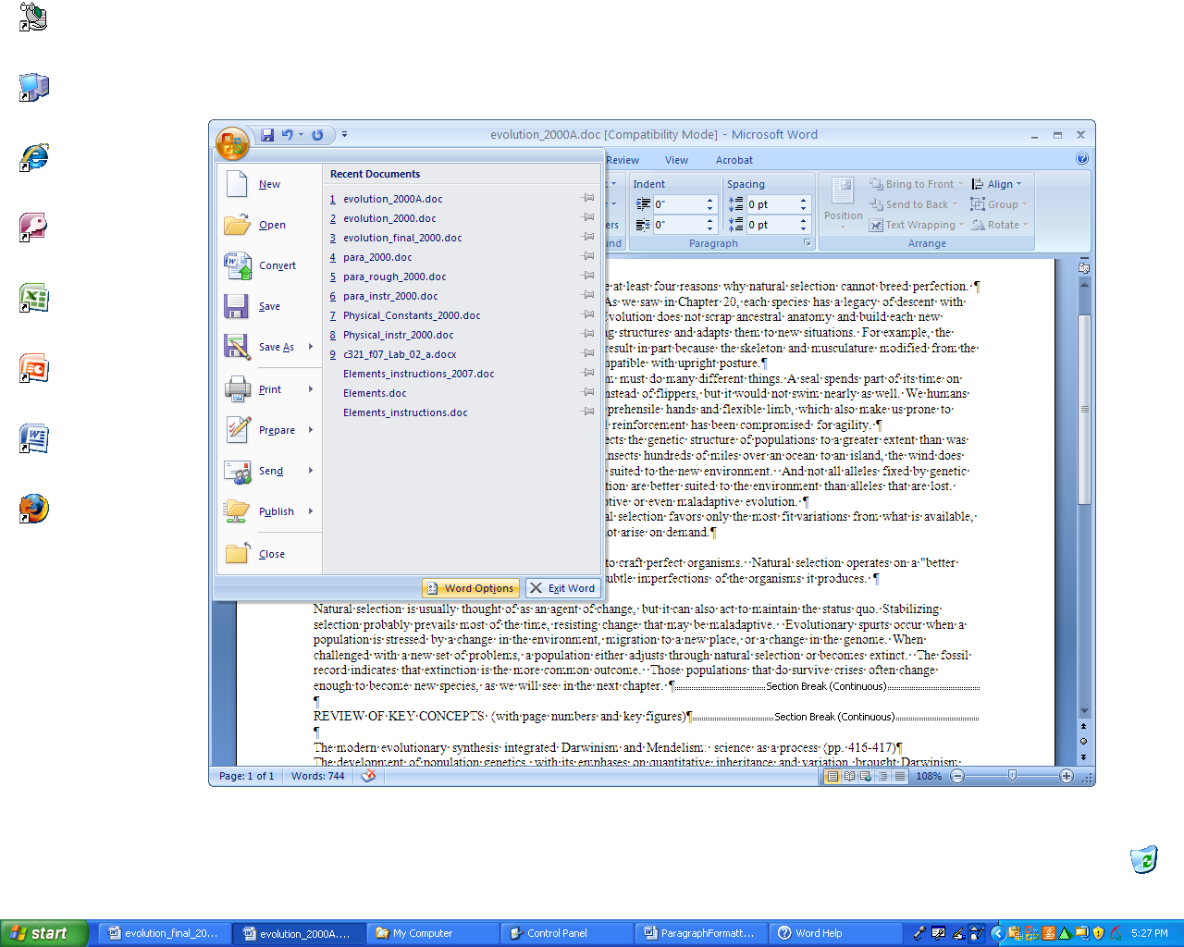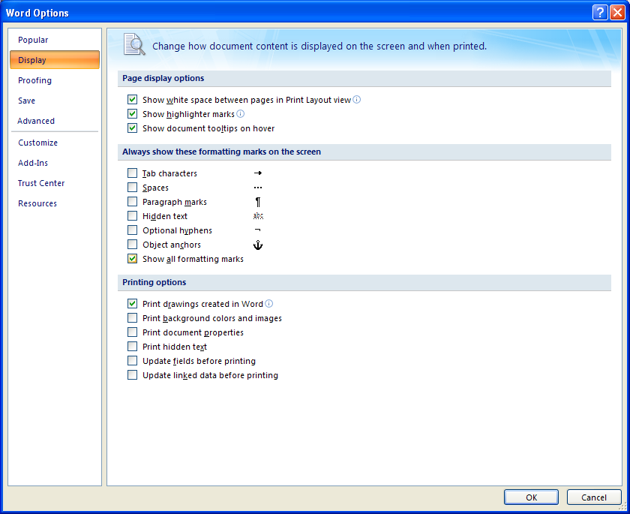

(Some people leave this on all of the time, but I just put it one to see if things like sections breaks are there.)
- Insert an endnote. Place the cursor after the title "Does evolution fashion perfect organisms?". Go to References/Footnote& Endnote dialog box launcher. Choose endnote. Choose custom mark. Enter an asterisk. Click Insert. Then enter the footnote: Material from Biology (Campbell et al.). Put Biology in bold and et al. in italics.
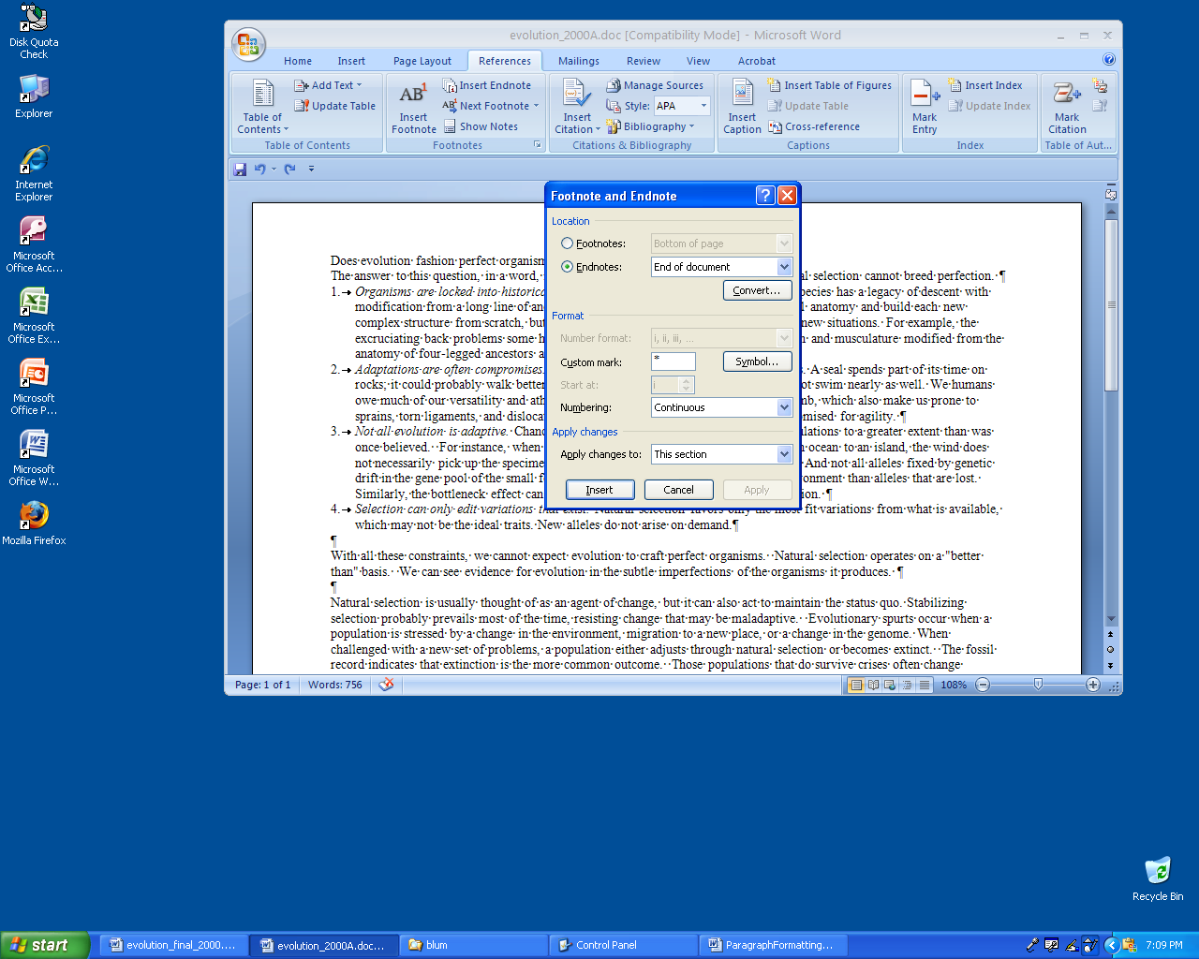
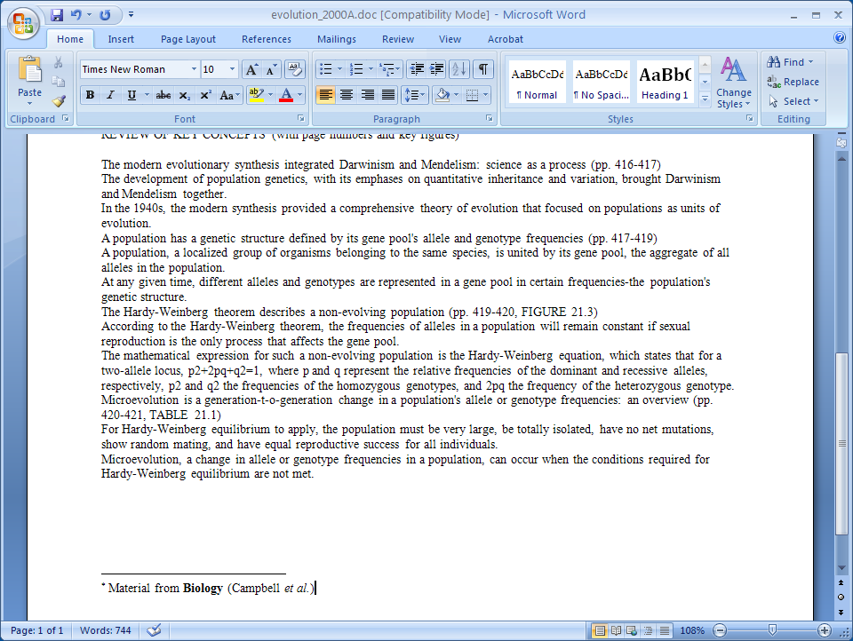
Note choosing footnote will cause a problem with the two-column formatting used later. Make sure it’s endnote!

- Turn bottom section into bulleted list. Go to Home/Bullets.
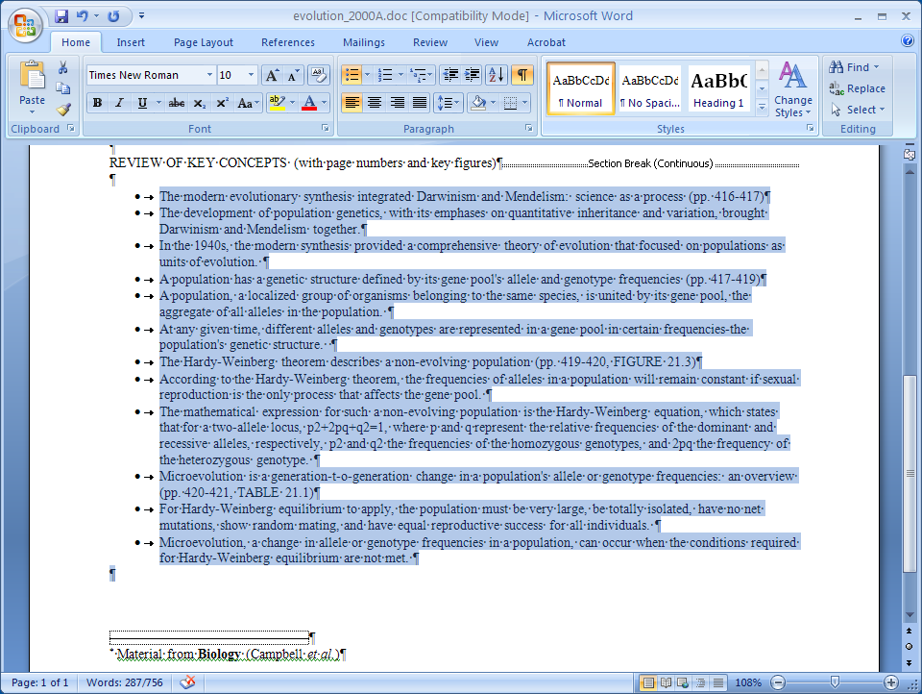

- Turn bullets into blue squares: Format/Bullets and Numbering/Customize/Font/Color.
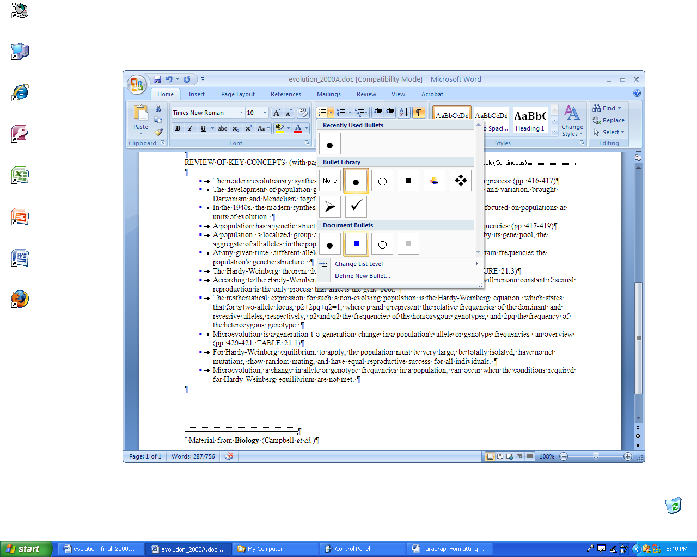

- Increase the indent of the 2nd, 3rd, 5th, 6th, 8th, 9th and 11th, and12th items. (Go to Home/Increase Indent). Turn the bullets to gray squares.
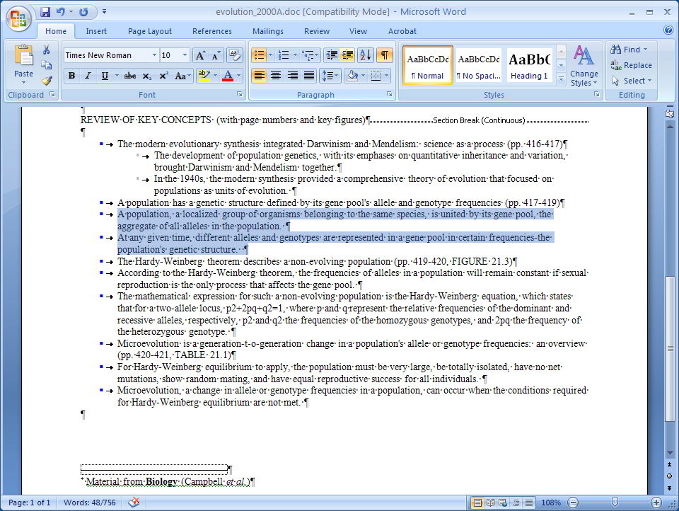

- For the outer items, click on the Paragraph Dialog Box launcher. Then change the left indent to 0 and the hanging indent to 0.2 inch.
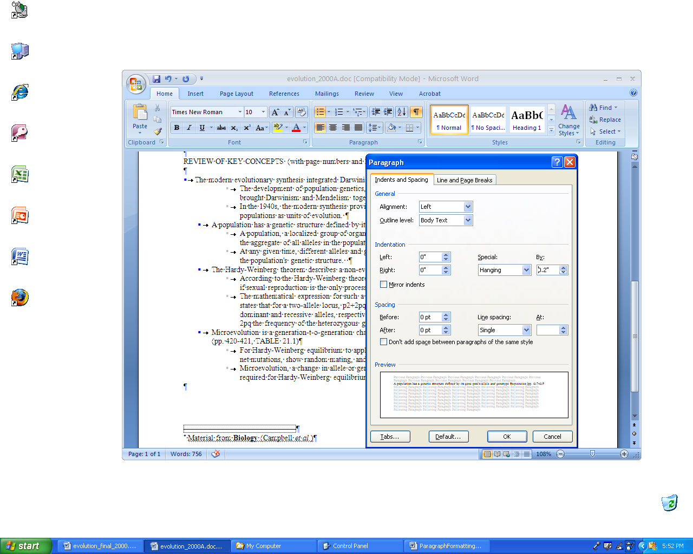
For the inner items change left indent to 0.2 and hanging indent to 0.2.

- Highlight top section (do not include REVIEW …), go to Page Layout/Columns/More Columns. Choose two columns with a spacing of 0.4.
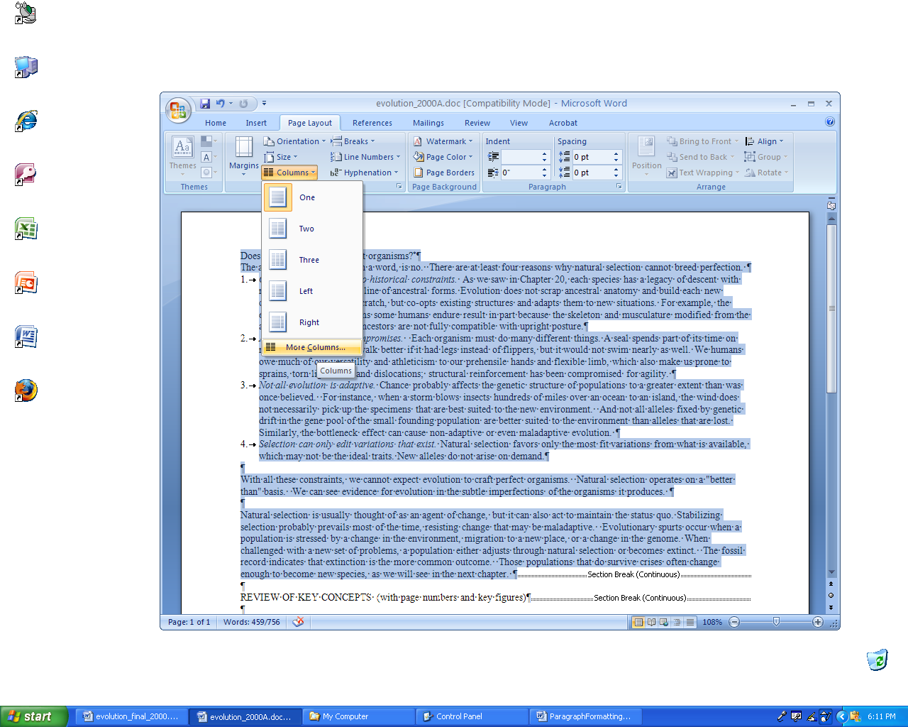
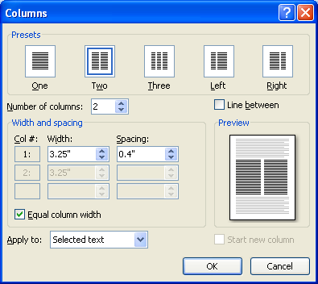
- Repeat the two-column process for bottom section.
- To make superscripts (i.e. making p2 into p²) go to Home/Superscript. Also put all p's and q's into italics.
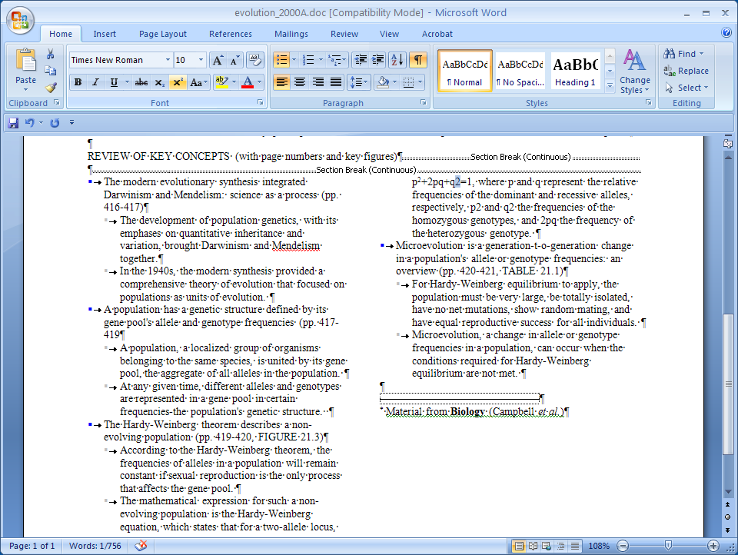

- Increase font size (14pt) of section title. Make it bold. Put in a return after fashion.
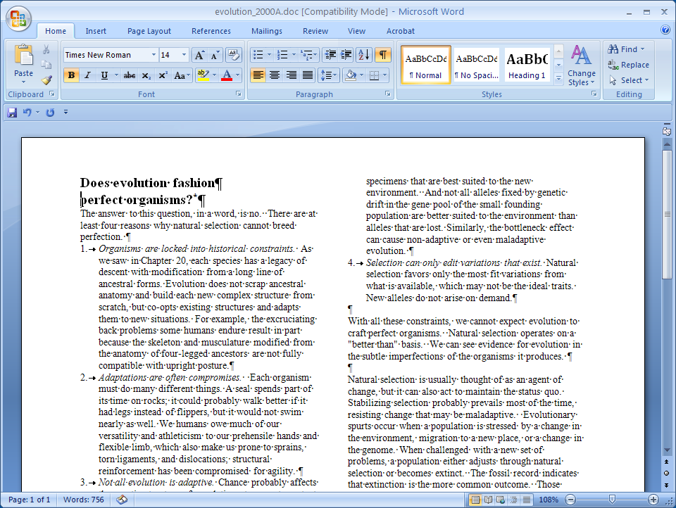

- Draw a little blue square. Insert/Shapes/Basic Shapes. Use the cross-hairs cursor to drag a small rectangle. With the rectangle selected, go to Drawing Tools/ Format and change the fill color (paint can).
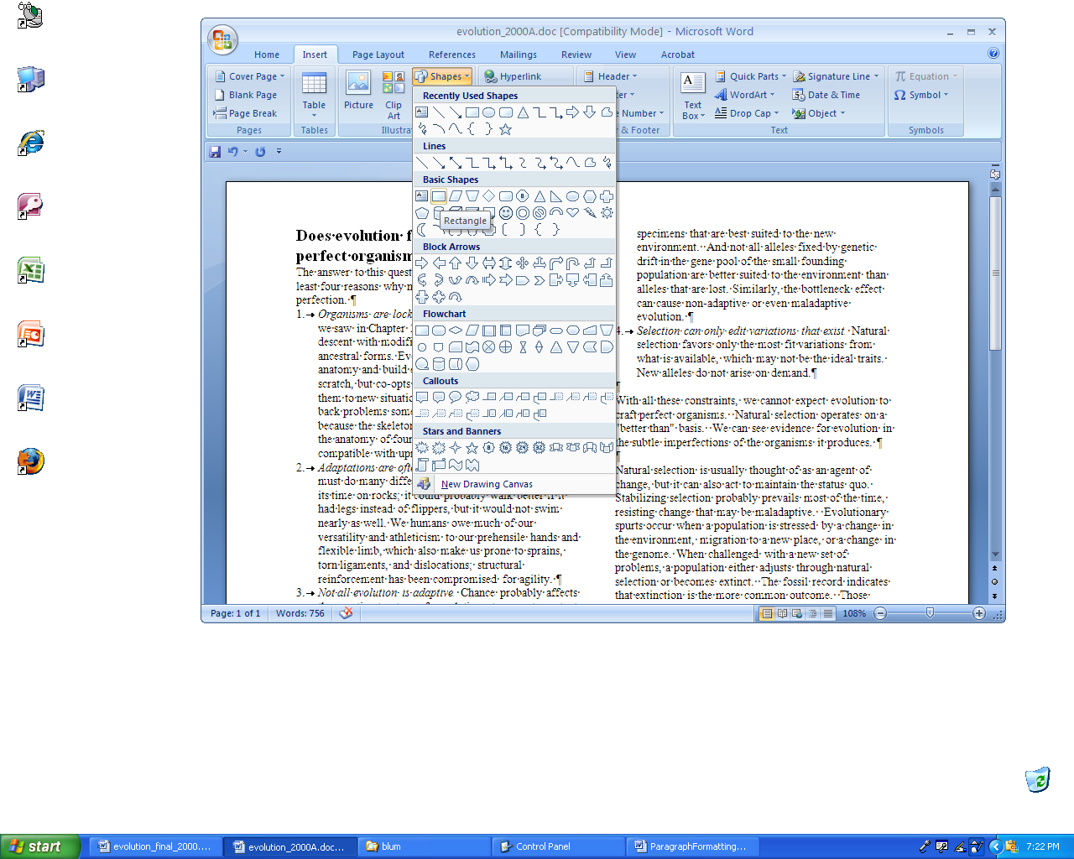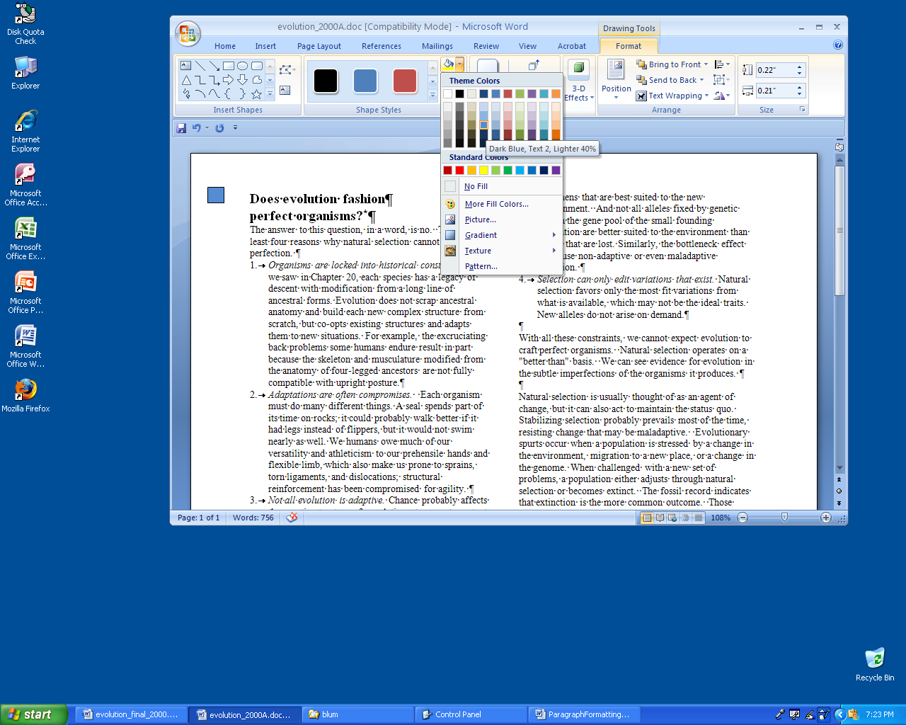
- Eliminate "hanging" of numbered list in top section. Format/Paragraph Special: choose "(none)" from the dropdown list.
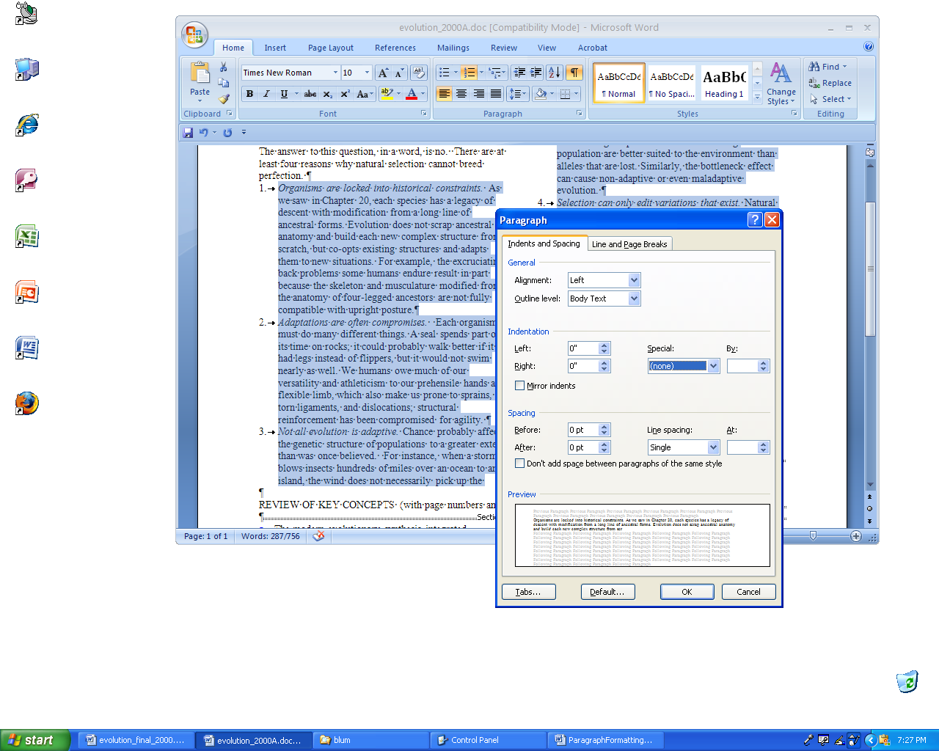
- Add space between paragraphs in top section. Go to the Paragraph dialog box launcher, then make the Spacing Before: 3 pt. Repeat in bottom section.
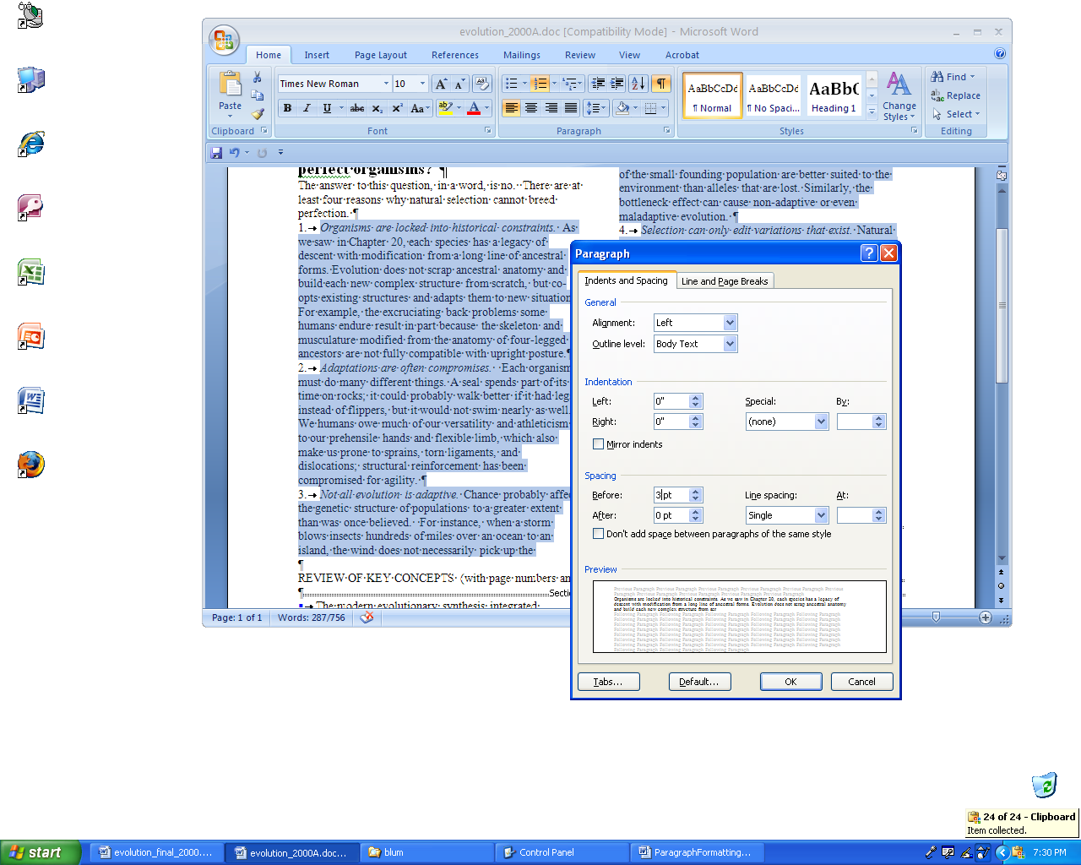
- Change space above first paragraph (as above, 8pt) and draw a line (Insert/Shape).
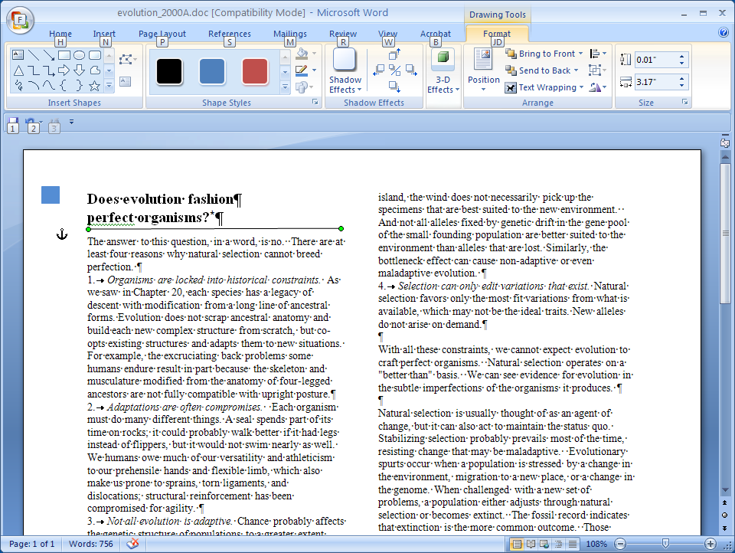

- Add space above and below "Review of Key Concepts …" (21pt above, 12 below). Draw lines above and below. Change thickness of upper line. Change colors.
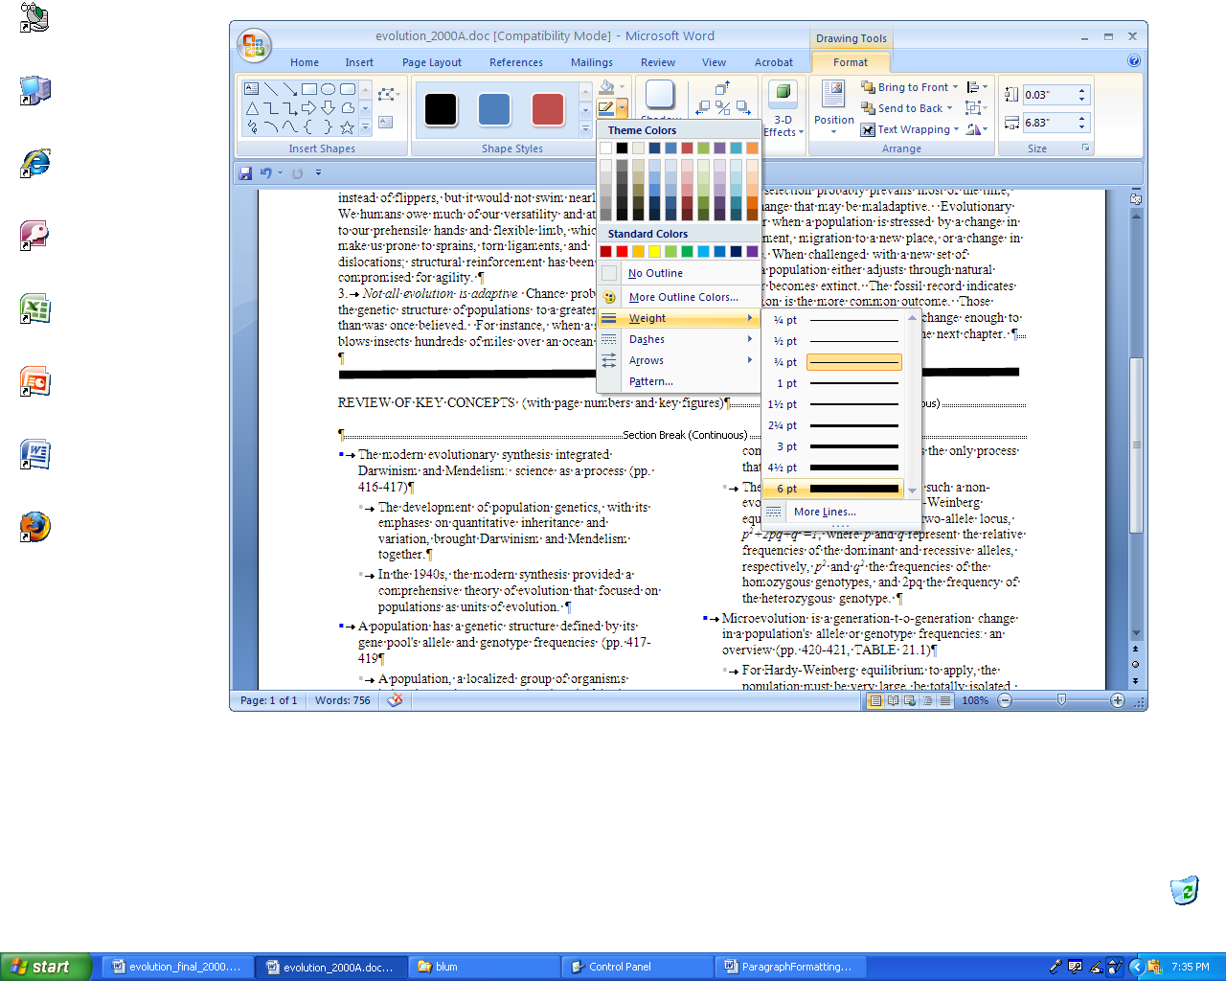

- Add footer. Go to Insert/Footer/Edit Footer. Click in the footer section and type "CHAPTER 21: THE EVOLUTION OF POPULATIONS 433" On the Home tab, put it in 8pt font, bold the page number, click the right align button. Return to the Header & Footer Tools/Design and change the Footer from bottom to 0.3 and then Close Header and Footer.
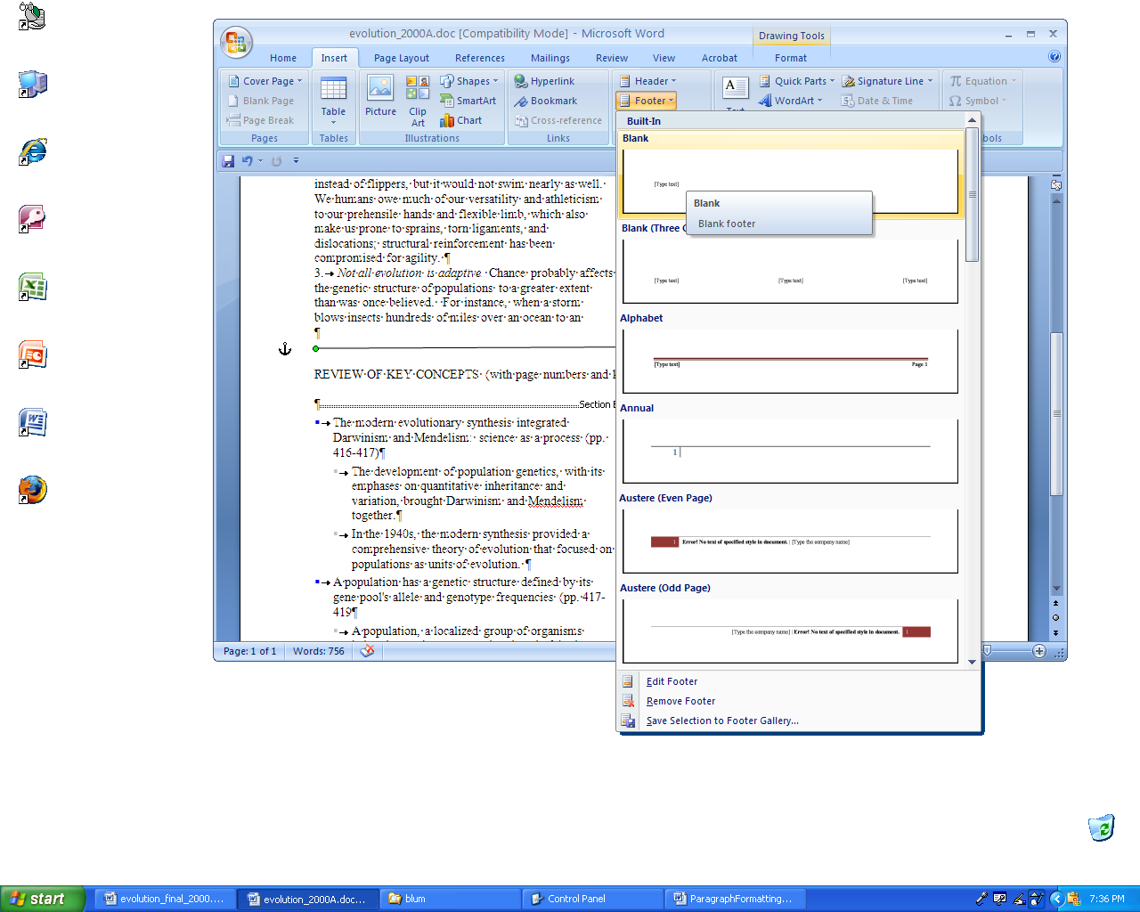

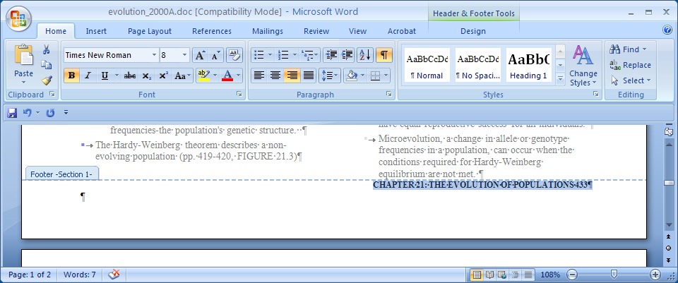
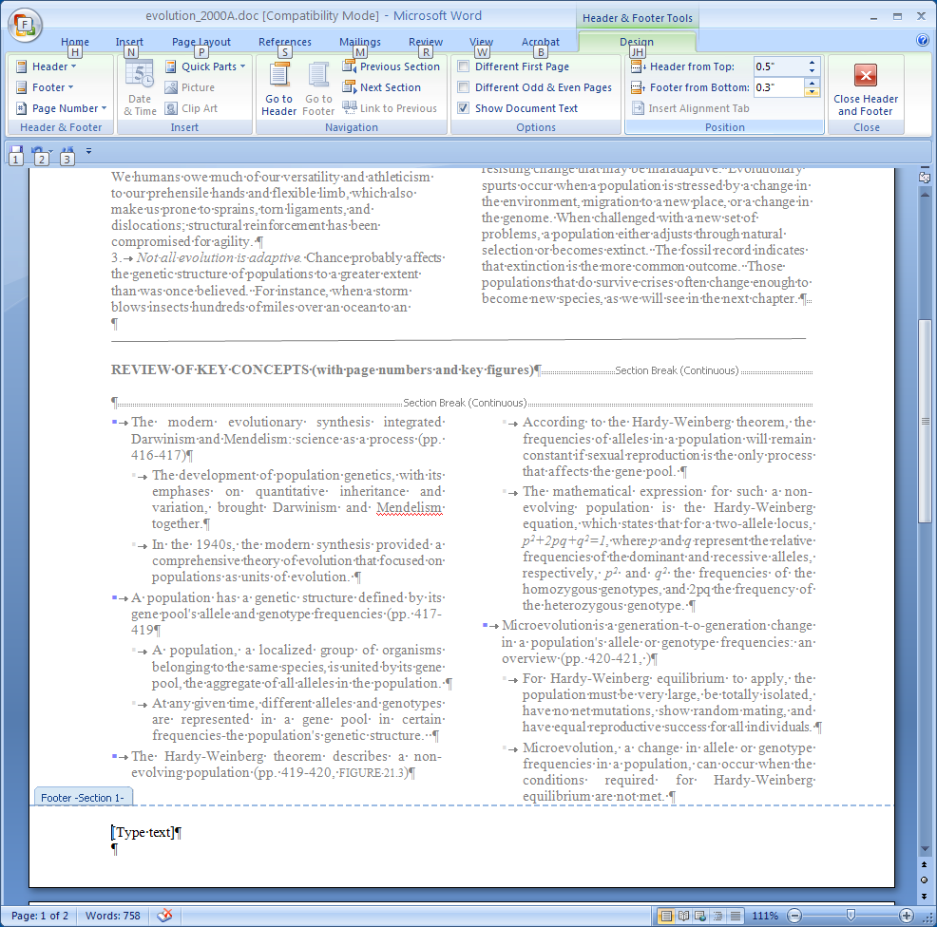

- Highlight the top section and click the "justify" button on the Formatting Toolbar. Ditto for the bottom section.
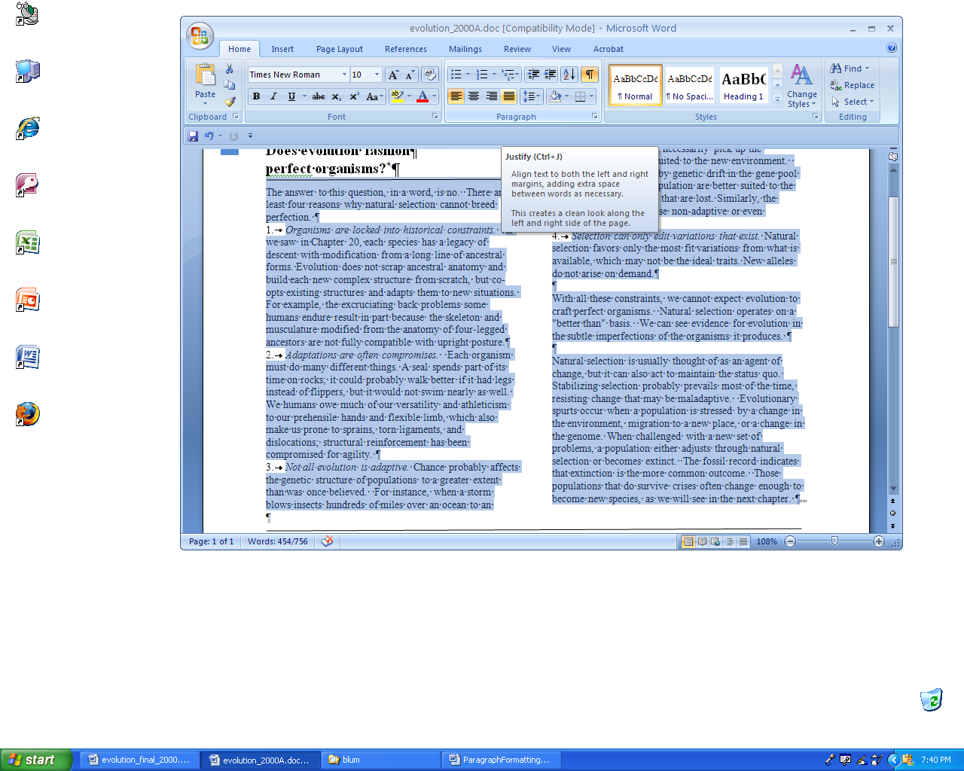
- Add in the line with blue asterisks. Change amount of space above and below if need be. Center them.
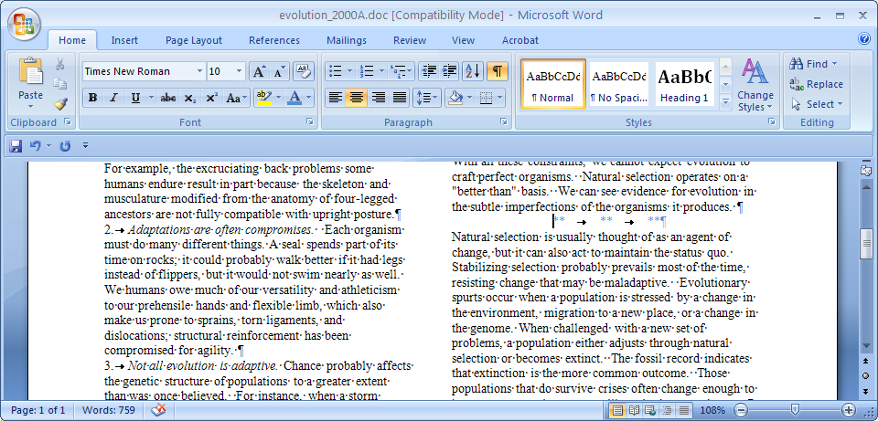

- Adjust space around Review … if it needs it. And make it bold. (Try to make the document one page.)
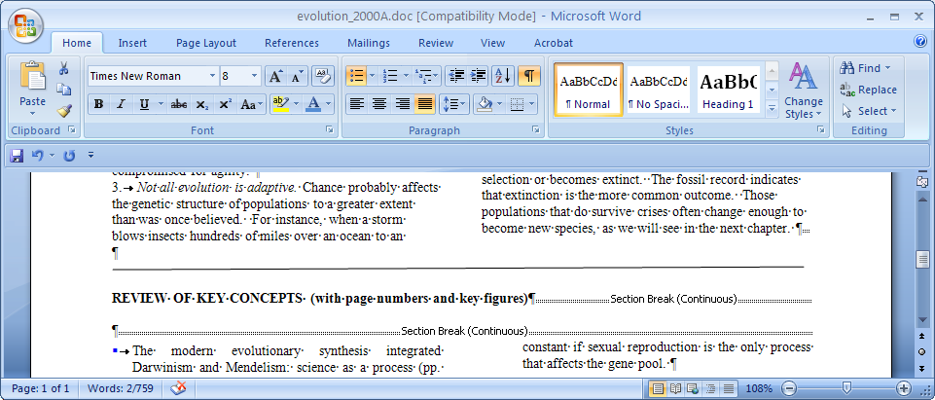

- Reduce font size of "FIGURE 21.3" and "TABLE 21.1".
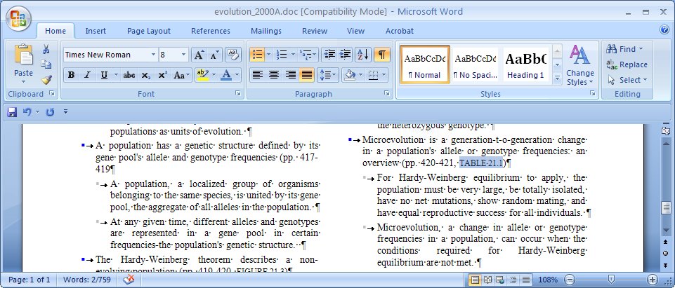
- Perform a Print Review. Office Button/Print/Print Preview.
