What I do below for the High temperatures from Monday, you should do for the Low temperatures.
We want to understand the steps behind the Standard Deviation calculation. Start with the data from the weather statistics lab. Calculate the Average (mean). Note that it does not have to be under the data.
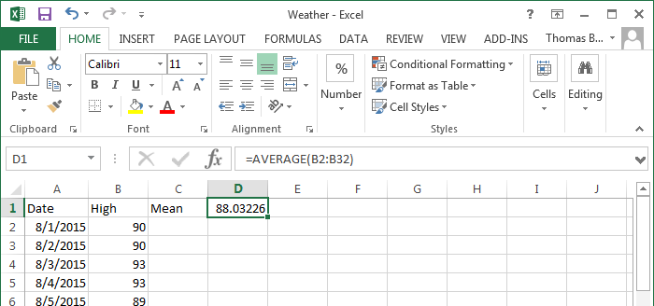
A data point’s deviation is how far that data point is from the mean which is obtained by subtracting. Because each data point has the same mean the formula we use is =B2-D$1 where the $ in front of the 1 in D$1 implies that as the formula is copied from cell to cell that the 1 should stayed fixed. This is called absolute addressing. The 2 in B2 on the other hand, changes to B3 to B4, etc. when the formula is copied. This is called relative addressing.
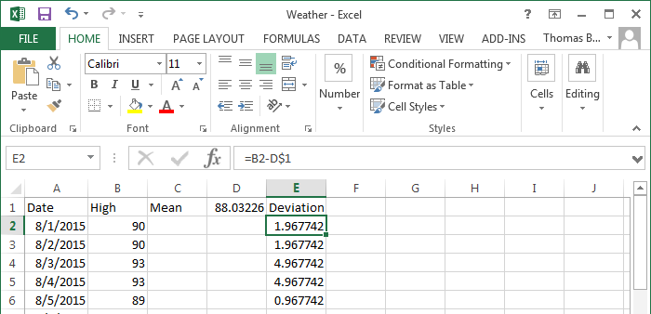
Deviations are both positive and negative – as we have data points both above and below average. We want to know how spread out the data is, and the deviations are a start, but there are too many of them and because some are positive and some negative, their average is zero.
We want to make the deviations all positive. One could use an absolute value, but the approach used in the standard deviation is to square the deviations. (Note that the unit here would be the square of whatever the original unit was.)
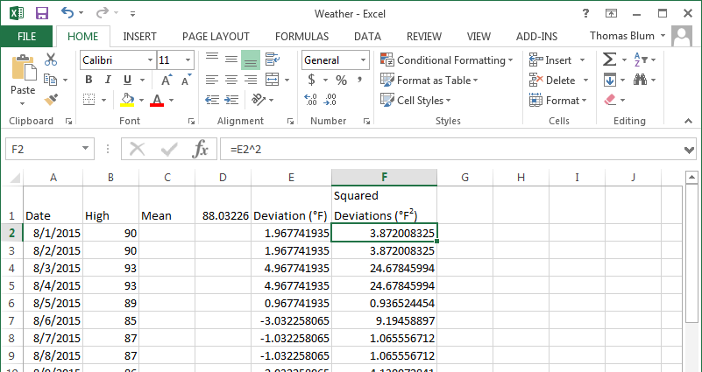
Now with all positive quantities we can sum them without them being cancelled.
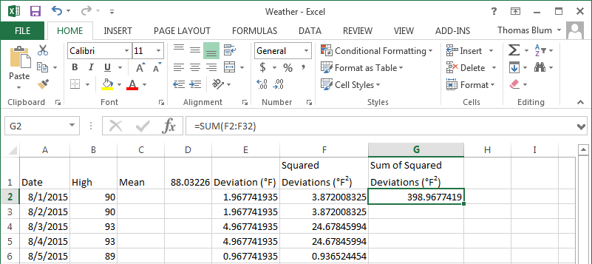
The average is the sum divided by the number of data points. In the STDEV.P (population) calculation, one divides by the number of points. In the STDEV.S (sample) calculation, one divides by the 1 less than the number of data points. We can get the number of data points using the COUNT function in Excel.
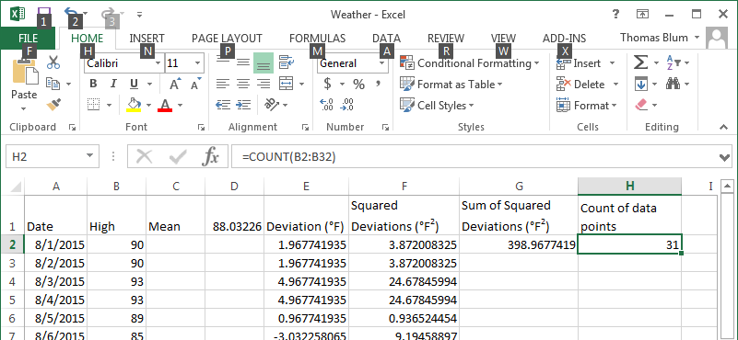
Next we divide by the Count and by Count -1.
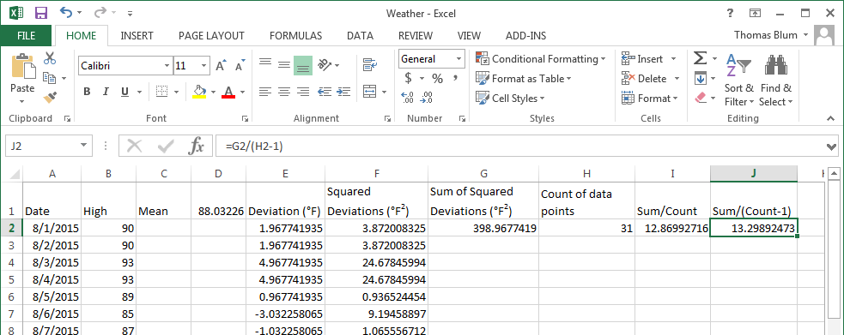
Note that this quantity has the square of the units of the original data points (in this case °F²). Thus we take the square root.
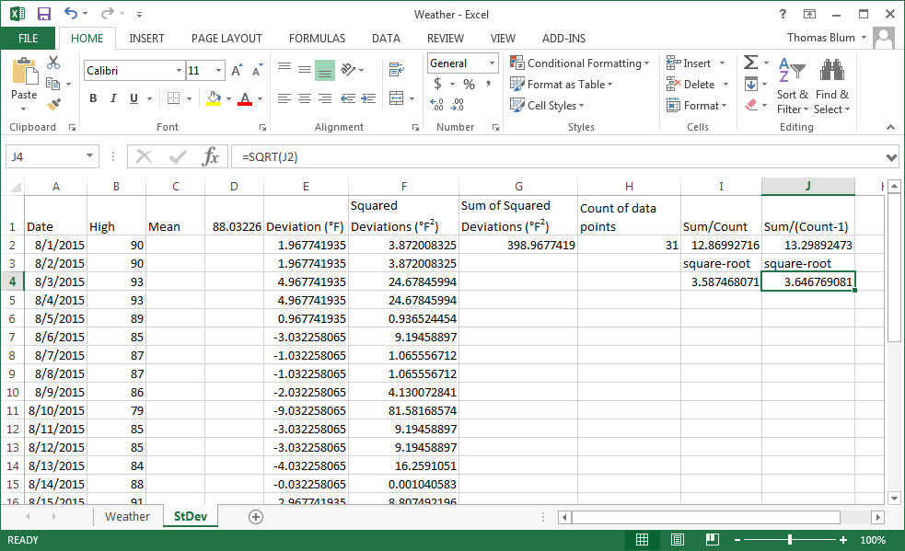
Compare this to the standard deviation.
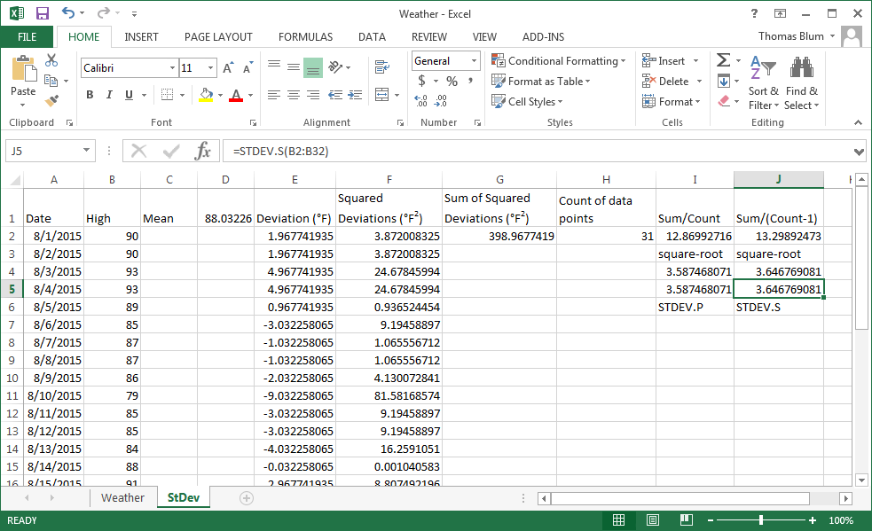
You can get some sense othe difference betweeen STDEV.P (divide by N) and STDEV.S (divide by N-1) by looking at the extreme example in which you have one data point. Since there is one data point it is the mean, the deviation is zero, squaring it gives zero, and since there is only one data point, the sum of the squares is also zero. Now if you divide by 1 and take the square root you get zero; whereas if you divide by N-1, 0 in this case, you get infinity. The first approach focuses entirely on the data you have (you have the whole population) – you have one piece of data with no spread. This is also called the root-mean-square (rms) deviation – which reminds you how it is calculated: find the deviations, square them, take the mean, then take the square root. The second approach attempts to figure out what you can expect from future measurements, with one point you have no knowledge of the spread and must assume it could be anything – thus infinity.
If you think of the temperatures from August as representing the entire population of August temperatures you would choose STDEV.P. But if you are, for example, using August temperatures as a sample of a larger population of summer temperatures, then you would use STDEV.S.

