Weather Excel Lab
Go to www.weather.com and find Philadelphia’s weather and then find Philadelphia’s temperatures for the month.
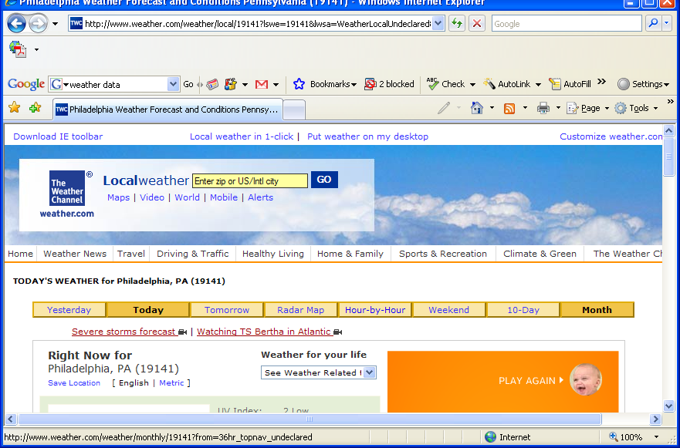

Make a column for entering the High and Low temperatures. Then “wrap” the text in the cell – on the Home tab, go to Format/Format Cells
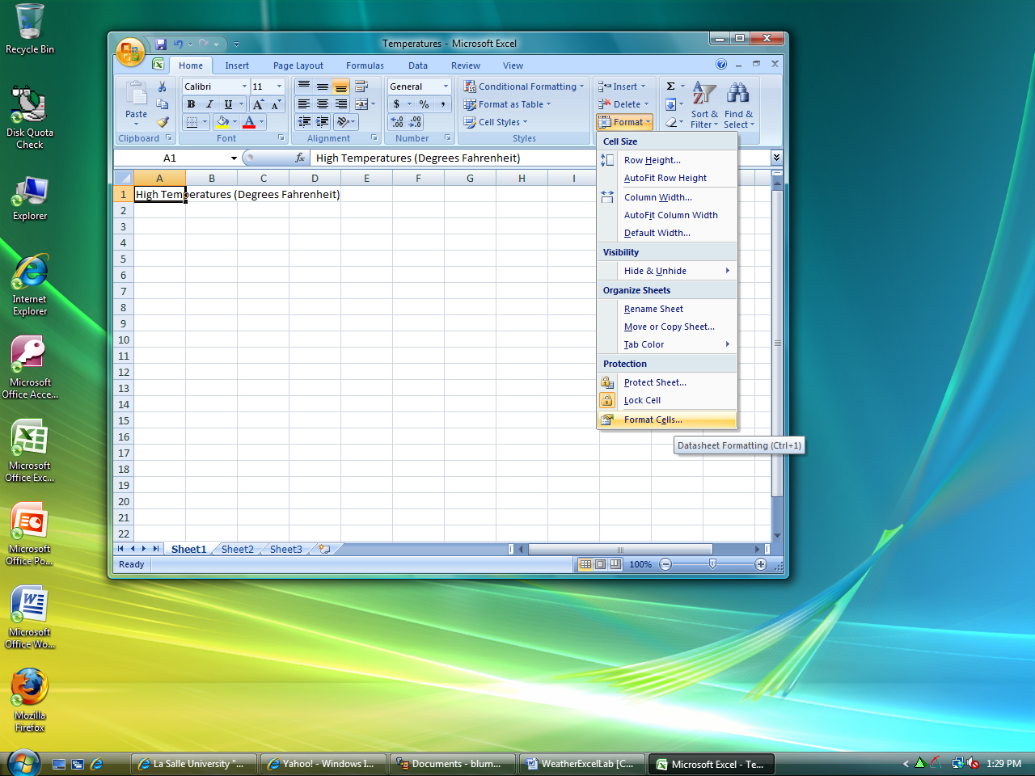

Click on the Alignment tab of the Format Cells Dialog Box and check the Wrap text checkbox, and click OK.
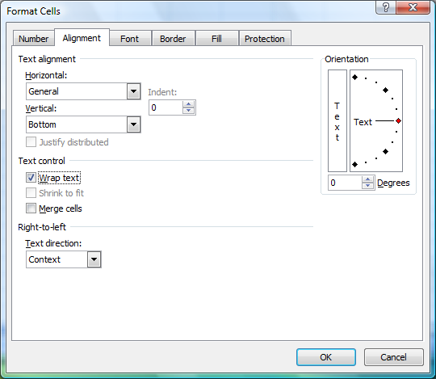
Enter into an Excel spreadsheet the observed high and low temperatures for the month so far.
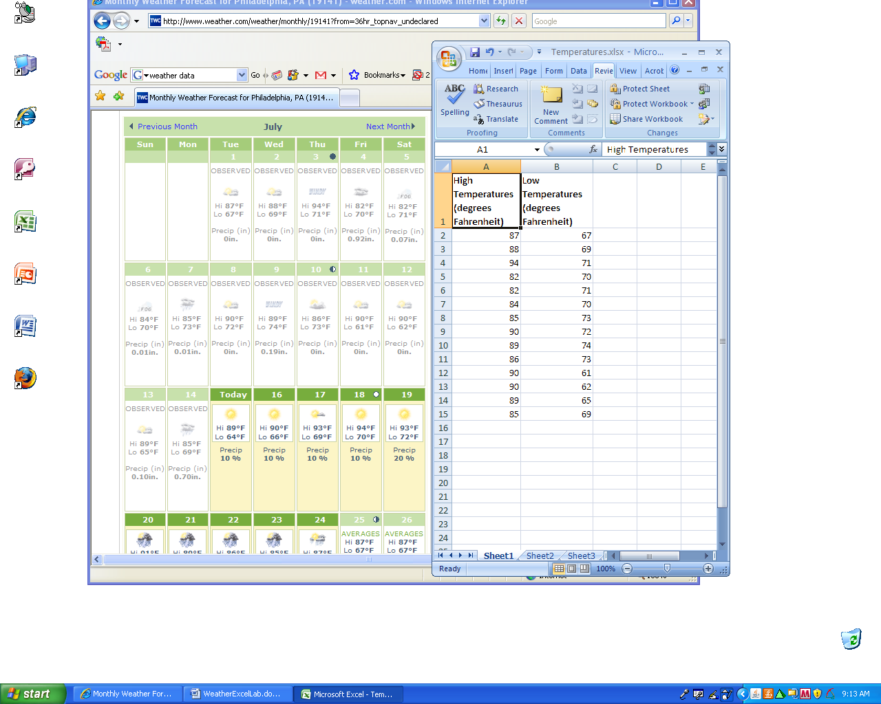
Highlight the entire first column by clicking on the letter A at the top. Right click and choose Insert from the menu. This will insert a column to the left.
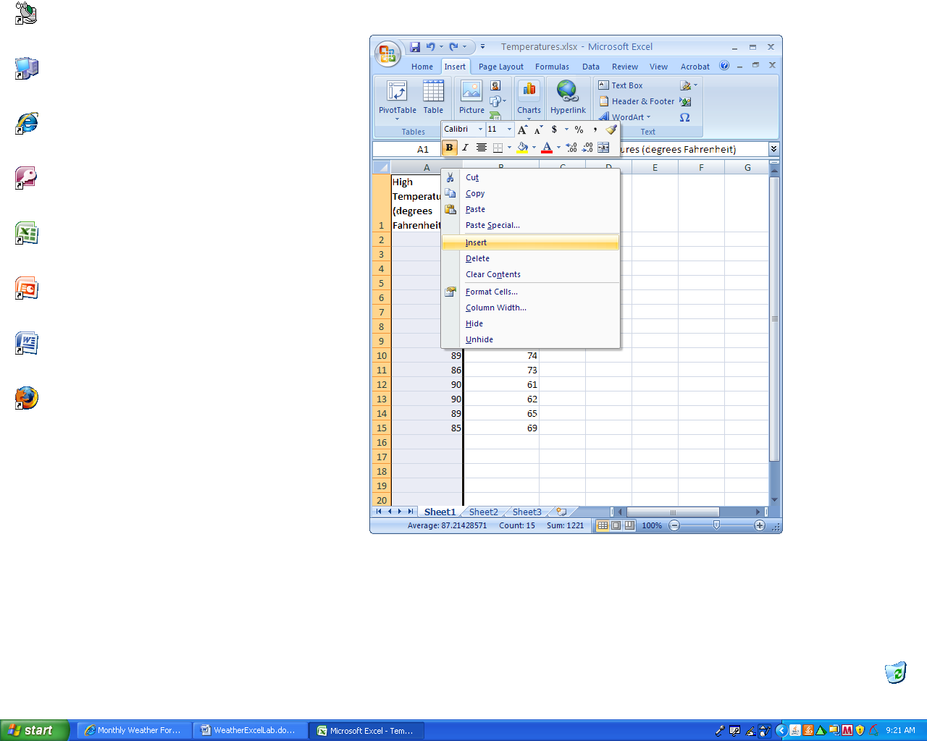

Make the cells in the first row bold, fill in the cells with a color, give all of the cells a border, and make the division between the first and second row thicker.
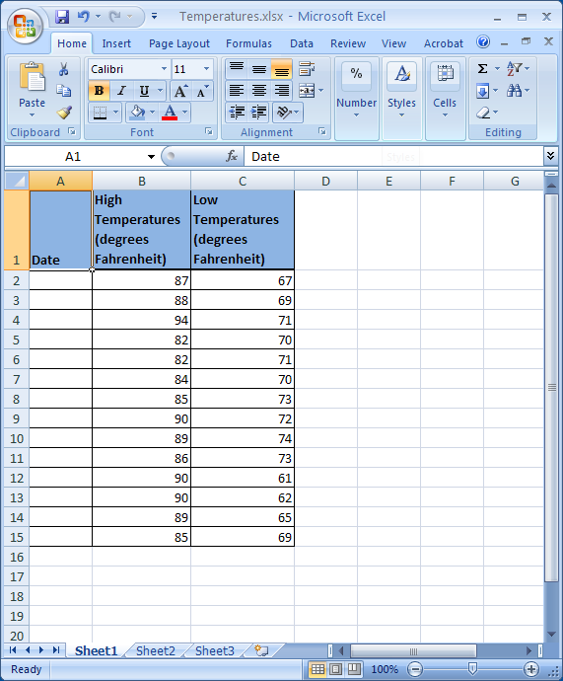

Enter the date for the start of the month in cell A2.
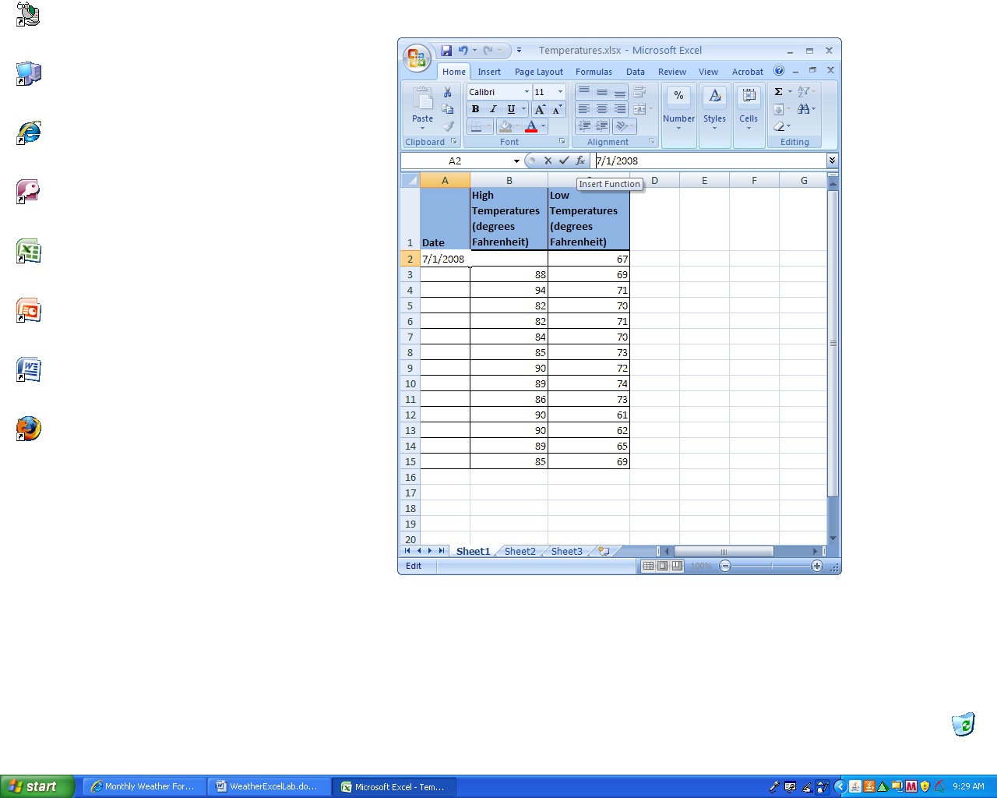
In the cell A3 enter the formula =A2+1
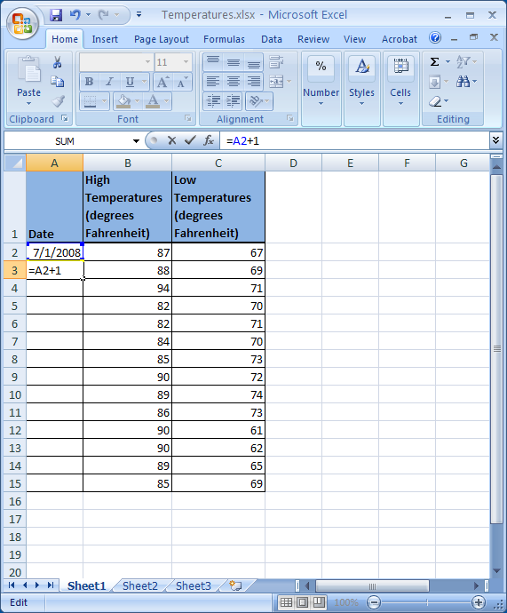

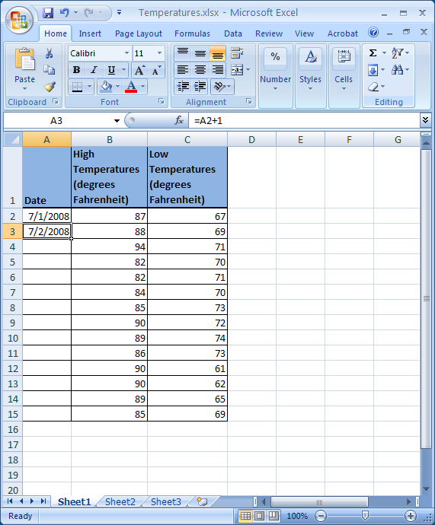
Note that the formula bar shows the formula we entered while the cell A3 displays the result of the formula (the date for the second day of the month).
Highlight cell A3; then place your cursor (which looks something like which I call the thick cross) in the lower right hand corner of the cell A3 (it should turn into something like  which I call the thin cross). Then double click, this should copy your formula down into the column.
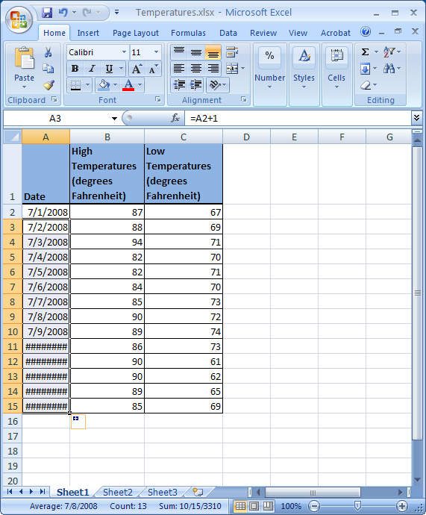
The pound signs ###### indicate that something is wrong – but here it is simply that the cell is not wide enough to display the answer. Place the cursor between the column headers A and B, the cursor should become a double-headed arrow. Then double click or drag to change the size of the column.
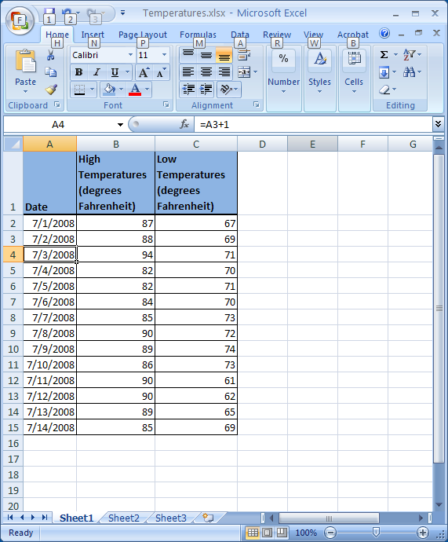
Note that when we copied the formula from A3, which was =A2+1, into cell A4, it became =A3+1. This is known as relative addressing. Since the formula in cell A3 refers to the cell above it; the formula, when copied to cell A4, is changed so that it also refers to the cell above it. In this case, this is exactly what we wanted to happen.
Next we want to show the temperatures in Celsius. Recall that the temperature for water freezing in Fahrenheit is 32 and in Celsius is 0. So the first step in converting is to subtract 32. Next recall the temperature for boiling water in Fahrenheit is 212 which is 180 degrees higher than freezing; whereas the boiling temperature in Celsius is 100 degrees higher than freezing. So the second step in converting is to multiply by 5/9 (the reduced form of 100/180).
C = (F-32)×5/9
We need the parentheses so that the subtraction is done before multiplication (remember “order of operations” also known as “precedence”). In Excel as with most computer operations multiplication will be represented by an asterisk *. The C above will correspond to the cell in which we want the answer displayed, while the F above will be replaced with the cell that holds the Fahrenheit temperature.
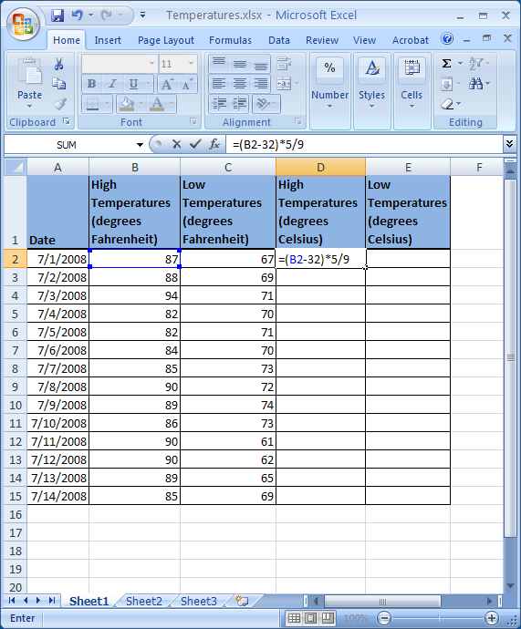
Copy the formula down as done with the dates.
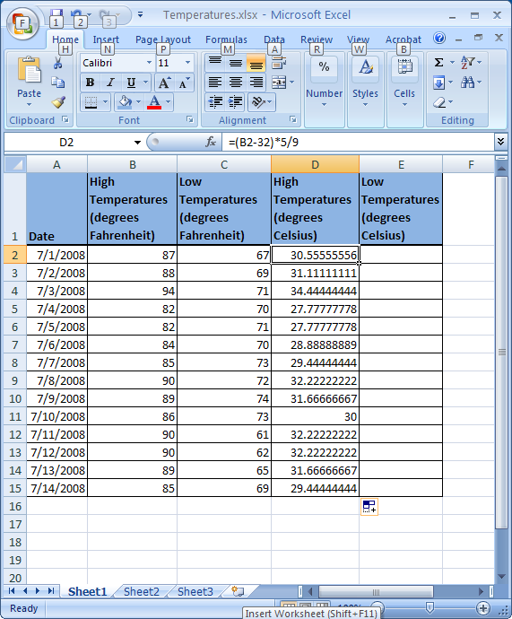
Since the formula for converting the low temperatures to Celsius is the same as converting the high temperatures, we can copy our formula by highlighting the cell D2, moving to the lower right-hand corner and getting the thin cross and dragging over to cell E2. Then copy that formula down the remaining cells in that column.
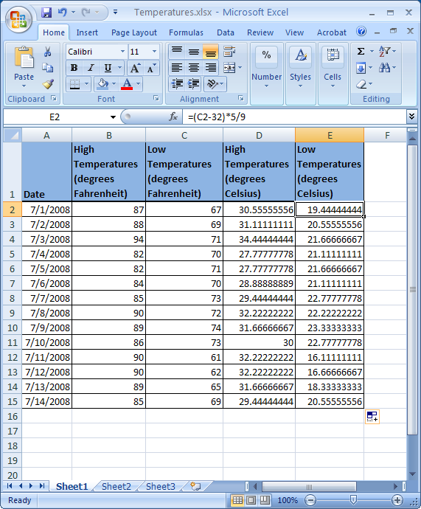
Note how the formula automatically changed from =(B2-32)*5/9 to =(C2-32)*5/9 which is the result of relative addressing again. Both formulas refer to a cell that is in the same row and two columns over to the left.
Suppose we do not wish to display so many decimal places in the result. Go to Home/Number find the dialog box launcher under there. Use the Number tab of the Format Cells dialog box, choose Number from the list and you will see a box that will allow you to control the number of decimal places.
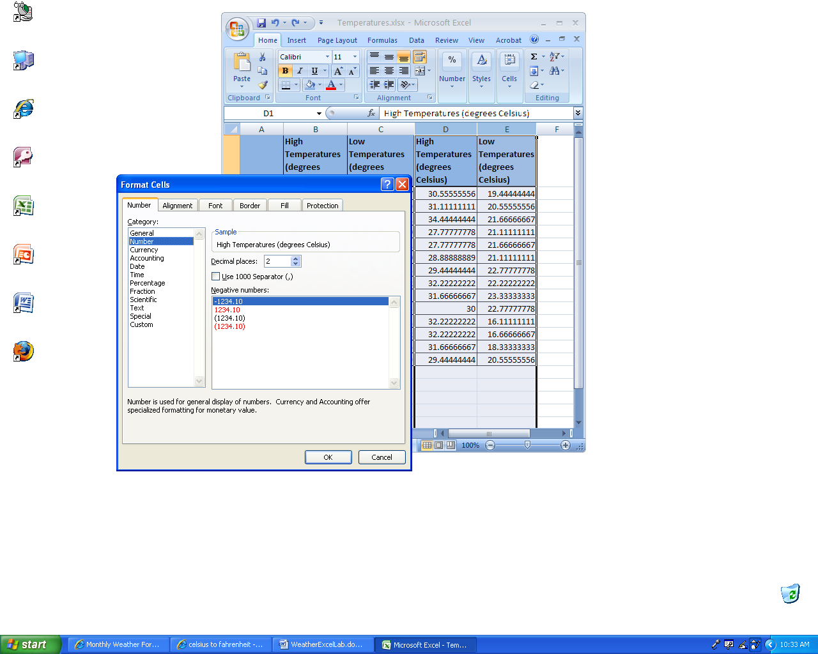
At the bottom of the high temperature column, enter the formula for the average of the range of cells. You can refer to a collection of consecutive cell using a colon notation. The range B2:B15 refers to the contents of all of the cells contained in the rectangle starting in B2 and ending in B15. (Ranges can span more than one column, such as B2:C15.) There is a function for calculating the average of a range of numbers, which is =AVERAGE(range of numbers). A shortcut for entering a range of numbers in an Excel formula is to drag your cursor through the range.
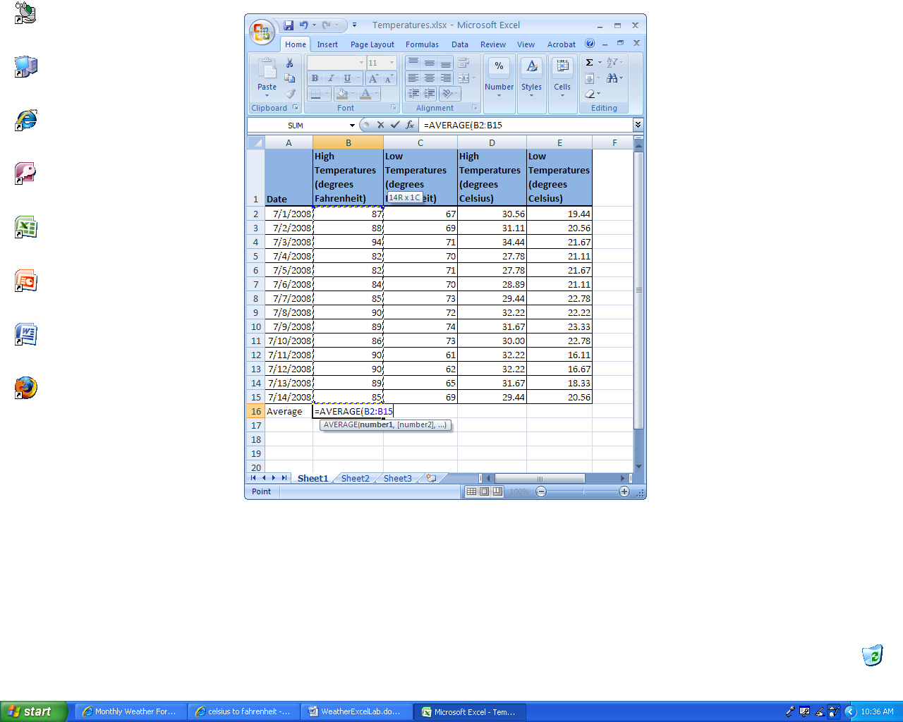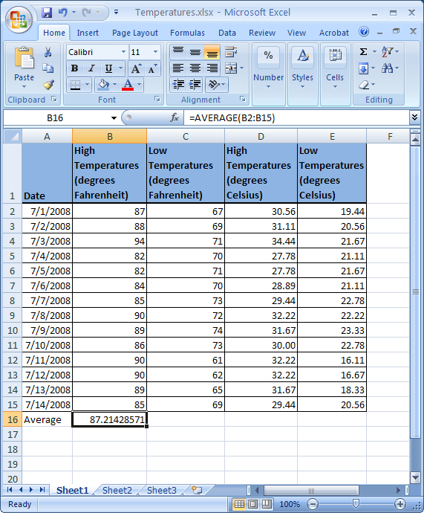
Format the cell so that only two decimal places are displayed and then drag the formula across the row to calculate the average of the other columns. (This copies the formula and the formatting.)
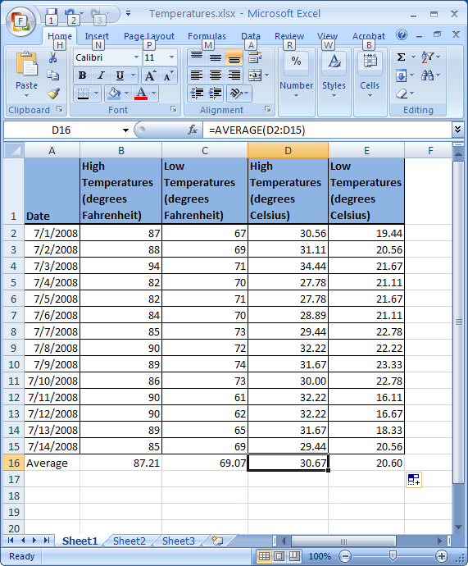
Enter the formula for the standard deviation.
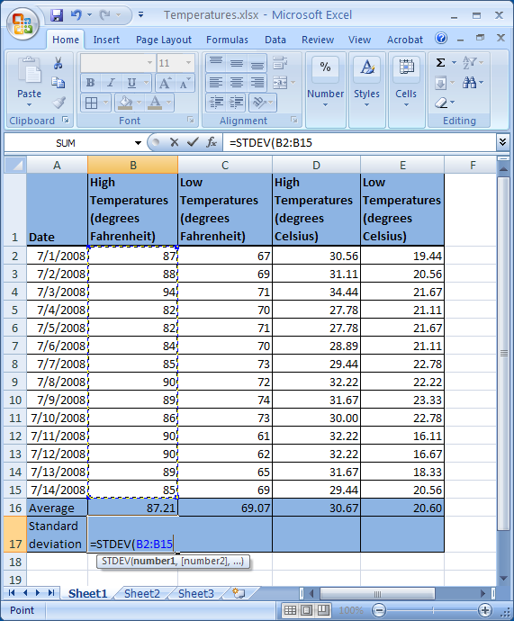

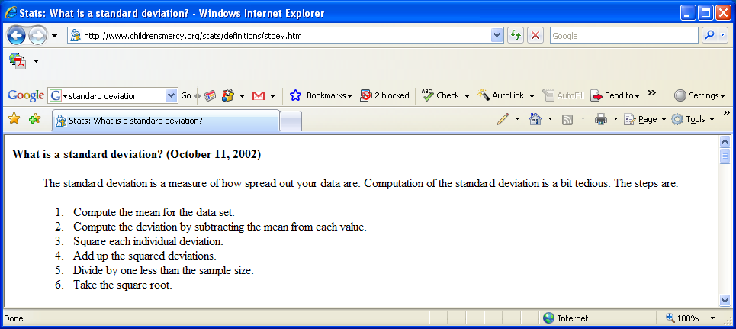
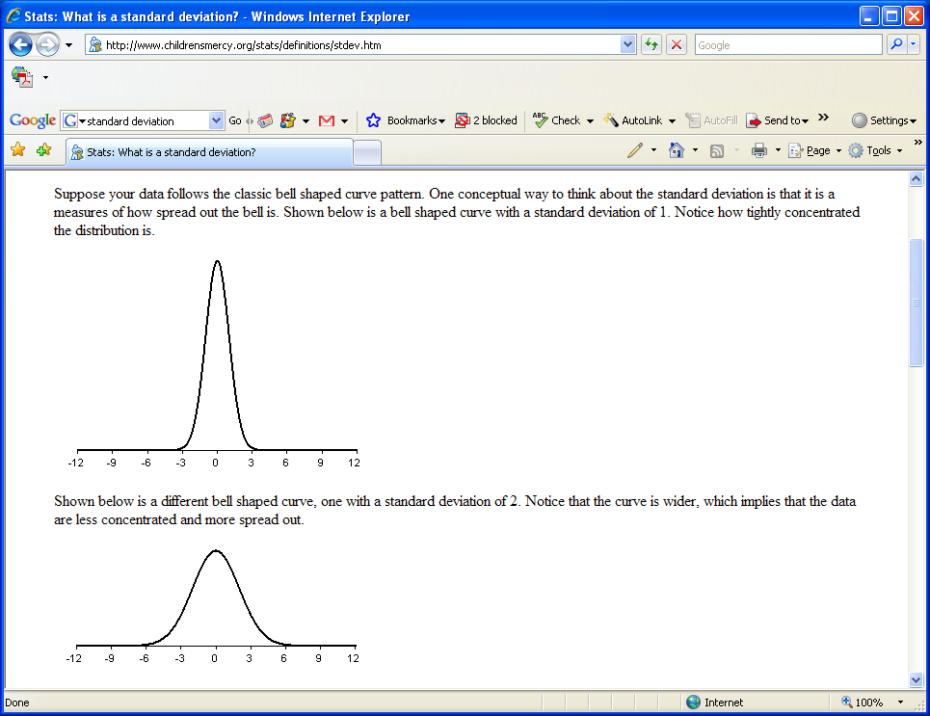
Make a row that will hold the maximum value for each column.
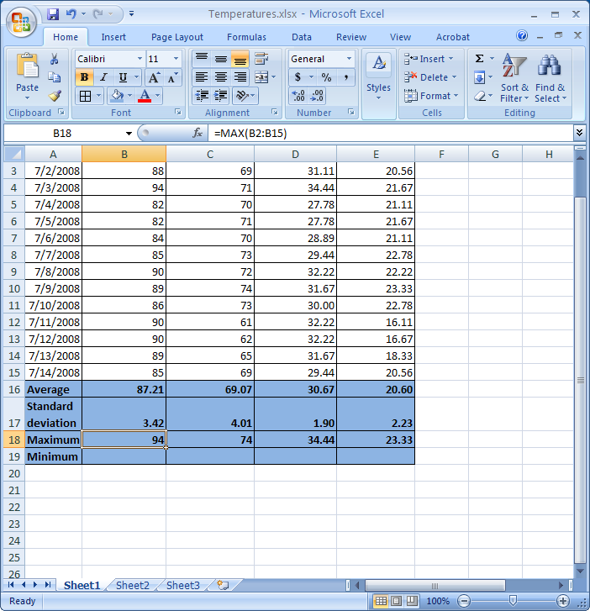
Make another row for the minima.
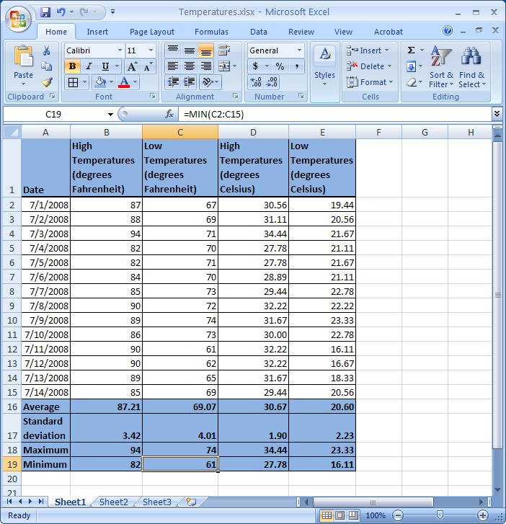
Lastly, make a clustered column chart of the original data.
