The Beatles

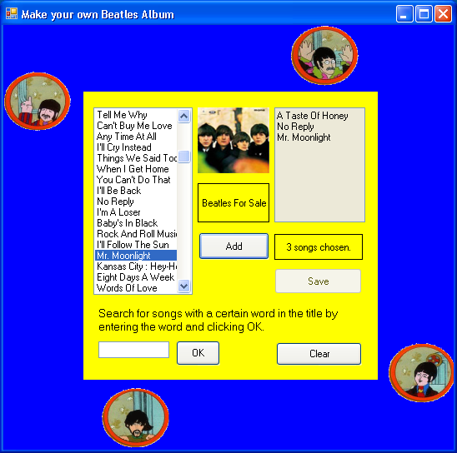

Design a form like the one above that allows the user to select ten Beatles’ songs to make up a personalized CD. The user selects songs from a list. When the limit of ten songs is reached, the user can then save the list of songs to a file that he or she selects.

- Have a comment with your name and meaningful control names.
- Make the Form that is square in shape.
- Make the Form blue and add a panel that is yellow.
- Add a PictureBox in each corner. Each PictureBox should contain an image of one of the Beatles which are provided (John.gif, Paul.gif, George.gif and Ringo.gif). The PictureBox in the upper left should move horizontally across and then “bounce” at the Form’s edge and return. The PictureBox in the upper right should move vertically and then “bounce” at the Form’s bottom, etc.
- Have it so that when the Form loads, the program should read and parse the file BeatlesSongs.txt which contains lines of data like the one shown below:

I Saw Her Standing There,PPM

The data should be loaded into SongTitle and SongAlbumCode arrays. (The program should not crash if the data file is missing, but it should display a message.)
The songs should also be placed in a list box on the left side of the panel.
- The program should also read and parse the file BeatlesAlbums.txt which contains lines of data like the one shown below

PPM,Please Please Me,Please.jpg

The data should be loaded into the arrays AlbumAlbumCode, AlbumTitle, and AlbumImage arrays.
- Have it so that when the user selects a song, the corresponding album image should be displayed in a PictureBox and the album title displayed in a Label in the center of the panel as shown above. (Hint: Find the index of the selected song which can then give you the SongAlbumCode, then find the index of the album code in the AlbumAlbumCode array to find the appropriate image.)
- Have a button that allows the user to add a selected song to a ReadOnly TextBox on the right of the panel. Have a Label below the TextBox displaying the number of songs selected thus far.
- When ten songs have been selected, the Save Button becomes enabled and the Add Button disabled. The Save button brings up a dialog box that allows the user to select a text file to which the list of selected songs (in the TextBox) is written.
- Have a TextBox and an OK Button, that allow the user to enter a word in the TextBox, and then display is a message all of the Beatles songs from the ListBox that contain that word. (The search should be case insensitive.)
- Have a Clear Button which clears out the TextBoxes, enables the Add Button and Disables the Save Button. Also clear out the Label showing the count and if you have a count variable, set it to zero.

