CSC 157  Final | Name: _________________________  December 10, 2003

This program allows the user to view the five-day weather forecast.

- Place a comment with your name at the top of the form and another at the top of the class. No other comments are needed.
- Create a Forecast class that has the following properties
Day
Description
HighTempF
LowTempF
The Day and Description are Strings and the high and low temperatures (in Fahrenheit) are integers.
- Have a constructor as well as sets and gets for all of the properties. The set for the low temperature property should check that the value is lower than the high temperature.
- Have a function that returns the high temperature in Celsius. Subtract 32 from the Fahrenheit temperature then multiply that result by 5/9.
C = (F – 32)*5/9
- Create a form like that shown below.
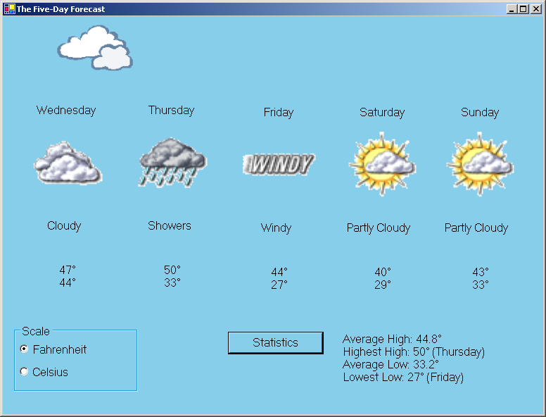
Panel with five usercontrols
- Change the name of the Form in all of the appropriate places.
- Change the font size on the Form to 12 pt.
- Change the color of the form to something other than default gray.
- All coded controls must have self-documenting names (i.e. do not leave the names such as Button1).
- When the form loads, read the file Forecast.txt (supplied on the floppy), which uses a comma as a delimiter to separate the forecast properties (day,description,hightempF,lowtempF). Use the data to instantiate and initialize an array of Forecast objects.
- Across the top of the form a picturebox with the image of a cloud (cloud.wmf supplied on the floppy) glides back and forth. Use a timer to control the speed.
- On the bottom left is a group box with two radiobuttons, one for Fahrenheit, one for Celsius. All displayed temperatures and statistics thereof are in the scale selected by the user. Fahrenheit should be selected when the form starts. Conversions to Celsius should use the class’s function. Clicking a radiobutton (use their click event!) should clear the statistics label.
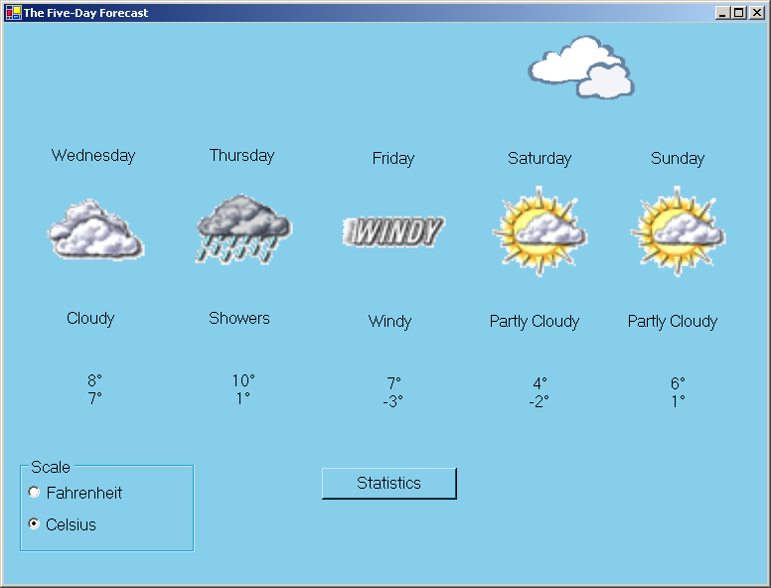
- In the bottom center is a Statistics button. When clicked the program determines the average high temperature, the average low temperature, the highest high temperature and the lowest low temperature for the five-day forecast. The highest high and the lowest low should be followed by the day they occur on. These should be displayed in the label to the right of the button. The degree symbol (°) is Character 176 in the MS Sans Serif Font.
- In the middle of the form should be a panel, the panel will contain five usercontrols.
- The usercontrol should contain a label at the top for the day, a picturebox to display a pictorial version of the description, a label for the description and a label for the high and low temperatures.
- When the form loads, the usercontrols should be loaded up with the appropriate information and images. The image file names are the descriptions but without any spaces, the image file extensions are .gif. For full credit this loading must be done in a loop. If the days do not appear in the correct order, a quick solution is to rearrange your usercontrols.
