CSC 230  Test 1 | September 21, 2007

L.L. Bean

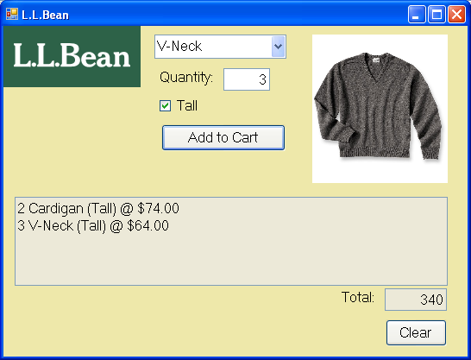

- You must have a comment with your name at the top of your program.
- Your control names and variable names should be meaningful (e.g. btnAdd not Button1).
- Design a form like that shown above.
- The Form’s color should be PaleGoldenrod. Its font size should be 12-pt.
- The bar at the top should say L.L.Bean.
- Place the LLBean logo (which is 159×71) in the upper left-hand corner.
- In the ComboBox, place the following names of types of sweaters:
  - Crew
  - V-Neck
  - Cardigan
  - Zip-Front
- When the user changes what is selected in the ComboBox, the corresponding image file (Crew.jpg, V-Neck.jpg, Cardigan.jpg, or Zip-Front.jpg) should be displayed (dynamically) in the PictureBox.
- There should be a Label saying Quantity and next to it a right-justified TextBox for the user to enter a quantity.
- There should be a CheckBox that says Tall.
- There should be a Button that says Add to Cart.
- There should be a multiline TextBox corresponding to the cart.
- Under that there should be a Label saying Total and a ReadOnly, right-justified TextBox for the total. (The Total TextBox should start out with a 0 in it. To simplify the program somewhat, the number in this textbox does not have to be formatted as currency.)
- Under that should be a Clear Button. The Clear Button should clear out the cart TextBox and place a 0 in the Total TextBox.
- When the user clicks the Button, get the quantity of sweaters ordered from the TextBox. If the user has not entered a number, pop up a MessageBox saying so.
- Next use the Type of sweater, determine the price from the following
  - Crew $29.50
  - V-Neck $59.00
  - Cardigan $69.00
  - Zip-Front $39.50
- If the user has checked the Tall CheckBox add $5.00 dollars to the price.
- Add a line to the cart TextBox indicating the Quantity, Style, (and if Tall), and the Price. The price should be formatted as currency.
- Add the Quantity*Price to the total and place the new total in the Total textbox.
- Print out your code (remember your name should be at the top).
- Zip up the project folder and send it to me in an email.

