CSD 340 Final : Cartoons
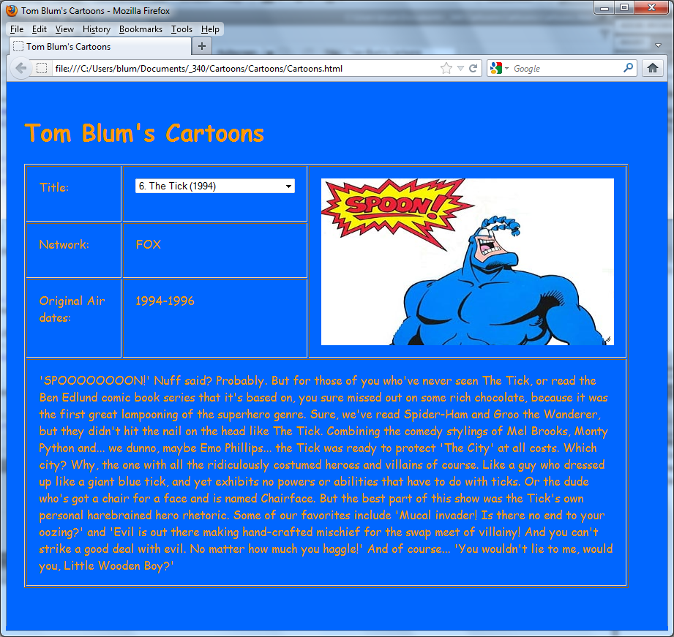
- Make a page with a title John Smith’s Cartoons (with John Smith replaced by your name).
- Add an HTML comment with your name.
- Have a style that controls the page’s background color and color (font color).
- Include a CSS comment with your name.
- Have a script tag that points to the jQuery library.
- Start a script area and place a comment with your name at the top.
- Place a header with your name at the top of the page.
- Make a table with three columns and four rows. In the last column merge the top three rows. In the last row merge all three columns.
- Have the cells in the table have a style with the vertical-align attribute set to top.
- Have your page read the Cartoon JSON file and extract the “cartoons” array object contained therein.
- Populate the drop-down select next with a concatenation of the rank and title.
- When the user chooses a new option in the drop-down select, display the corresponding Network, Airdate, and Description in the appropriate table cells. Also display the corresponding image.
- Make the image so that the user can resize it. Recall this may require you to have additional link and script tags added to your program.
- At the end of getJSON have the browser pick one of the cartoon array indices at random, set the drop-down select’s value, and then trigger drop-down select change event.

