CSC 230 Test 2A: Rock, Paper, Scissors
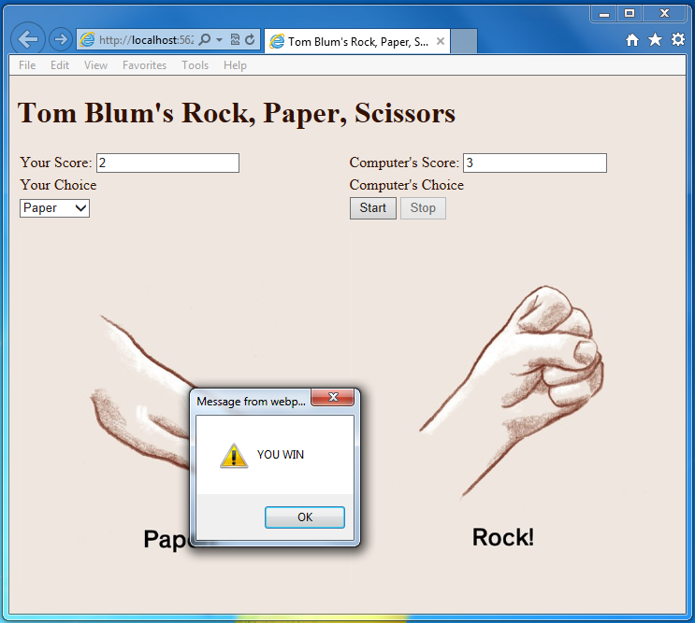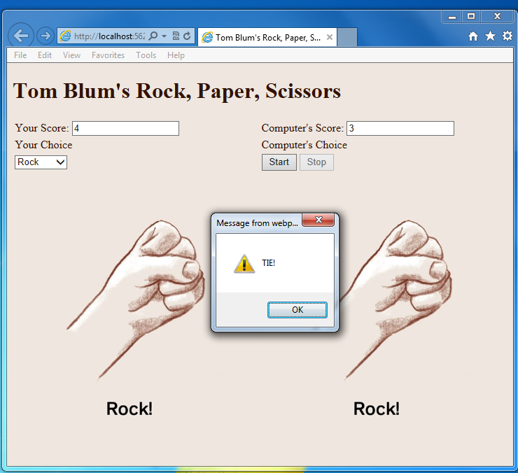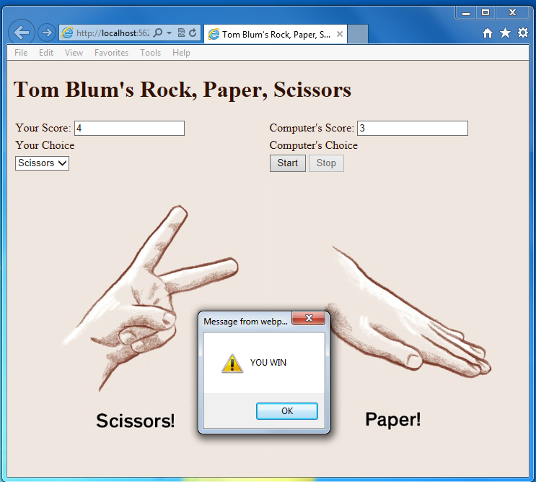
- Make a page with a title John Smith’s Rock, Paper, Scissors (with John Smith replaced by your name).
- Add an HTML comment with your name.
- Give the page’s body a background color of #EFE6DF and a font color (#331100).
- Put a header at the top of the page reading John Smith’s Rock, Paper, Scissors (with John Smith replaced by your name).
- Below that add a table with 4 rows and 2 columns. If Visual Studio gave your table a style that makes the table’s width 100%, then eliminate the style attribute from the table tag.
- Each cell in the first row should contain a read-only text input that will display scores (the user’s and the computer’s).
- The second row just contains some text “Your choice” and “Computer’s Choice”.
- The first column of the third row contains a drop-down select that will allow the user to choose between Rock, Paper and Scissors.
- The second column of the third row will have a Start button and a Stop button. Initially the Stop button should be disabled.
- Give the cells in the 4th row cell a style with a width of 400px and a height of 400px.
- Place an image of a “rock” with height 380px in each cell in the 4th row.
- Start a script area and place a comment with your name at the top.
- When the user uses the drop-down select to change his/her choice the image underneath should change to reflect the choice.
- When the start button is clicked, start a (repeating) timer that calls a function every hundredth of a second.
- Clicking the Start button should also enable the Stop button and disable the Start button.
- The function called by the timer should generate a (pseudo)-random number with three possible outcomes – one for rock, another for paper and a third for scissors.
- The image should be updated.
- The Stop button should stop the timer.
- The Stop button should also enable the Start button and disable Stop button.
- The code should then determine if the user won (alert and add one point to the user’s score) or if the computer won (alert and add one point to the computer’s score) or if it was a tie (just an alert).
Rock beats Paper
Paper beats Scissors
Scissors beats Rock
- Print your code (File/Print).
- ZIP up your files and email them to me.

