CSC 349

Mobile Computing

November 21, 2017

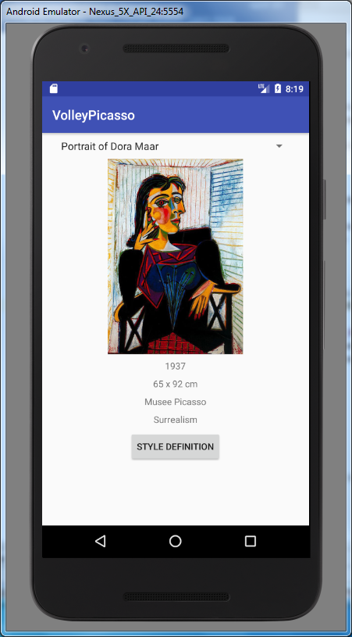 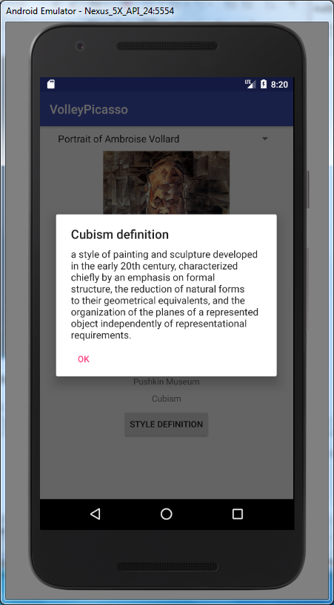

Picasso Picasso!

1. Make your app so that you have access to the Volley code.
2. Make your app so that you have access to the Picasso code.
3. Make your app so that you have permission to use the Internet.
4. Create a layout that has
   1. A spinner
   2. An ImageView (height 300dp)
   3. Four TextViews
   4. Button

They should have vertical and horizontal constraints

1. Use Volley to read and parse the JSON file found at

http://www1.lasalle.edu/~blum/c341wks/Picasso/picasso.json

(Read it from its remote location)

1. Load up the titles of the paintings into the spinner
2. When the user selects an item in the spinner, have the TextViews display the year, size, location and style.
3. Also have the ImageView display the corresponding image from the remote location. For instance, if the image property is the-old-blind-guitarist-1903.jpg, then the url is

http://www1.lasalle.edu/~blum/c341wks/Picasso/ the-old-blind-guitarist-1903.jpg

1. When the user clicks the button read the corresponding style file (e.g. neoclassicism.txt). You will need to take the style name and eliminate/replace any space and put it in all lower case

a = a.replaceAll("\\s","");

a = a.toLowerCase();

1. Adapt the following code to display contents of the corresponding style file

AlertDialog alertDialog = new AlertDialog.Builder(MainActivity.this).create();

alertDialog.setTitle("Alert");

alertDialog.setMessage("Alert message to be shown");

alertDialog.setButton(AlertDialog.BUTTON_NEUTRAL, "OK",

new DialogInterface.OnClickListener() {

public void onClick(DialogInterface dialog, int which) {

dialog.dismiss();

}

});

alertDialog.show();

(https://stackoverflow.com/questions/26097513/android-simple-alert-dialog)

It requires an import. I used:

**import** android.support.v7.app.AlertDialog;

(For a slight reduction use a Toast.)

**Submit any files that you explicitly changed**