**CSC 230 Test 1: Subway**

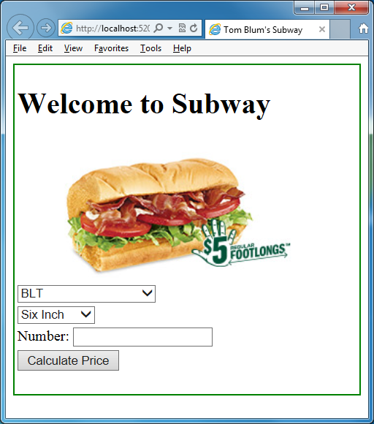

1. Make a page with a title John Smith’s Subway (with John Smith replaced by your name).
2. Add an HTML comment with your name.
3. Make a page with a table with 7 rows and one column and a border
4. The first row has a header element containing the text “Welcome to Subway”.
5. The second row has an image element of height 150px that has the file BLT.jpg as its source.
6. The third row has a drop-down select with sandwich choices. The user should see the following options. (The corresponding image file names and prices are also shown below)

<option value="">BLT</option>

<option value="">Cold Cut Combo</option>

<option value="">Spicy Italian</option>

<option value="">Tuna</option>

<option value="">Sweet Onion Teriyaki</option>

|  |  |  |
| --- | --- | --- |
| **Option Text** | **Image File Name** | **Six-Inch Price** |
| BLT | BLT.jpg | 3.50 |
| Cold Cut Combo | ccc.jpg | 3.50 |
| Spicy Italian | spcyital.jpg | 3.75 |
| Tuna | tuna.jpg | 4.50 |
| Sweet Onion Teriyaki | soct.jpg | 4.75 |

1. The fourth row has a drop-down select where the user sees two options

Six Inch

Foot long

1. The fifth row the words “Number” followed by an input text element.
2. The sixth row has an input button element which, when the user clicks it, calculates the cost of his/her order; the results of the calculation will be displayed in the seventh row.
3. Start a script area and place a comment with your name at the top.
4. Have JavaScript code that uses the page load event to show an alert that says “$5 Any Regular Footlong All Subtember Long!”
5. When the user changes the sandwich selection (drop-down), the image element’s source should change to the corresponding sandwich.
6. When the user clicks the button, determine which sandwich is being ordered, whether it Six-Inch or Foot-Long, and how many are ordered. Then determine the amount of the user’s order by multiplying the price by the number ordered. (Recall you may need to use parseInt or parseFloat.) Note that the price depends on the sandwich ordered as well as its size. The Six-Inch sandwiches have the prices shown above, but all Foot-Long sandwiches are $5.00.
7. Your result should be formatted as currency, that is, it should have a dollar sign at the beginning and display two decimal places.
8. Your code should check that the user’s input in the text field is a number. If not, it should alert the user, and clear out the text field. It should not proceed with the calculations if the user enters anything else.
9. Your code should check that the number is greater than or equal to zero. If not, it should alert the user, and clear out the text field. It should not proceed with the calculations if the user enters anything else.
10. If the user changes either the text input (use the onkeydown event) or the either of the drop-down selects (use the onchange event), any previous answer being displayed should be cleared out.
11. Print your code (File/Print).
12. ZIP up your files and email them to me.

