CSC 230  Test 3A | November 17, 2010

Horror Movie Rating

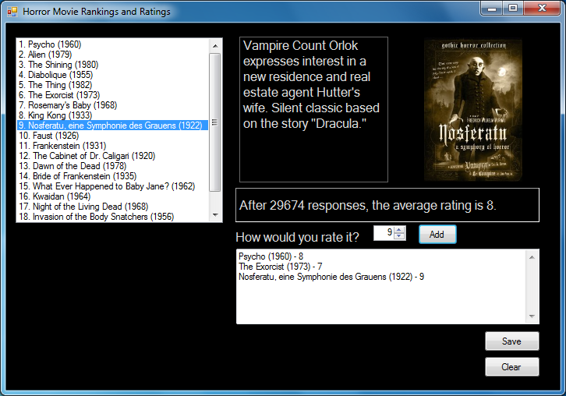

Based on http://www.imdb.com/chart/horror

- You must have a comment with your name at the top of your program.
- Your control names and variable names should be meaningful (e.g. btnCalculate not Button1).
- Your program should not crash if there are any difficulties reading or writing the files.
- Design a form like that shown above.
- Read and parse the file HorrorMovies.txt, which has lines of the following format – a MovieRank, a MovieRating, a MovieTitle, a MovieImage, a MovieNumber (of Voters) and a MovieDescription, separated by vertical lines |.

17|8|Night of the Living Dead (1968)|NightLivingDead.jpg|39,844|A group of people hide from bloodthirsty zombies in a farmhouse.

- Declare, instantiate, and initialize arrays based on this data.
- Enter the ranks and titles into a ListBox.
- When the user selects a movies, the corresponding image and description should be displayed in a PictureBox and a Label. Another Label should something like “After YYY responses, the average rating is ZZZ.” Where YYY is the number of voters and ZZZ is the rank.
- Have a Label and a NumericUpDown control (1 to 10) that allows the user to rate the movie. Also have a Button that adds the user’s rating (movie title, a dash, and a rating) to your choice of a Listbox or a multiline, scrollable TextBox.
- Have a Button that allows the User to save a file with their ratings in a file that the user selects the name and location of.
- Have a Button that clears out the User’s ratings.
- Extra: Write code that prevents the user from rating the same movie twice. However, if the user uses the Clear Button, then he or she should be able rate a movie rated before clearing but not since.
- Zip up the project folder and send it to me in an email.

