CSC 230  Test 3B | November 17, 2010

Weather Forecast

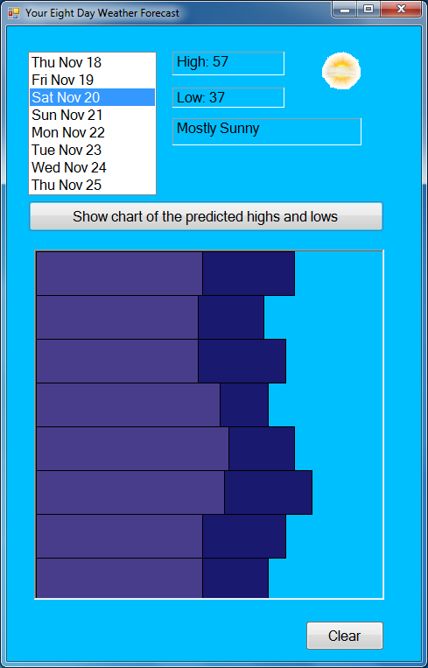

Based on http://www.weather.com

- You must have a comment with your name at the top of your program.
- Your control names and variable names should be meaningful (e.g. btnCalculate not Button1).
- Design a form like that shown above.
- Paste the following arrays into your program. These arrays (beginning with FC) correspond to the forecast for the next eight days

Dim FC_Day As String() = New String() {"Thu", "Fri", "Sat", "Sun", "Mon", _
"Tue", "Wed", "Thu"}
Dim FC_Date As String() = New String() {"Nov 18", "Nov 19", "Nov 20", "Nov 21", _
"Nov 22", "Nov 23", "Nov 24", "Nov 25"}
Dim FC_Desc As String() = New String() {"P_CL", "SU", "M_SU", "P_CL", "P_CL", _
"P_CL", "SH", "M_CL"}
Dim FC_High As Integer() = New Integer() {59, 52, 57, 53, 59, 63, 57, 53}
Dim FC_Low As Integer() = New Integer() {38, 37, 37, 42, 44, 43, 38, 38}

- Have your program load the Days and Dates into a ListBox.
- When the user selects an item from the ListBox, display the high temperature in a Label and the low temperature in another Label.
- Use the Desc code for that day to look up the corresponding description and the corresponding image and display them in a Label and PictureBox respectively.

Dim W_Code As String() = New String() {"P_CL", "SU", "M_SU", "SH", "M_CL", "W"}
Dim W_Desc As String() = New String() {"Partly Cloudy", "Sunny", "Mostly Sunny", _
"Showers", "Mostly Sunny", "Windy"}
Dim W_Image As String() = New String() {"30.gif", "32.gif", "34.gif", "11.gif", _
"28.gif", "24.gif"}

- Have a Button and a Panel (400 by 400) beneath it. When the Button is clicked, make a bar chart of the highs and lows (like the lab the Week beginning Oct 4). Draw the highs and then the lows on top of them. Use different colors for highs and lows. Also “draw” an outline around the bars. Use a bar height of 50. As a rule of thumb use a width that is five times the number it represents.
- Have a clear Button that clears the panel
- Extra: put a gap between the bars and use the DrawString method to write the temperatures being represented.

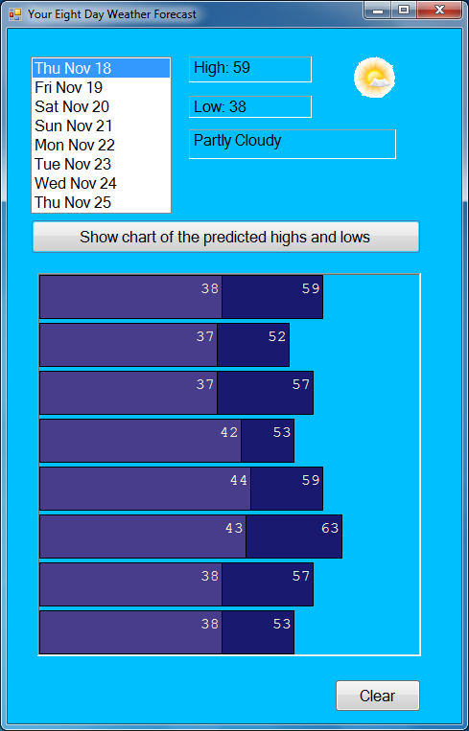

- Zip up the project folder and send it to me in an email.

