CSC 230  Practice Test | September 2014

BMI

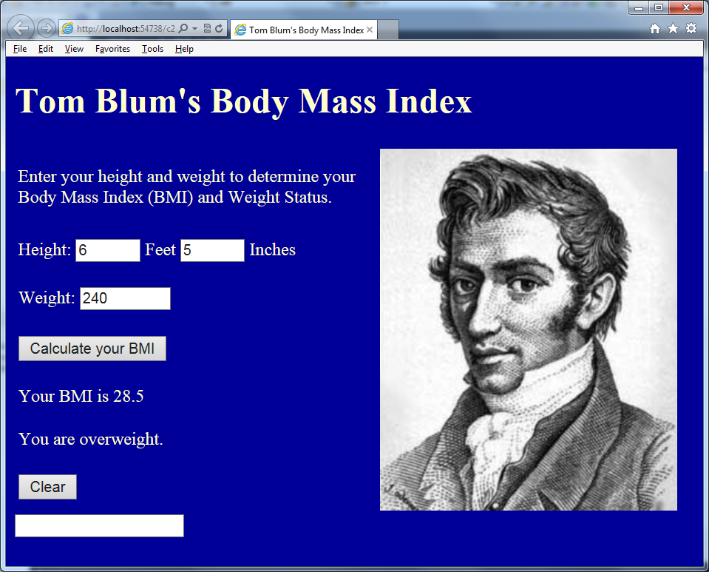

Based on http://www.whathealth.com/bmi/formula.html

Focus on what you can do – don’t get hung up on the one thing you can’t do.

Comment out code that isn’t working that you want me to look at for partial credit.

- You must have an HTML comment with your name near the top of your page.
- Your page should have a title with your name, such as John Smith’s Body Mass Index.
- Your page should have a header with your name, such as John Smith’s Body Mass Index.
- Your element names and variable names should be meaningful (e.g. btnCalculate not Button1).
- Design a page like that shown above. Make a table with seven rows and two columns. Highlight the second column, right click and choose Modify/Merge.
- The page’s color should be anything but default white.
- Place the image of Adolphe Quetelet quetelet.jpg in an Image element that is 268×326 on the right-hand side.
- In Row 2, the text input for feet should have its MaxLength property set to 1 and its Size property set to 4. Similarly the text input for inches should have its MaxLength property set to 4 (so one can enter a number like 11.5) and its Size property set to 4..
- In Row 3 you should have the text input for Weight (in pounds) with MaxLength set to 5 and Size set to 8.
- In Row 4 you should have a Button saying “Calculate your BMI” that when clicked retrieves the data from the user and proceeds with the calculation.
- Rows 5 & 6 are for displaying your answer.
- Row 7 contains a Clear Button.
- Your script area should have a JavaScript comment with your name.
- Make sure that the weight input is a number and is greater than 0.
- Make sure the Feet data is a number and is between 2 and 8. Report any problems to the user using an alert and do not continue with the calculation. Put the Focus back into the text input.
- Make sure the Inches data is a number and is between 0 and 11.9. Report any problems to the user using an alert and do not continue with the calculation. Put the Focus back into the text input.
- Calculate the height in inches by multiplying the feet by 12 and adding the inches

HeightInInches = Feet*12 + Inches

(Recall you may need to use the parseInt() method.)
- Calculate the Body-Mass Index (BMI) from either of the following equivalent formulas

BMI = Weight*703 / HeightInInches / HeightInInches
BMI = (Weight*703) / (HeightInInches * HeightInInches)

- Display the resulting BMI showing one decimal place. You must include (somehow) the words “Your BMI is ”.
- Display the corresponding Weight Status based on the following ranges

Below 18.5 | Underweight
18.5 to 25 | Normal
25 to 30 | Overweight
30 and higher | Obese

- If the user changes any of the data (Feet, Inches or Weight), the BMI and Weight Status results should be cleared out.
- When the Clear Button is clicked, the Feet and Inches and Weight inputs should be cleared out, and the BMI and Weight Status results should be cleared out.
- Print out your code (remember your name should be at the top).
- Zip up the project folder and send it to me in an email.

