CSC 230  Test 2A | Name:____________________  October 18, 2007

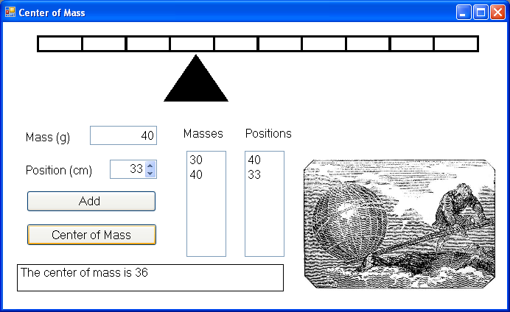

You should design a form like the one above that has the user enter a set of masses and positions from which the center of mass will be calculated. Your program should have

- A comment with your name and meaningful control names.
- The Form’s BackColor set to White and its Font Size set to 12. Its Width should be 692 pixels.
- A PictureBox at the top which contains the image lever.gif and is 600 pixels wide, 23 pixels high, and has a left position of 46 pixels.
- Another PictureBox (96 wide, 67 high) which contains the image fulcrum.gif and is under the previous one.
- A Timer that has the second PictureBox move back and forth across the form.
- A Label and a right-justified TextBox for the user to enters a mass (which should be a positive number).
- A Label and a right-justified NumericUpDown control for the user to enter a position (a number between 0 and 100).
- A Button, two ListBoxes and two Labels. The Button checks that the mass is positive and then adds the mass and the position to the corresponding ListBoxes. Messageboxes should arise if the user’s entry is not a number or if it is a negative number. The Labels indicate the contents of each ListBox.
- The Add Button should clear out any old result from the label and restart the timer if it was stopped.
- A PictureBox that contains the image Archimedes.jpg.
- A Button and a Label. When the Button is pressed two sums are calculated and then one is divided by the other.
  - The Numerator is the sum of each mass times its corresponding position.
  - The denominator is the sum of the masses.
The result of the division (the center of mass) is displayed in the Label. Use Math.Round to display two decimal places. If there are no entries in the ListBox (hint: count=0), then a MessageBox should appear and the calculation should not be performed.
- When the button is pressed the fulcrum PictureBox should stop moving and be moved so that its X position is 6 times the value determined to be the center of mass.

