CSC 230  Test 3A | Name:____________________  November 15, 2007

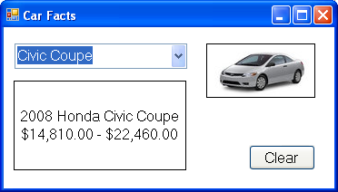

You should design a form like the one above that allows the user to view some information about cars. Your program should have

- A comment with your name and meaningful control names.
- The Form’s BackColor set to White and its Font Size set to 12. Its title should be Car-Facts.
- A ComboBox that displays car names, a Label (with a border) that displays information about the selected car, and a PictureBox (with a border) that displays an image of the selected car.
- When the program loads, read and parse the file Cars.txt, which has lines like the following:

2007,MINI,Cooper,18050-25400,mini_cooper_ht_2007_120x60.jpg

With the year, the manufacturer, the name, the manufacturer’s suggested retail price (MSRP) as a range (two number separated by a hyphen), and the image file name. Make arrays for the information. Break the price range into two arrays (e.g. MSRP_low and MSRP_high). Pop up a MessageBox if there is a problem reading the file.
- When the user selects a car name from the ComboBox, display the image of the car in the PictureBox.
- Also display the name of the selected car, along with the year of the car, the manufacturer of the car on one line and the manufacturer’s suggested retail price range for the car (formatted as currency) on another line in the Label.
- Have a Clear Button that removes the Text from the ComboBox, clears out the Label and puts “nothing” in the PictureBox.

