CSC 230  Test 4B | Name:____________________  December 6, 2007

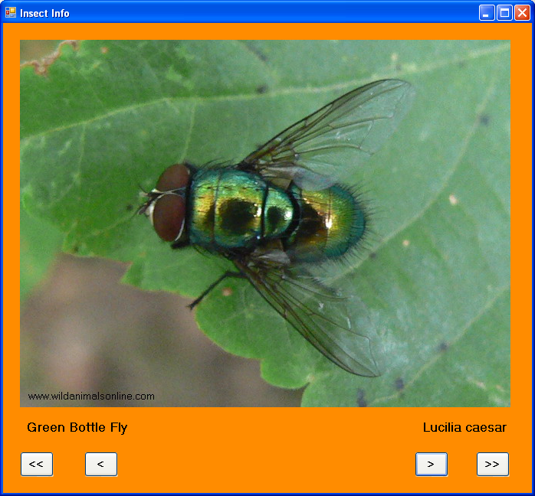

Resource: http://www.wildanimalsonline.com/insect/

You should design a form like the one above that allows the user to view images and names of insects. Your program should have

- A comment with your name and meaningful control names.
- The Form’s BackColor set to some color other than default gray. Its title should be Insect Info.
- Write a class of insect information that has the following properties
  - Common Name (String)
  - Genus (String)
  - Species (String)
- The class should have a trivial constructor as well as sets and gets for the above properties.
- There is an image file (e.g. carpenterbee-xylocopaviolacea.jpg) corresponding to each insect. The class should have a function that returns the name of an image file associated with the insect object. The image file name is constructed as follows
  - Put the common name in lower case and eliminate any spaces using the Replace string method (as in the Weather lab).
  - Concatenate a dash
  - Concatenate the genus name in lower case.
  - Concatenate the species name in lower case.
  - Concatenate the file extension “.jpg”
- Read and parse the file InsectData.txt, which has rows with the format CommonName/Genus/Species, as in the following example:

Queen of Spain Fritillary/Issoria/lathonia

Use the information instantiate and initialize an array of Insect objects.
- Make a slide show that displays the Insect image (using your class function) in a PictureBox (640 × 480) as well as the common name and scientific name (genus and species) in Labels.
- There should be four buttons
  - Forward (or Next) that advances the user to the insect with the next higher index. (This should be disabled if there are no further insects in the array.)
  - Previous (or Back) that takes the user to the insect with the next lower index. (This should be disabled if the user is at the first (0th) insect in the array.)
  - First that takes the user to the first (0th) insect in the array.
  - Last that takes the user to the last insect in the array.

