CSC 230 Final A: Going to the Dogs
Remember other than the JSON you do not have to use jQuery. (Non-jQuery functions should be outside of jQuery’s document-ready.)
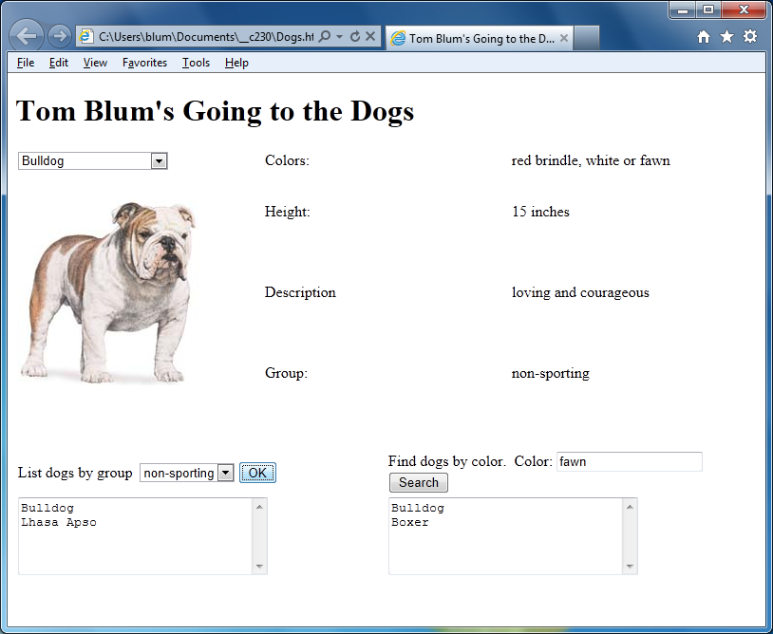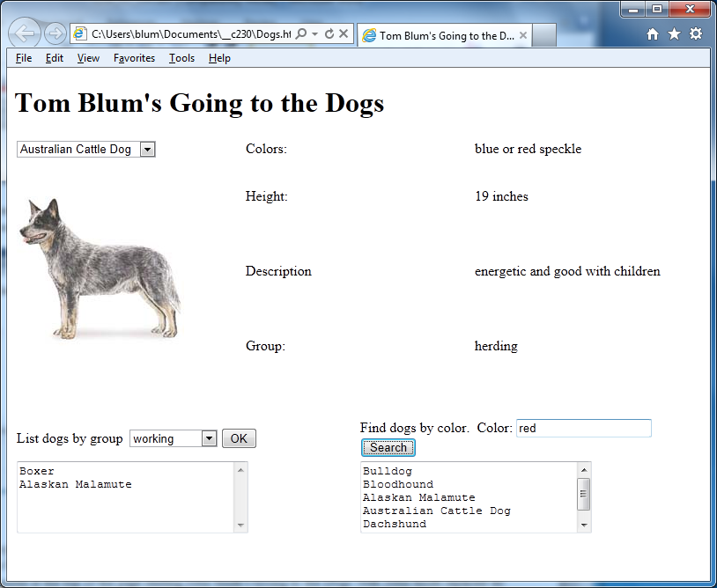
- Make a page with a title John Smith’s Going to the Dogs (with John Smith replaced by your name).
- Add an HTML comment with your name.
- Put a header at the top of the page reading John Smith’s Going to the Dogs (with John Smith replaced by your name).
- Make a table with four rows and three columns and merge rows 2-4 in the first column. Set the width of the cells in the first row to 33%. Set the height of the merged cell to 250px.
- The first column of the first row should have a drop-down select for the dog names.
- The merged cells should have an image for a picture of the dog.
- Start a script area and place a comment with your name at the top.
- Add the link to the jQuery library.
- When the page starts, read in the JSON file DogData.json and populate the drop-down select with the names of the dogs as the options the user sees. There should be no blank option.
- When the user selects a dog from the drop-down select, have the image of that dog displayed as well as the other data (colors, height, description, and group). The height should be followed by the word “inches”.
- Below the table made above make another table with two rows and two columns. Set the width of the cells in the first row to 50%.
- The first row/first column should contain a drop-down select for dog groups (hound, working, herding, non-sporting) and a button.
- When the button is clicked, dogs from that group are displayed in a textarea (cols: 30, rows: 5) in the cell below. (Remember to clear the textarea of any previous results.)
- Clear out the textarea if the user changes the value in the drop-down select.
- The first row/second column should contain a text input and a button.
- When the button is clicked, dogs that have that color as part of the color property should be displayed in the textarea (cols: 30, rows: 5) in the cell below. (This part reminds me of something we did with Beatles songs – the Week of Nov. 5).
- Clear out the textarea if the user changes the text to be searched.
- Print your code (File/Print).
- ZIP up your files and email them to me.

