CSC 230 Test 1: Wooden Memory Cubes
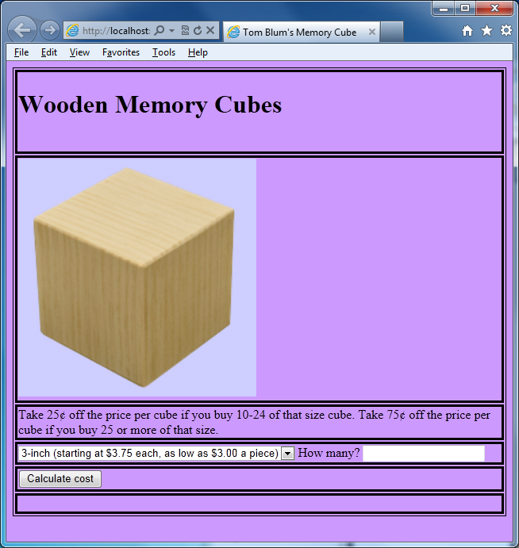
- Make a page with a title John Smith’s Memory Cubes (with John Smith replaced by your name).
- Add an HTML comment with your name.
- Make a page with a table with 6 rows and one column and a border
- The first row has a header element containing the text “Wooden Memory Cubes”.
- The second row has an image element of height 300px that has the file MC_3.jpg as its source.
- The third row has the following text: (Copy and paste it.)

Take 25¢ off the price per cube if you buy 10-24 of that size cube. Take 75¢ off the price per cube if you buy 25 or more of that size.

- The fourth row has a drop-down select where the user sees the following three items (one at a time)

3-inch (starting at $3.75 each, as low as $3.00 a piece)
4-inch (starting at $5.00 each, as low as $4.25 a piece)
5-inch (starting at $6.50 each, as low as $5.75 a piece)

- Next to the drop-down select are the words “How many?” followed by an input text element.
- The fifth row has an input button element which, when the user clicks it, calculates the cost of his/her order; the results of the calculation will be displayed in the sixth row.
- Start a script area and place a comment with your name at the top.
- Have JavaScript code that determines which size cube is ordered, and how many are ordered, and then the amount of the user’s order by multiplying the price by the number ordered. (Recall you may need to use parseInt or parseFloat.) Note that the price of the cubes is dependent on the number ordered:

3-inch cubes cost
$3.75 if the user buys 9 or less
$3.50 if the user buys between 10 and 24
$3.00 if the user buys more than 25
4-inch cubes cost
$5.00 if the user buys 9 or less
$4.75 if the user buys between 10 and 24
$4.25 if the user buys more than 25
5-inch cubes cost
$6.50 if the user buys 9 or less
$6.25 if the user buys between 10 and 24
$5.75 if the user buys more than 25

- Your result should be formatted as currency, that is, it should have a dollar sign at the beginning and display two decimal places.
- Your code should check that the user’s input in the text field is a number. If not, it should alert the user, clear out the text field, and place the focus on it. It should not proceed with the calculations if the user enters anything else.
- Your code should check that the number is greater than or equal to zero. If not, it should alert the user, clear out the text field, and place the focus on it. It should not proceed with the calculations if the user enters anything else.
- If the user changes either the text input (use the onkeydown event) or the drop-down select (use the onchange event), any previous answer being displayed should be cleared out.
- Print your code (File/Print).
- ZIP up your files and email them to me.

