CSC 230 Test 2A makeup: Oscillatory Motion
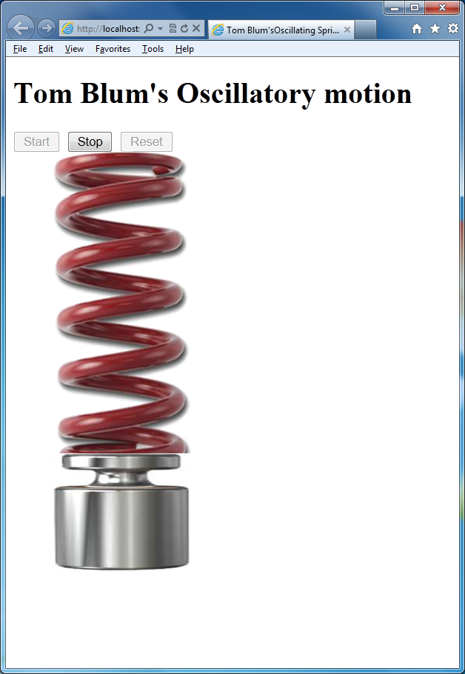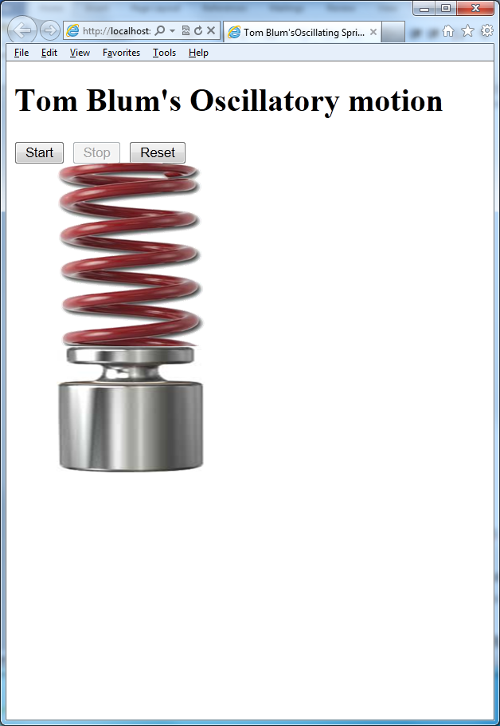
- Make a page with a title John Smith’s Oscillatory Motion (with John Smith replaced by your name).
- Add an HTML comment with your name.
- Give the page’s body a white (#FFFFFF) background and a dark blue (#000066) color (for the font).
- Put a header at the top of the page reading John Smith’s Oscillatory Motion (with John Smith replaced by your name).
- Place three buttons at the top that say: Start, Stop, and Reset. The Stop and Reset buttons should be initially disabled.
- Below the buttons place two images. The first should use the image file Spring.png and have a style with position absolute, top 100px, left 50px, width 150px, and height 300px. The second should use the image file Weight.png and have a style with position absolute, top 380px, left 50px, and width150px.
- Start a script area and place a comment with your name at the top.
- Declare a global variable t and initialize it to 0.
- Clicking the Start button should enable the Stop button and disable the Start button.
- When the start button is clicked, start a (repeating) timer that calls a function every 50 milliseconds.
- That function should increment t by 1 and then calculate the following quantities

y = 300 + 100 * Math.sin(0.2 * t);

- Then set the first image’s (the spring’s) height to y.
- Then set the second image’s (the weight’s) top to (y+80).
- The Stop button should stop the timer.
- The Stop button should also enable the Start and the Reset buttons and disable itself.
- Clicking the Reset button should set the variable t to 0. It should set the spring image’s height to 300. And it should set the weight image’s top to 380. It should also disable itself.
- Print your code (File/Print).
- ZIP up your files and email them to me.

