CSC 230 Test 3A: TV Shows
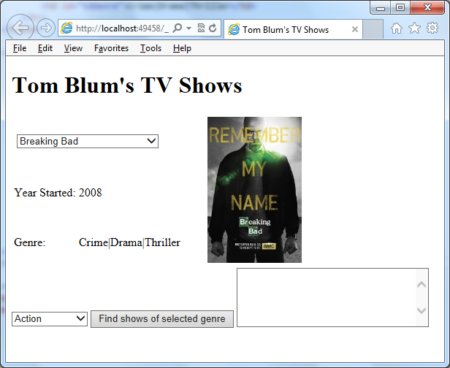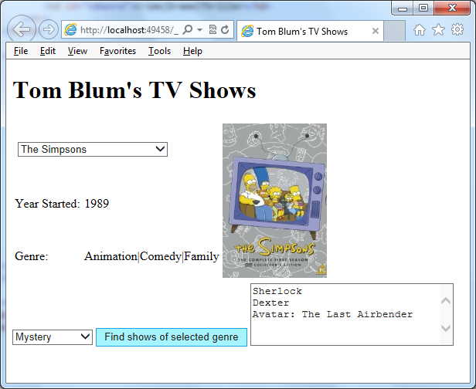
- Make a page with a title John Smith’s TV Shows (with John Smith replaced by your name).
- Add an HTML comment with your name.
- Put a header at the top of the page reading John Smith’s TV Shows (with John Smith replaced by your name).
- Below that add a table with 3 rows and 3 columns. Merge the cells as shown below.

Use for drop-down select |  | Use for image
Year Started | XXXX | Use for image
Genre(s) | yyyy|yyyy|yyyy | Use for image

- Make the width of the first cell in the second row 20% and the second cell in the second row 40%.
- Add a drop-down select in the cell shown above.
- Add an image element in the cell shown above. Use the BreakingBad.jpg file to start. Make the image height 200px.
- Add below the table another drop-down select (with the code found in TV_Show_start.txt), a button, and a textarea.
- Start a script area and place a comment with your name at the top.
- Use the data in TV_Show_start.txtto create arrays.
- Write code that populates the drop-down select with the names of the TV Shows when the page comes up. Do not have an empty option, instead have Breaking Bad initially displaying in the list.
- Write code so that when the user chooses a TV Show from the drop down select, the year started and genre(s) of that TV Show are displayed in the appropriate cells shown above.
- Also display the image of the TV Show.
- When the button at the bottom is clicked, determine the user’s choice of genre from the drop-down list, and then loop through the TV Shows adding the name of any TV Show in that genre to the textarea – each on its own line. (Note many TV Shows belong to more than one genre.)
- When the user changes the description choice, clear out any list in the textarea.
- Print your code (File/Print).
- ZIP up your files and email them to me.

