CSC 230 Test 3B: Survey
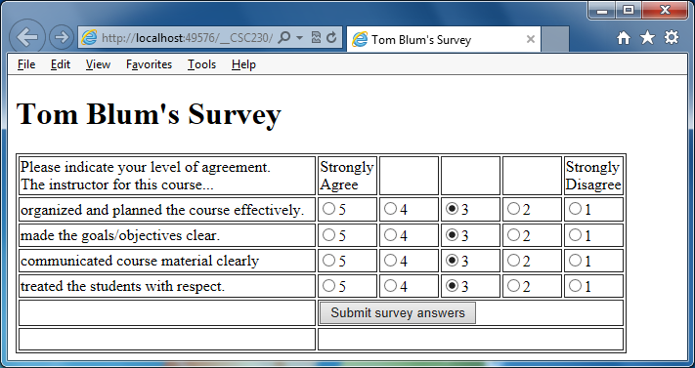
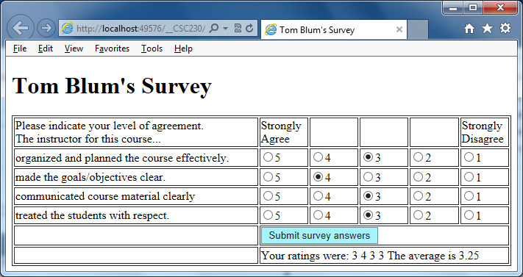
- Start with Survey_start.html, add a title John Smith’s Survey (with John Smith replaced by your name).
- Add an HTML comment with your name.
- Put a header at the top of the page reading John Smith’s Survey (with John Smith replaced by your name).
- Make it so that you can choose only one answer (1 through 5) for each of the four survey questions.
- Preselect for the user the answer 3 for each survey question.
- Merge the last five cells in the sixth row. Similarly merge the last five cells in the seventh row.
- Add a button in the merged cell in the next-to-last row.
- Start a script area and place a comment with your name at the top.
- When the button is clicked, determine the user’s rating for each of the four questions.
- Calculate the average rating.
- Display the user’s individual ratings as well as the average in the merged cell in the last row.
- Clear out the results if the user changes any of his/her ratings.
- Print your code (File/Print).
- ZIP up your files and email them to me.

