Name: _________________________
Mostly Joins Lab
For each of the following scenarios paste the SQL (and not the result of the SQL) that would provide the answer.
Reminder of the Northwind design and relationships.
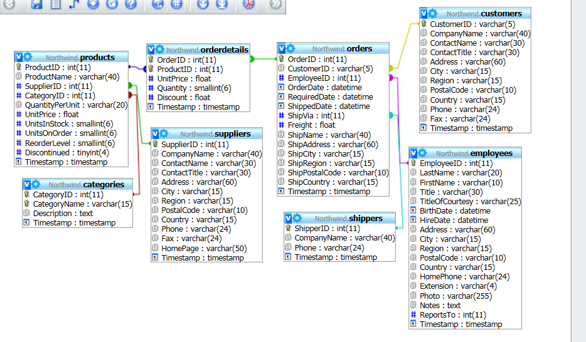
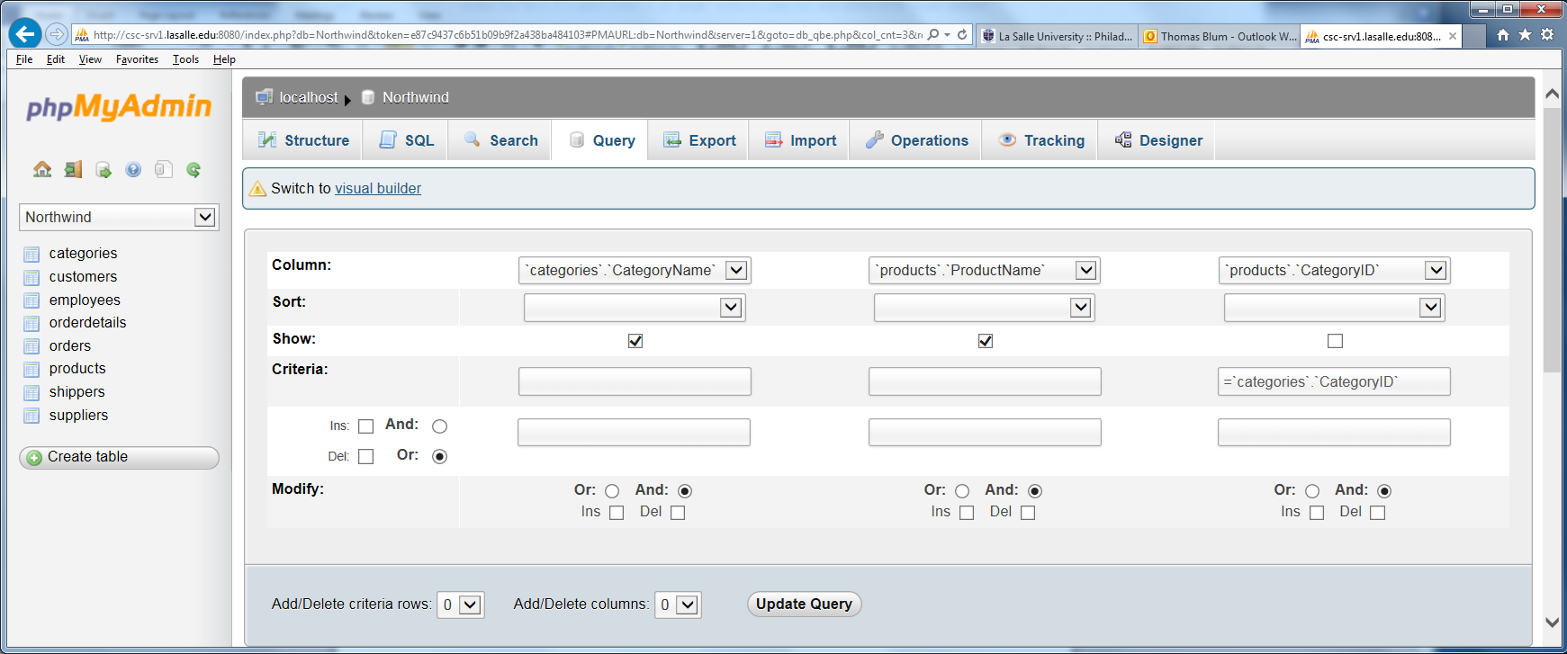

- Make a list of the category names and the products belonging to those categories.

- (Semi-join) Make a product names just in the Beverages category.

- (Outer join) Make a list of categories and products that would include any categories that did not have products in them.

- (Outer join) Make a list of categories and products that would include any products that have not been placed in a category.

- Make a list of company names and the products they supply.

- (Semijoin) Make a list of the products supplied by Exotic Liquids.

- (Joining three tables) Make a list of supplier company names, products and categories.

- (Union) Make a list of the company name, contact name and contact title of both supplier and customers.

- Make a list of OrderID’s and Customer Company names.

- Make a list of OrderID’s and Employee FirstName and LastName.

- (Joining three tables) make a list of OrderID’s and Customer Company Names and Employee FirstName and LastName.

- (Joining three tables). Make a list if OrderID’s and the products in those orders (must use the bridge table OrderDetails).

