Northwind Database Queries

Name:

The relationships for the Northwind Database are shown below.

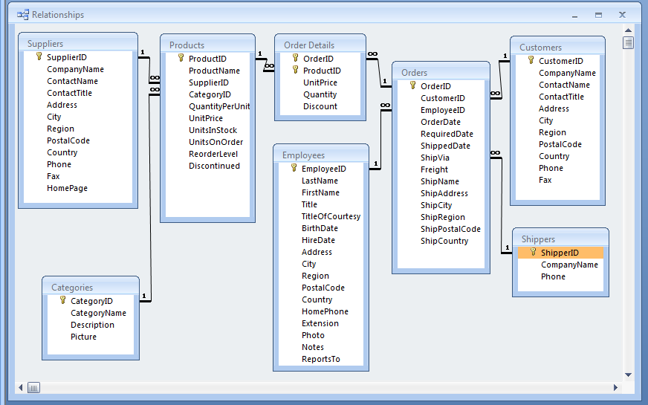

Paste the SQL statements for the queries below the query statements.

- NumberOfOrdersHandledByShippers: Make a list of the shippers and the number of orders handled by each. (My query yielded 3 records starting with Federal Shipping|255.)

- NumberOfTimesEachEmployeeUsesAShipper: Make a list of the employees (last name concatenated with first name) and for each employee show the number of times that employee has used each of the shippers. (My query yielded 27 records starting with Buchanan, Stephen|Federal Shipping|13.)

- EmployeesFromTheSixties: Make a list of Employees born in the 1960’s. You can model your query on Product Sales for 1995. (My query yielded 4 records starting with Leverling| Janet|30-Aug-63.)

- ValueOfStockDesc: Make a list of the Products and the “value” of that item that is in stock (units in stock multiplied by unit price). Have the products ranked by “value” with the most valuable first. (My query yielded 77 records starting with Côte de Blaye|$4,479.50.)

- Make a list of cities that have both a supplier and a customer. (My query yielded 5 records: London, São Paulo, Berlin, Paris and Montréal.)

