Northwind Database Queries

Name:

The relationships for the Northwind Database are shown below.

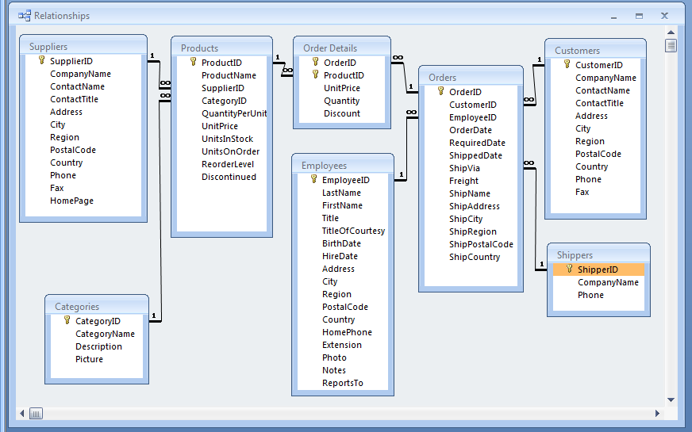

Paste the SQL statements for the queries below the query statements.

- OutOfStockProducts: Make a list of products that are out of stock. (My query yielded 5 records.)

- OutOfStockProductsNotDiscontinued: Make a list of products that are out of stock and have not been discontinued. Include the suppliers’ names. (My query yielded 1 record.)

- ReorderProducts: Make a list of products that need to be re-ordered i.e. where the units in stock (the number you have) and the units on order (the number you have coming) is less than the reorder level (the number that prompts you to order more). (My query yielded 2 records.)

- ProductPopularity: Make a list of products and the number of orders in which the product appears. Put the most frequently ordered item at the top of the list and so on to the least frequently ordered item. (My query yielded 77 records; Raclette Courdavault (54 orders) was at the top and Mishi Kobe Niku (5 orders) was at the bottom.)

- ProductPopularity2: Make a list of products and total up the number of actual items ordered. Put the most frequently ordered item at the top of the list and so on to the least frequently ordered item. (My query yielded 77 records; Camembert Pierrot (1577) was at the top and Mishi Kobe Niku (95) was at the bottom.)

- CategorySuppliers: Make a list of categories and suppliers who supply products within those categories. (My query yielded 49 records.)

- CustomerOrders: Make a complete list of customers, the OrderID and date of any orders they have made. Include customers who have not placed any orders. (My query yielded 832 records.)

- CustomerNumberOfOrders: Make a complete list of customers along with the number of orders they have placed – including if they have made 0 orders. Sort it from the customer with the most orders to the one with the least. (My query yielded 91 records.)

- CustomerWithMaxNumberOfOrders: Create a query that determines the customer who has placed the maximum number of orders. You can use SQL’s TOP key word and the above query as a subquery. (My query yielded Save-a-lot Markets with 31 orders.)

- CustomerAndSuppliersParameterizedByCity: Create a parameterized query that has the user enter a city and then list the customers or suppliers from that city. You might want to use their union query as a starting point. (London had 6 customers and 1 supplier.)

