Northwind Database Queries

Name(s):

The relationships for the Northwind Database are shown below.

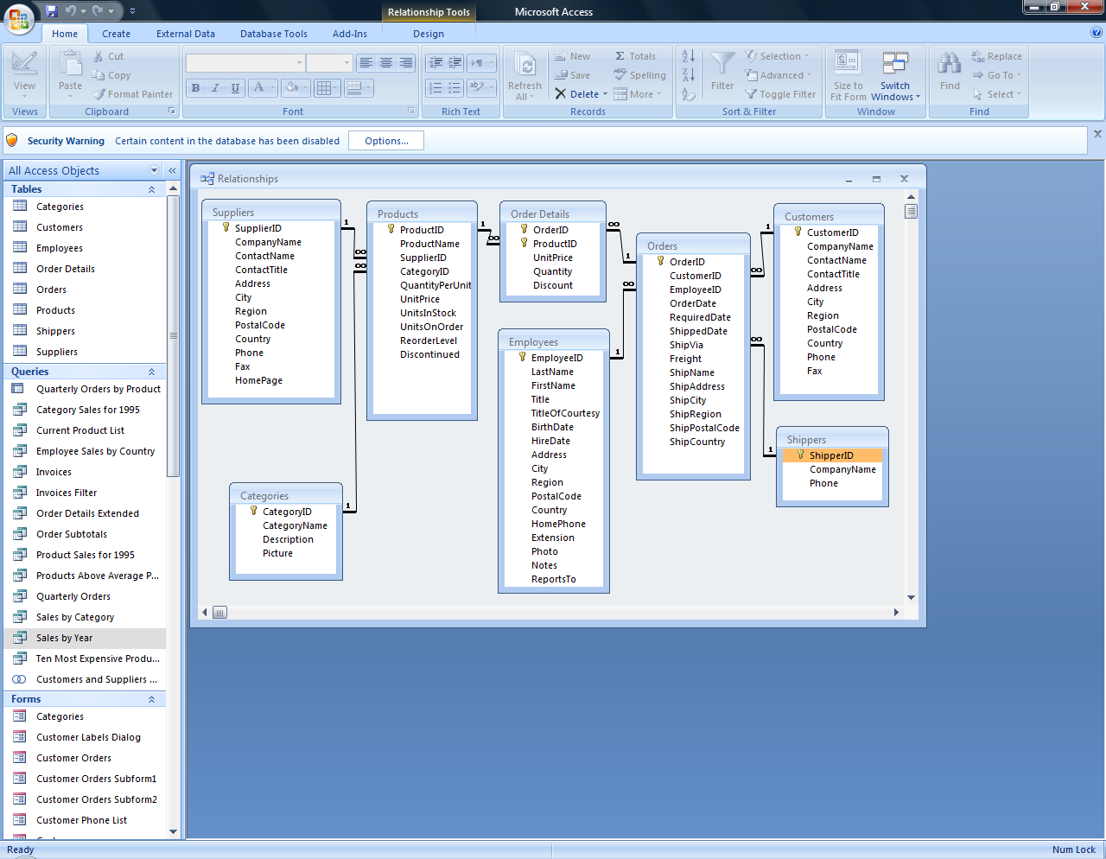

Paste the SQL statements for the queries below the query statements.

- OutOfStockProducts: Make a list of products that are out of stock.

- OutOfStockProductsNotDiscontinued: Make a list of products that are out of stock and have not been discontinued. Include the suppliers’ names.

- ReorderProducts: Make a list of products that need to be re-ordered i.e. where the units in stock (the number you have) and the units on order (the number you have coming) is less than the reorder level (the number that prompts you to order more).

- ProductPopularity: Make a list of products and the number of orders in which the product appears. Put the most frequently ordered item at the top of the list and so on to the least frequently ordered item.

- ProductPopularity2: Make a list of products and total up the number of actual items ordered. Put the most frequently ordered item at the top of the list and so on to the least frequently ordered item.

- NumberOfTimesEachEmployeeUsesAShipper: Make a list of the employees (last name concatenated with first name) and for each employee show the number of times that employee has used each of the shippers.

- EmployeesFromTheSixties: Make a list of Employees born in the 1960’s.

- ValueOfStockDesc: Make a list of the Products and the “value” of that item that is in stock (units in stock multiplied by unit price). Have the products ranked by “value” with the most valuable first

- Make a list of cities that have both a supplier and a customer.

