Queries based on the AviaCo database from Database Systems (Rob and Coronel)

Paste the SQL for queries below the problem statement.

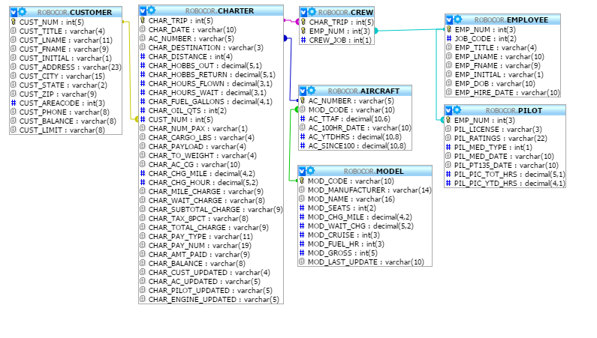

- Make a list of the Aircraft registration numbers as well as their model manufacturers and model names.

- Make a list of customers and the flights and dates flown on. Include customers that have never flown.

- Make a list that has both the customer names and the employee names.

- Make a list having customers and employees who flew on February 7, 2004.

- Count the number of charters to the various destinations.

- Calculate the fuel efficiency (number of miles per gallon) for all of the flights. Group the information by aircraft used for the trip.

- Calculate the average fuel efficiency for each of the aircraft. Put them in order from most efficient to least efficient.

- Customers are charged by the mile (the Charter table lists distances) depending on the model they fly (the Model table lists charge per mile). Make a list of the customers, their flights and the mileage charge. Group by customer.

- Total up the mileage charge for each customer.

