Name: _____________________________

Acronym | Spelled out
ACL
BPU
CAV
CD-DA
CD-R
CD-RW
CLV
CPRM
DAO
DMA
DMCA
DVD
ECC
EDC
FAT
FIFO
HDD
LLF
MBR
MFT
MPEG
NTFS
OEM
PCI
PIO
PnP
RAW
RPM
SSD
TAO
TPI
UDF
WAR
ZBR

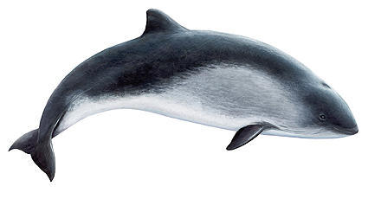
Adapt the CD-DA standards to porpoises. What transmission data rate is required by your standards? Explain your reasoning.
Species Approximate Hearing Range (Hz)
Human: 64 – 23,000
Porpoise: 75 – 150,000

If a 27-second process were broken into 7 stages, (3 requiring 3 seconds, 2 requiring 4 seconds and 2 requiring 5 seconds), then it would take __________ (number of seconds) for an instruction to move through the pipeline as opposed to the original 27 seconds. However, one instruction would be issuing from the pipeline every __________ (number of seconds) as opposed to 1 every 27 seconds without pipelining. This, of course, assumes that there are no ____________________ in the pipeline, delays caused by one stage having to wait for some data it requires.

The DVD-audio standard uses 3 bytes per sample meaning that it can distinguish between _______________ levels. (Looking for a number.)

If a file is smaller than the hard drive’s ___________________ size, then some of the space is wasted. This wasted space is known as ____________________.

FAT32 can address up to ____________________ (a number) clusters. Be careful.

What “unit” is indicated in each of the images below?

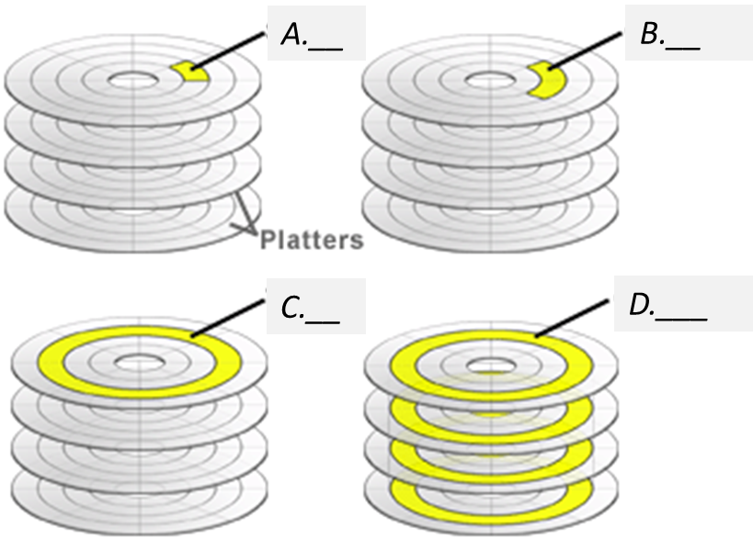
A.

B.

C.

D.

