CSC 301  Test 2 | Name: __________________________  March 27, 2007

Closed book. No Internet. Use a blue book if there is not enough room on the sheet for your answer. Please indicate where the answer can be found.

1. (3 points) What are the detailed steps involved in accessing memory?

2. (4 points) Match (draw a line connecting) the generation of computer with the device that characterizes the generation. Then match the device with the inventor(s).

Generation |  | Device |  | Inventor(s)
1. First |  | A. Vacuum tube |  | I. Hoff
2. Second |  | B. Integrated Circuit |  | II. De Forest, Armstrong
3. Third |  | C. Microprocessor |  | III. Bardeen, Shockley, Brattain
4. Fourth |  | D. Transistor |  | IV. Noyce, Kilby

3. (1 point) ________ True or False. An instruction cache has a data array.

4. (4 points) At one point the PGA (pin grid array) microprocessor package was replaced by the FC-BGA (flip chip ball grid array). Why flip the chip? Why replace pins with balls? What’s the name of the current standard for microprocessor package?

5. (4 points) Why might upping the amount of memory be more beneficial than increasing the processor speed when it comes to executing program faster?
6. (1.5 points) The cache controller can determine whether a cache line has been written to by looking at the cache line’s ____________________.

7. (4 points) Discuss in some detail the pros and cons of SRAM (compared to DRAM).

8. (1 point) A 4-GHz processor would have a period of
- 0.25 microseconds
- 4 microseconds
- 0.25 nanoseconds
- 4 nanoseconds
- none of the above

9. (24 points, 3 points each) In your blue book, select 8 of the following pairs and distinguish between the two items
  - Direct Mapping and Fully Associative
  - Physical and virtual memory
  - Front-side bus and back-side bus
  - Passive cooling and active cooling
  - Data cache and Instruction cache
  - Temporal and Spatial Locality of Reference
  - Architecture and micro-architecture
  - Paging pool and Non-paging pool
  - Synchronous and asynchronous DRAM
  - Tag array and data array
  - Northbridge and Southbridge
  - L1 cache and L2 cache
  - Write-back and write-through

10. (1.5 points) If the item the cache is looking for is not found (an occurrence known as a(n) ___________________) then the cache must obtain the item from main memory.

11. (1.5 points) The cache controller uses its ___________________ to determine the location of a new item.
12. (4 points) While the unit of data in memory is a byte, the unit of data in cache is a line. What is a line? What are the benefits of using lines instead of bytes in caching?

13. (4.5 points) When one declares a variable, one is ____________________ memory for the program’s use. Modern programming languages have a(n) ____________________ to help free up memory that is no longer needed by the program. A poorly written program that uses increasing amounts of memory without freeing any up is said to have a(n) ___________________.

14. (10 points, 1 point each) Spell out 10 of the following acronyms
Acronym | Spelled Out
ALU
BPU
CAM
DDR
FPU
FSB
IC
LRU
MMX
NVRAM
RISC
SDRAM
SIMD
SO-DIMM
SPD

15. (3 points) Name three distinct ways of dealing with the problem of heat in microprocessors.

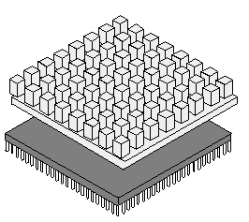

16. (2 points) In the above figure, the upper part in light gray is the ____________________, and the lower part in dark gray is ____________________.

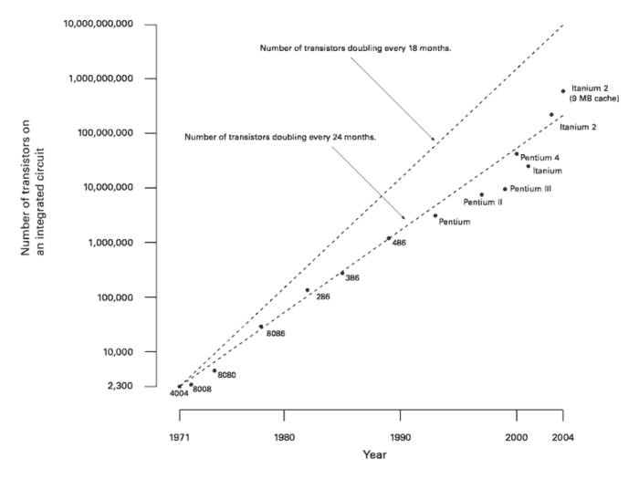

17. (1 point) The figure above shows ____________________.
18. (1 point) The widening of the address bus to 64 bits allows one to address ________________ items.

19. (1 point) If a new processor can run code written for an older version of the processor without any change to the code, then the new processor is said to be ____________________.

20. (24 points) Define 8 of the following terms in your blue book.
- Branch prediction
- CAS latency
- Celeron
- DIMM (do more than spell out)
- Edge Triggered
- Harvard cache
- Overclocking
- Pipelining
- Protected mode
- ROM shadowing
- Stepping
- Victim cache

