CSIT 301  Test 3 | Name: _____________________________  April 24, 2007

Closed book. No Internet. Use a blue book if there is not enough room on the sheet for your answer. Please indicate where the answer can be found.

1. (3 points) A mouse has a hearing range of 1,000-91,000 Hz. Determine a data transfer rate for a CD that a mouse would listen to. Explain your reasoning.

2. (3 points) If a 28-second process were broken into 7 stages, (2 requiring 3 seconds, 3 requiring 4 seconds and 2 requiring 5 seconds), then it would take __________ seconds for an instruction to move through the pipeline as opposed to the original 28 seconds. However, one instruction would be issuing from the pipeline every _________ seconds as opposed to 1 every 28 seconds without pipelining. This, of course, assumes that there are no ____________________ in the pipeline, delays caused by one stage having to wait for some data it requires.

3. (3 points) List the steps involved in accessing something from the hard drive.

4. (1 point) The DVD-audio standard uses 3 bytes per sample meaning that it can distinguish between _______________ levels. (Looking for a number.)

5. (3 points) Explain the meaning of the statement Ultra DMA uses DDR and CRC. Be sure to explain all terms.
6. (1 point) Blu-ray drives use a laser with a smaller wavelength than a DVD drive. This allows Blu-ray to resolve/distinguish smaller ____________________ and lands than DVD.

7. (6 points) For each step in the program below, indicate whether a register is being written to by entering a “W”, read from by entering an “R” or not involved by leaving it blank.

1. AND r2, r1, r3
2. LD r5, (r4)
3. MUL r4, r6, r3
4. ADD r7, r1, r3
5. ST (r8), r12
6. SUB r10, r12, r3
7. OR r7, r6, r12

 | R1 | R2 | R3 | R4 | R5 | R6 | R7 | R8 | R9 | R10 | R11 | R12
1
2
3
4
5
6
7

Indicate any data dependencies and their type.
Register | Dependency | Instructions  Involved | Restriction

Write the program, splitting it up for processing by as many different execution units as possible.
Pipeline 1 | Pipeline 2 | Pipeline 3 | Pipeline 4

PPPPPPPPPPPPPPPPPPPPPPPPPPPPPPPPPPPPPPPPPPPPPPPPPPPPPPPPPPPPPPPPPP

- (1 point) In an analogy of Moore’s Law for hard drives, there has been an exponential growth in the hard drive’s __________________.

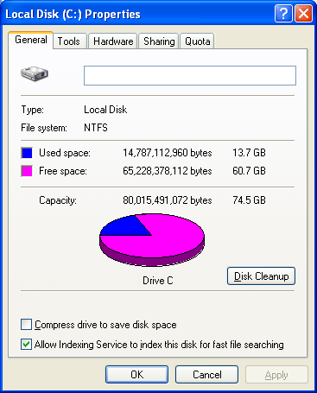

- (1 point) Name one of the utilities one would find under the Tools tab in the picture shown above: ___________________.

- (2 points) If a file is smaller than the hard drive’s ___________________ size, then some of the space is wasted. This wasted space is known as ____________________.

- (1 point) ___________________ uses Discrete Cosine Transform, Quantization, Huffmann Coding, and so on to squeeze more data into less space.

- (3 points) Before burning files to a CD, they are copied to a special place on the hard drive. Why?

- (8 points, 1 point each) Spell out 8 of the following acronyms

Acronym | Spelled Out
ACL
BPSI
DMCA
ECC
FIFO
IDE/ATA
NTFS
OEM
PIO
RPM
SCSI
UDF
ZBR

- (1 point) Never open a hard drive because the ____________________ (the distance between the head and one of the platters) is typically millionths of an inch whereas a dust particle is typically hundredths of an inch.

- (1 point) The ___________________ bit indicates that something will be written to a register in pipelining.

- (2 points) Describe a situation in which you would partition a hard disk.

- (24 points, 3 points each) In your blue book, select eight of the following pairs and distinguish between the two items
  - CAV and CLV
  - Diffuse and specular
  - First-party and Third-party DMA
  - ILP and VLIW
  - Latency and seek time
  - Lossy and lossless compression
  - Low-level and high-level formatting
  - Multicore and multithreading
  - NTFS and WinFS
  - PATA and SATA
  - Pipelined and superscalar
  - RAW and WAR
  - Red Book and Yellow Book

- (3 points) Name three things a high-level programmer can do to promote vectorization of his/her code.

- (2 points) On a hard disk the data is written in concentric circular paths known as ____________________. These are further divided into ____________________.

- (2 points) Because NTFS is a genuinely multi-user filesystem, it has a notion of ____________________, that is which user ultimately controls the file, and _____________________, that is the actions allowed by other users on that file.

- (1 point) FAT32 can address up to ____________________ (a number) clusters. Be careful.

- (1 point) ____________________ theorem states that the sampling frequency should be twice the highest frequency.

- (1 point) ___________________ was one of the standard ways to store and input programs before hard drives became standard.

- (1 point) The ___________________ is a non-data space on a computer's hard disk where the read/write heads rest when the computer's power is turned off.

- (3 points) Identify the following pictures as SCSI, IDE and SATA.





- (1 point) __________ True or False. Audio CDs use a lossy compression scheme.

- (24 points) Define eight of the following terms. (Remember do not use the term or part of it in your definition!)
- Boot sector infector
- Bus mastering
- Control hazard
- Execution unit
- Head skew
- ILP
- Logical volume
- Loop unrolling
- MFT zone
- Phase change
- Servo information
- Speculative execution
- Spindle

