1. Screen captures

One task a support person may have to perform to write a set of instructions. Screen captures are very useful when writing instructions.

One obtains a screen capture by hitting the Print Screen key on the upper right portion of the keyboard. At a very low level (e.g. when you are looking at CMOS settings) it actually prints the screen (provided you are connected to a local printer), but under usual circumstances this action places an image on the clipboard. The image can then be pasted into a document such as Word or PowerPoint using Edit/Paste or the keyboard shortcut (Crtl-v).

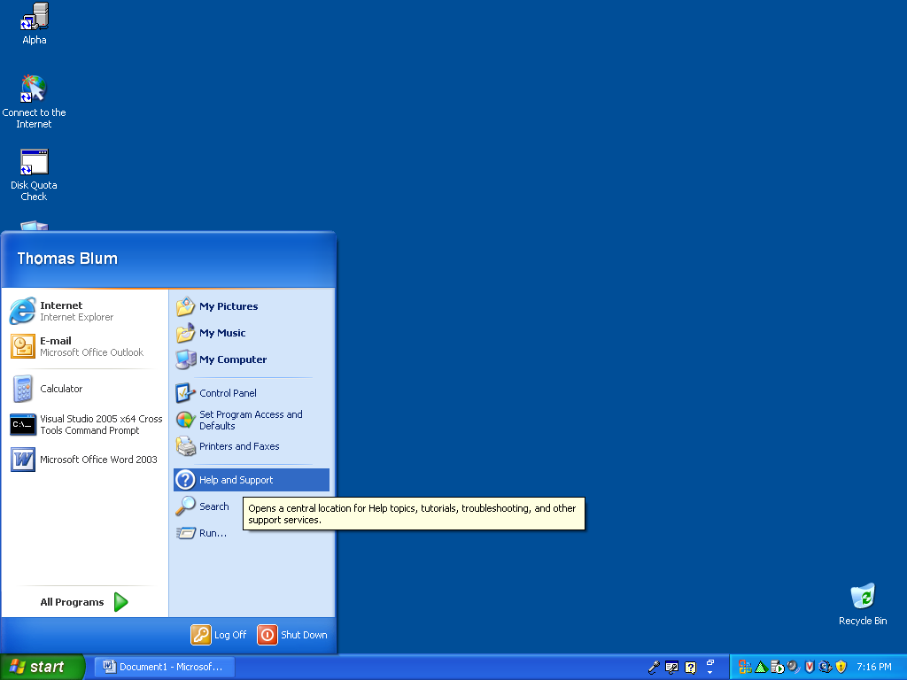

Replace my screen capture with yours (yours won’t have my name on it).

What’s CMOS? (You can copy a definition provided you cite your source.) How does one access the CMOS settings?

Distinguish between a local printer and a network printer. Explain why when printing CMOS screen, the printer should be local.
What’s the clipboard? (You can copy a definition provided you cite your source.)

What’s a keyboard shortcut? Give another example.

By clicking Alt-Print Screen you place an image of the application which has the focus instead of the full screen.

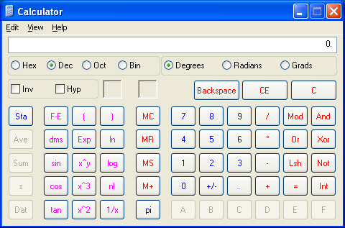

Replace the above screen capture of the calculator with one that displays the value of pi.

Hitting the Alt key closes any menu that might be open. Thus, to show an application with a menu open
- Make a full screen capture and paste into the application (here Word).

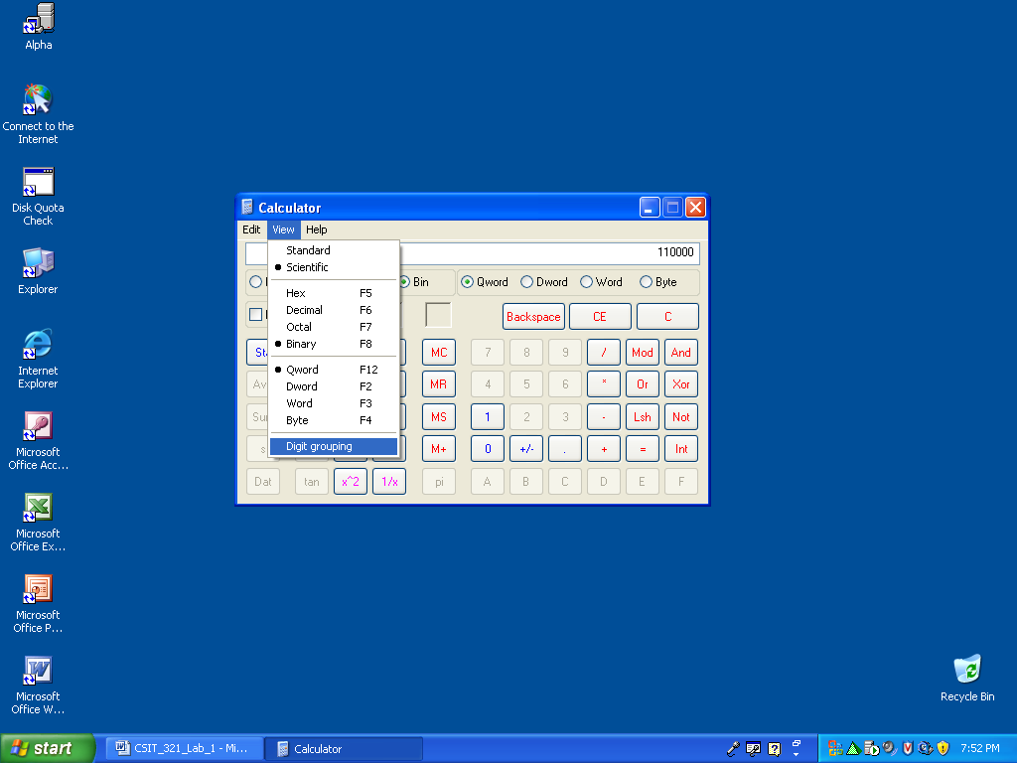

- Crop the image (there is a crop tool on the Picture toolbar which may appear when you highlight an image or can be obtained by going to View/Toolbar/ Picture.

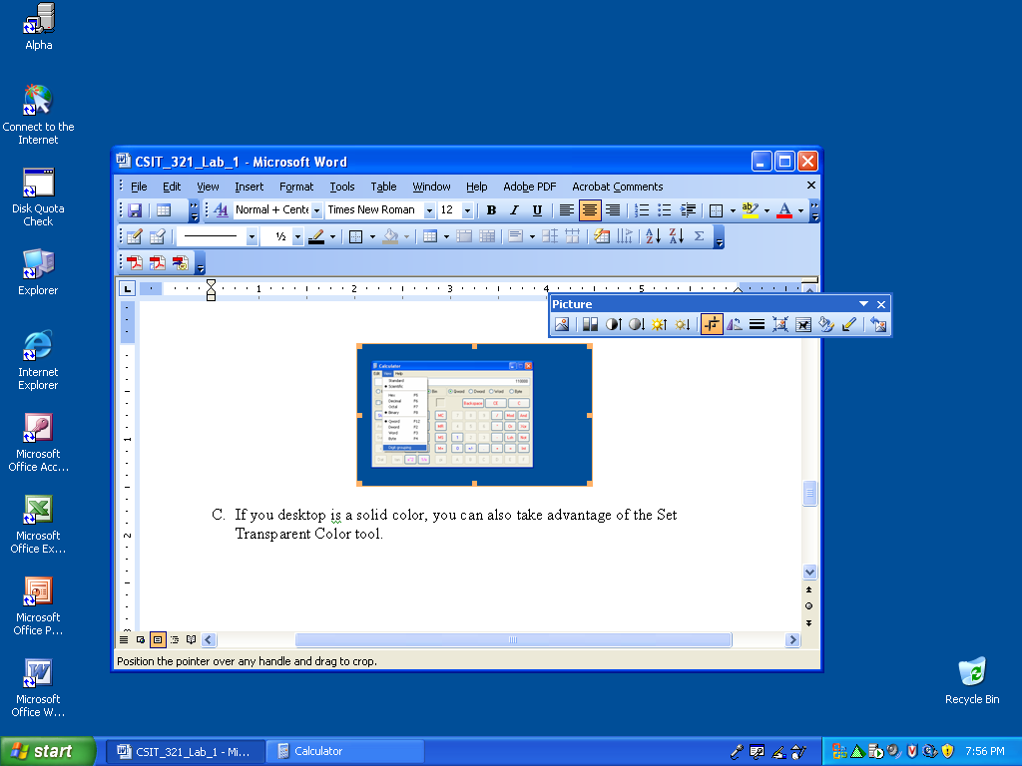

- If your desktop is a solid color, you can also take advantage of the Set Transparent Color tool.

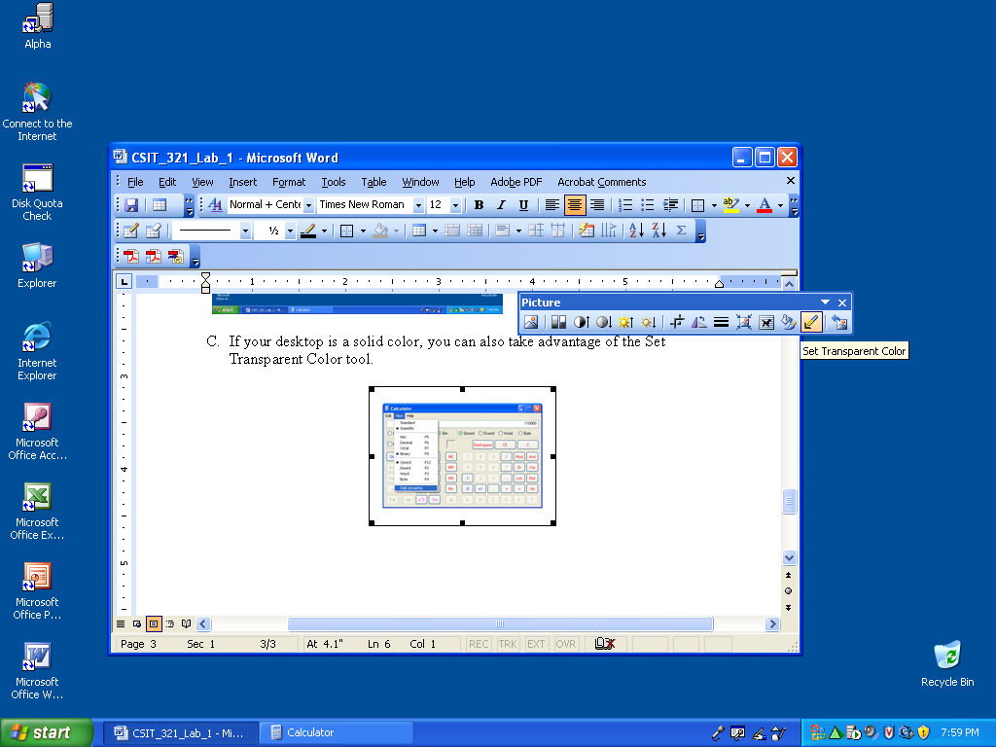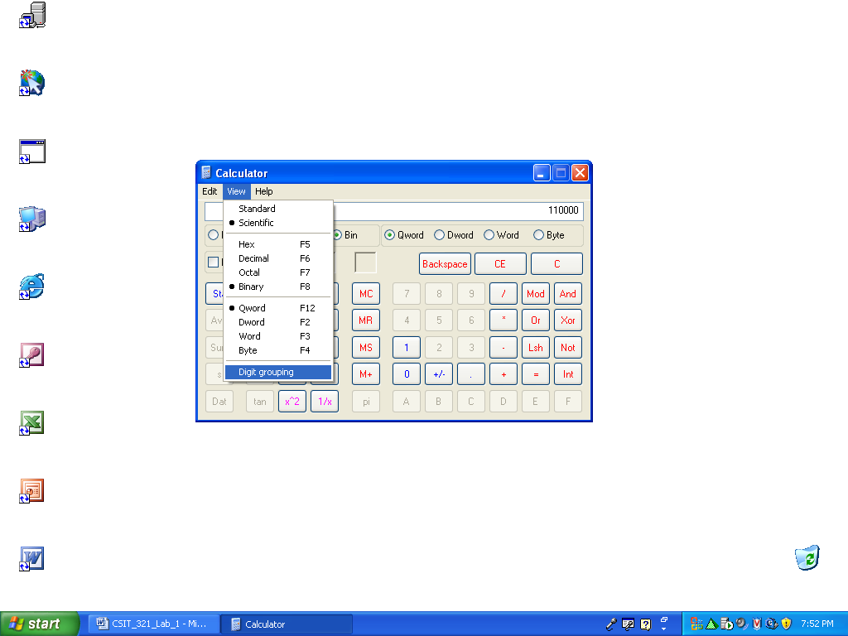

The final screen capture above has the number 48 displayed in binary with the Digit grouping feature about to be applied. Paste below a screen capture of the calculator displaying the number 56 in binary with the Digit grouping feature about to be removed.

Finally it is useful to draw on top of the screen capture to indicate some particular feature. For this purpose we can use Word’s Drawing toolbar (View/Toolbar/Drawing)
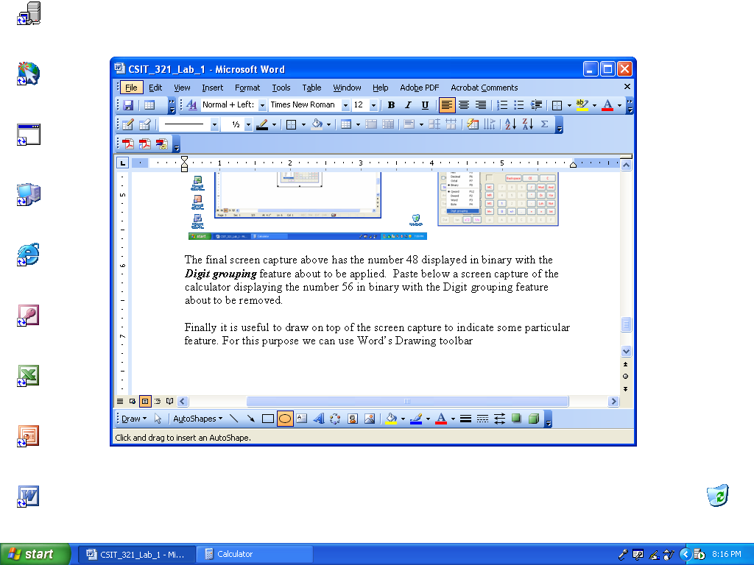
To make the red circle above I used the Oval tool, followed by the Fill Color, Line Color and Line Style tools. Paste another copy of your calculator screen capture, but this time add a circle indicating the Digit grouping item on the menu.

2. Network settings instructions

- Write a set of detailed instructions for determining the network settings such as IP address, subnet mask, default gateway and DNS server. Include at least two screen captures and something from the drawing toolbar.

- Imagine a scenario in which the mouse is unavailable. Rewrite your instructions in a way that does not use the mouse.

