CSIT 321
Lab 16
Nov. 3, 2005
Name:

- (This is my revenge on those who forget to put their names on their labs.) Place below your name and put it in TheBirds font found at http://www.1001freefonts.com/fonts/tfonts2.htm.

- Did your computer “fall back” (change by an hour this past weekend) on its own?

- Change the command window background color to white and the text color to black.

- Replace my command window (I know it’s mine, it has my name on it) with yours (which should have your name on it). There’s a command to make this change. What is it?
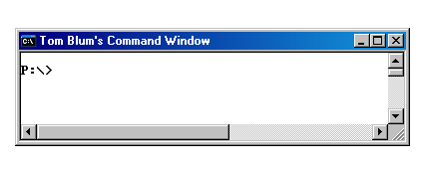

- What information comes from the systeminfo command?

- What does the command getmac do?

- What does the command arp –a do?

- What does the command assoc > e:\AssocResults.txt do?

- Has Visual Studio 2005 been launched?

- Write a set of instructions (including at least two screen captures) for changing the size (and if possible the location) of the virtual memory paging file.

- Write instructions (including at least one screen capture) for setting a Power Scheme.

- What is hibernation? How is it distinct from the alternative(s)?

- What is a UPS?

- What is DEP (in the context of protecting your PC)?

- What do the following keyboard short cuts do?

Short cut | Description of action
+Break
+E
+F
+R
+L
+M

