CSIT 321
Lab 11
Oct. 3, 2006
Name:

- (This is my revenge on those who forget to put their names on their labs.) Place below your name and put it in the Embossed Black font (20-pt) found at http://www.1001freefonts.com/fonts/efonts3.htm.

- Write a set of instructions (including at least two screen captures) for changing the size (and if possible the location) of the virtual memory paging file.

- Write instructions (including at least one screen capture) for setting a Power Scheme.

- What is hibernation? How is it distinct from the alternative(s)?

- What is a UPS?

- What is DEP (in the context of protecting your PC)?

- What do the following keyboard short cuts do?

Short cut | Description of action
+Break
+E
+F
+R
+L
+M

- Start a command window. (Help save on toner by changing its background color to white and its text color to black.) Change the directory to the root c:\. Use the command attrib to find the attributes of the files (i.e. Are they system files? Hidden files? Read only files?). Paste a screen capture.

- List all of the files found above. Find out what does each of these files does.

- Create a file like the following in Notepad and save it with a .bat extension.

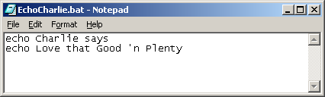

In the folder containing the above file, use the title of your file as a command. Show the results in a screen capture below.

The file you have created is known as a batch file, the .bat extension tells the operating system to treat it differently that it would a regular text file. Add a line at the beginning as shown in the following

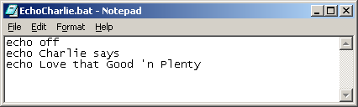

Paste a screen capture of the executing the above batch file below.

Edit the line at the beginning as follows

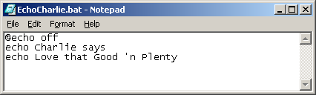

with an @ sign at the beginning of the line. Run your batch job again and paste a screen capture below.

- If you change your location and attempt to run your batch file, the computer will not understand it. The system is trained to look for .bat, .exe and .com files in the current directory as well as a set of standard locations. If the appropriate file is not found in one of these places, the command is not understood. The locations that the system looks in can be found by running the command path. Run the command path and paste a screen capture below.

