How to get your MS Software for STEM department members or for students taking courses in our Department.

1. Go to this URL <https://azureforeducation.microsoft.com/devtools>

This is the page that is displayed.

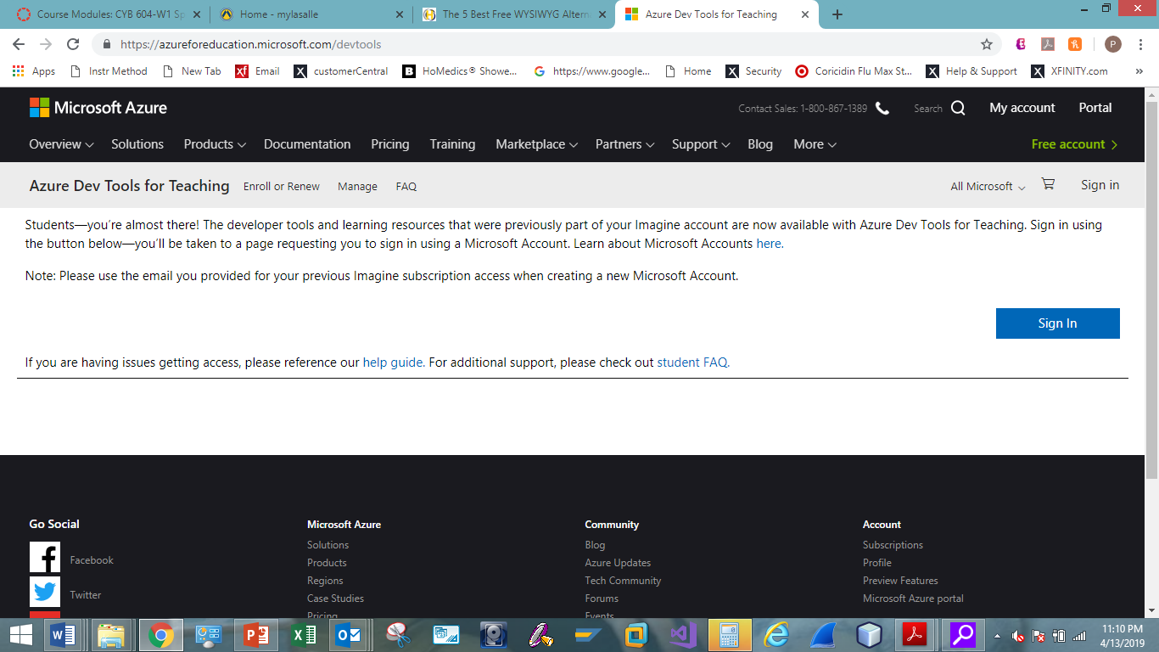

1. Click on the SIGN IN Button.

Use the same credentials used for email. (Full email address and your email password).

You will see this page.

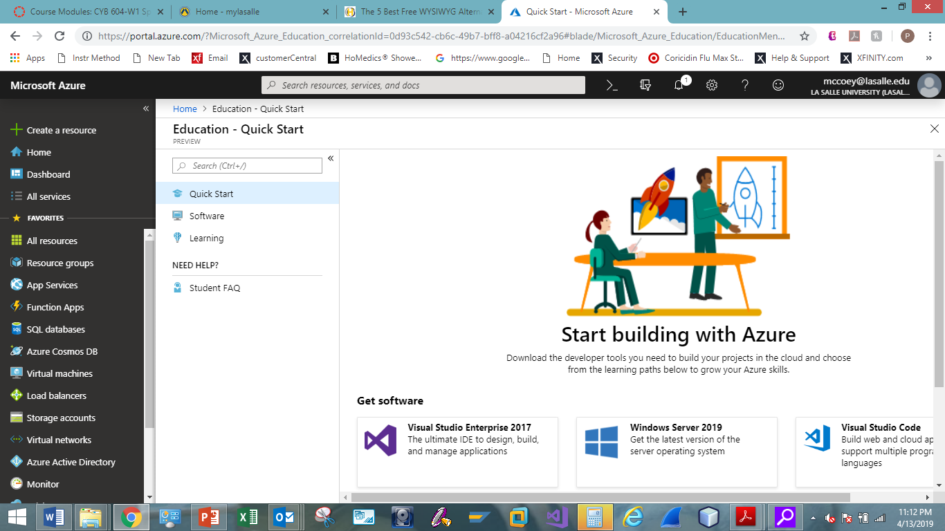

1. Click on Software to see the list of products you can download.

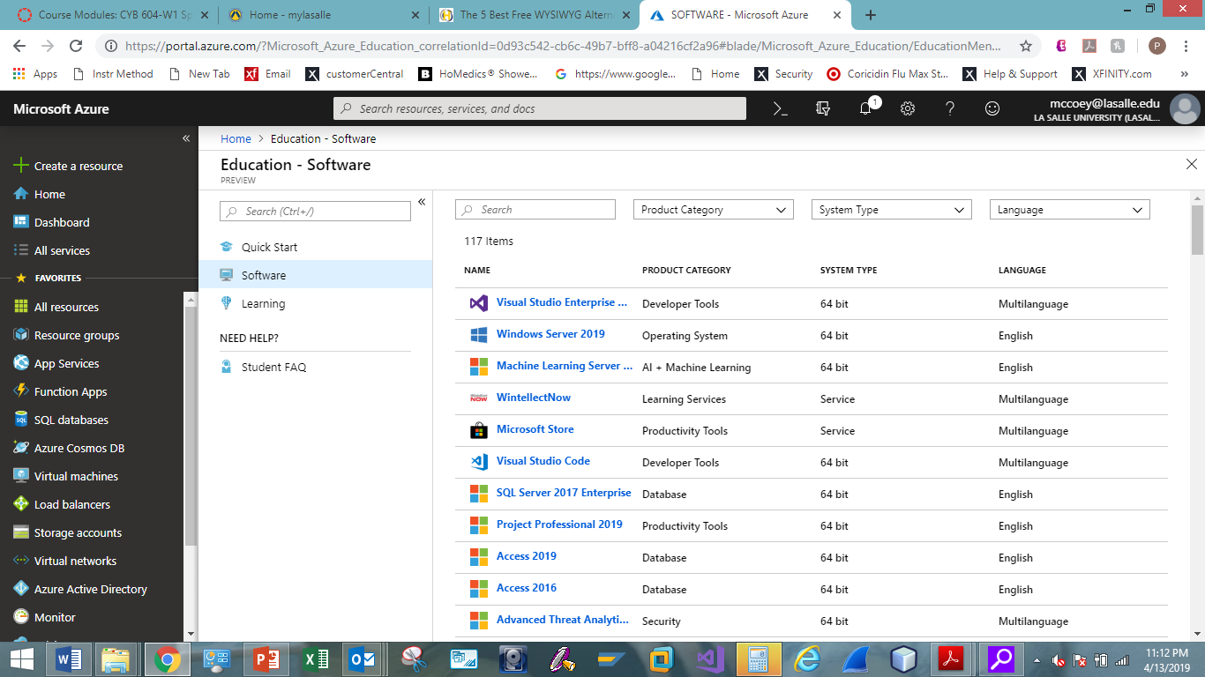

1. Look for the product you wish to download. Click on the item. In this example, I clicked on Windows Server 2019.
2. You will see an explanation of the item. You can download the item and get your product key.

