Chinese Take Out Menu

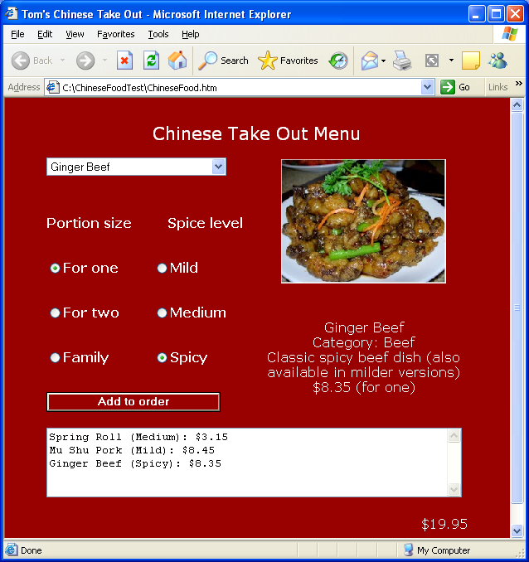
Design a page like the one above that allows the user to order Chinese Take out. The user selects an item from the drop-down list, a portion size. When the button is clicked, that information is added to a display and a running total is calculated.
This is an old JavaScript test (without CSS – your test would include CSS), so there are a lot of individual instructions. You don’t have to follow all of the instructions, particularly those specifying sizes. However, I am leaving them in to give you a sense of how I might test.
- Give the page a title like “Bob’s Chinese Take Out” with your name in place of “Bob”.
- Make the page some color other than the default.
- Make the document’s font some color other than the default.
- Have a table with nine rows and three columns. Center it on the page. The first two columns should be 125px wide and the third column 250px wide.
- Merge cells as shown below. The rows should be 50px high.

Words (title)
Drop-down list |  | Image
Words | Words | Image
Radio button | Radio button | Image
Radio button | Radio button | Words (description)
Radio button | Radio button | Words (description)
Button |  | Words (description)
TextArea
 |  | Words (total)
- Place an image in the upper right. Set its height to 150px. The initial image should be SpringRoll.jpg.
- Under the image should be text describing the item selected. The initial text should be
Spring Roll
Category: Vegetarian
Traditional side dish - a venerable favorite
$1.75 (for one)
- The code for the drop-down list options can be found in the file DropDownListStuff.txt that was supplied. When the page starts the spring roll item should be showing in the drop-down list. Note that the option values correspond to the indices of the arrays.
- The array declarations, instantiations and initializations can be found in the file ChineseFoodArrayInitializations.txt provided.
- Have the radio buttons in the first column pertain to portion size (for one, for two, family).
  - When the time comes, if the user selects “For one” use the price found for that item in the array initializations, if the user selects “For two” use 1.8 times that price, and if the users selects “Family size” use 3.4 times the price. The portion size should be displayed in the order (see below).
- Have the radio buttons in the second column refer to spice level (mild, medium and spicy).
- Have it so that when the user selects an item from the drop-down list (use the onchange event), the corresponding image is displayed on the right and the information about the item (name, category, description and price for one, each on a separate line) is below the image.
- Have an Add to Order button that determines the price from the item selected and the portion-size radio buttons and then adds an entry to the textarea display (menu item name, spice level, portion size and price). One can get onto a new line in the textarea by concatenating a “\n”. Also have a running total of the order displayed on the bottom right. The prices and total should have a dollar sign before and two decimal places showing.
- Post your code, send me the link.

