Safari Tech Books Online

- Log on to the mylasalle portal.  - Click on the Connelly Library link. | - Log on www.lasalle.edu.  - Click on the Library link.  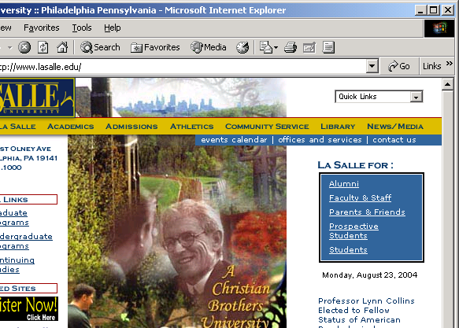

- On the Connelly Library homepage, click on Catalog.

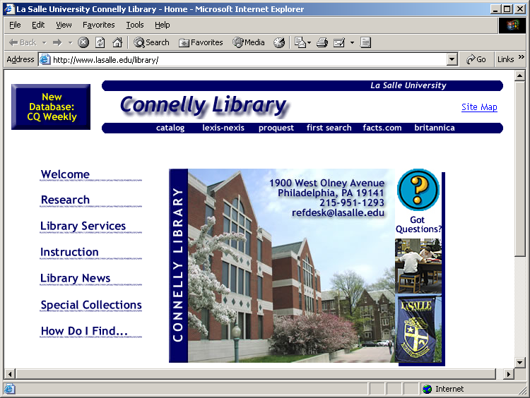

- Use the drop-down list to select a KEYWORD search, enter Safari Tech Books Online into the textbox, and click on the Search button.

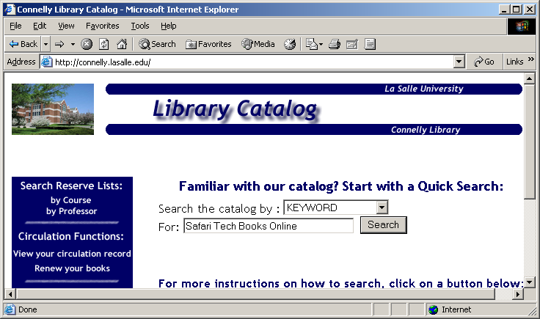
1
2
3

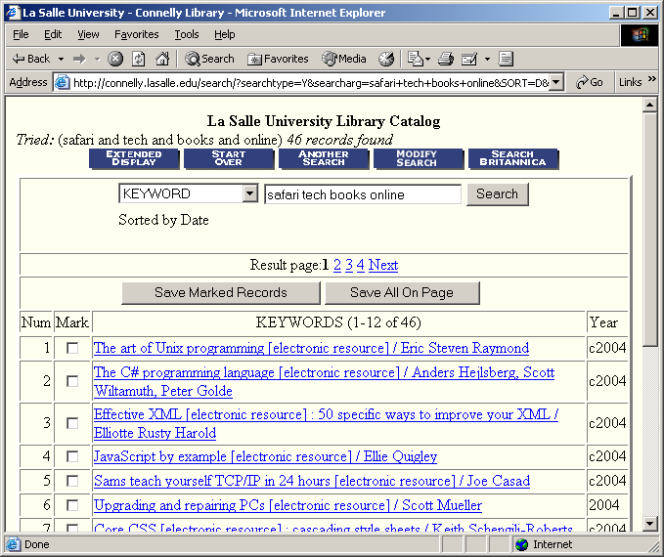

- Click on the desired title.

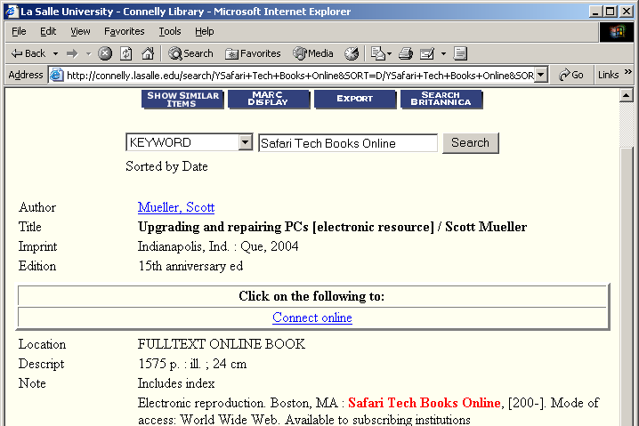

- Click on the Connect online link.
- If you are not on campus when logging on, you will be asked for a username and password. This will be your EXPLORER network username and password; the password is typically the first five numbers of your Social Security Number, an underscore and the first three letters of your last name.

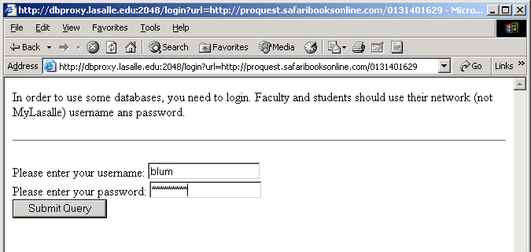

- The resulting web page has a search feature. To limit the search to the book you have previously selected, click on the Current Book radio button. Enter a search phrase into the textbox and click Go.

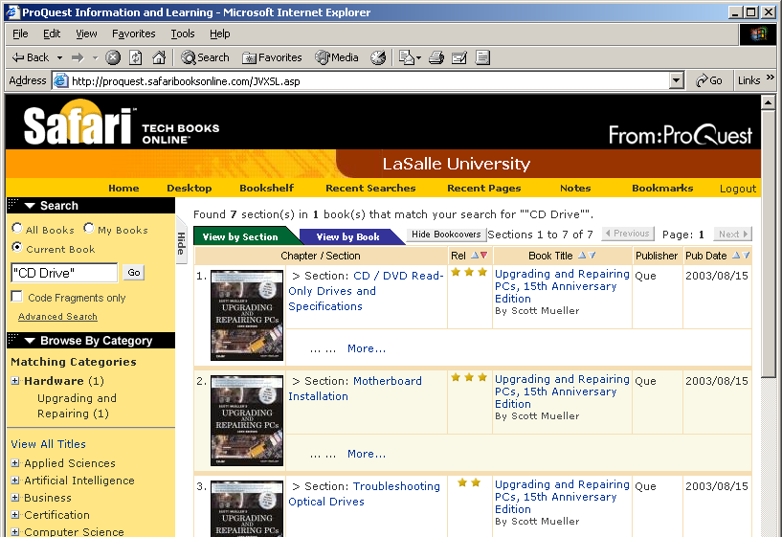

- To start reading the book from the beginning, return to the first page for the book and click the Start Reading button.

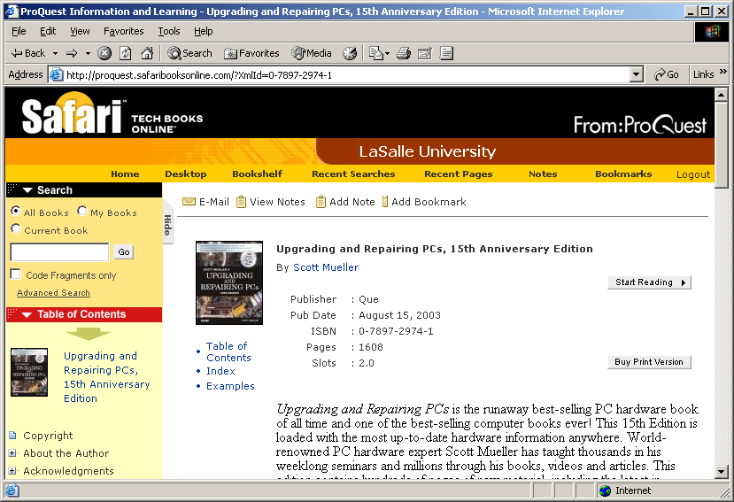
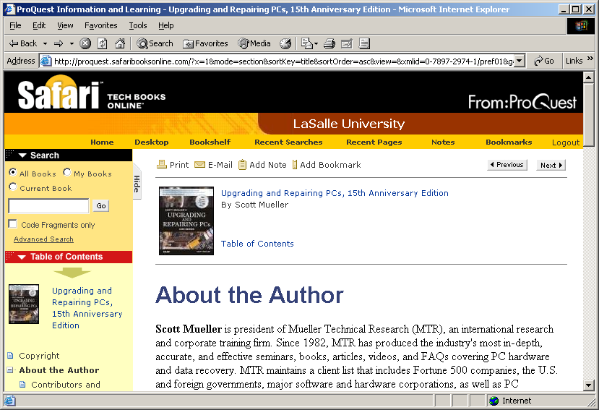

- One can start reading a particular chapter by clicking on a link found in the Table of Contents region under the search area.

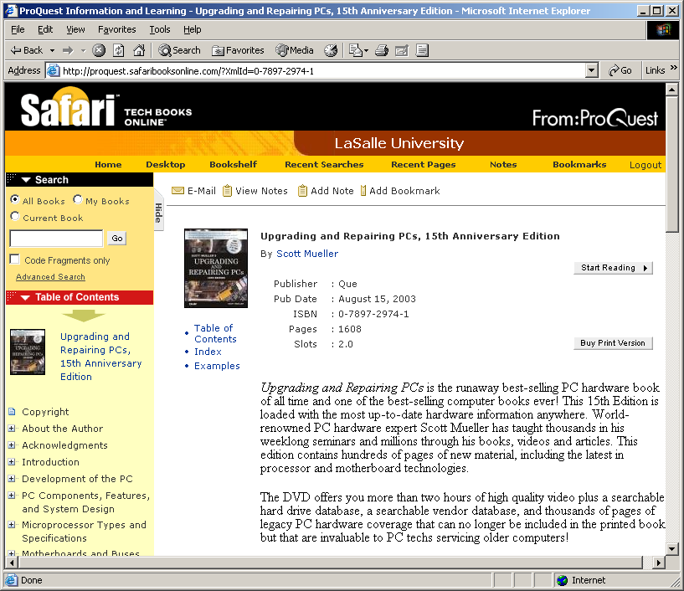
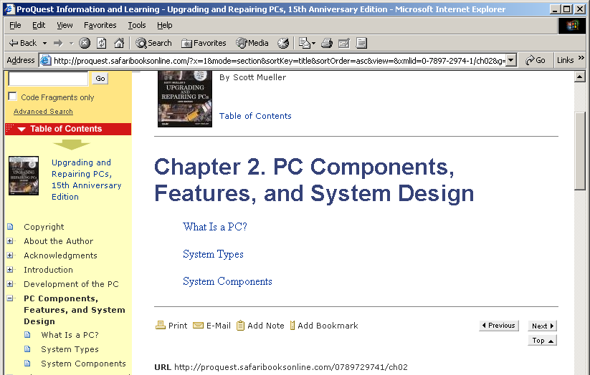

- Note in this case that the chapters are broken into sections. Click on a section link to start reading the particular section.

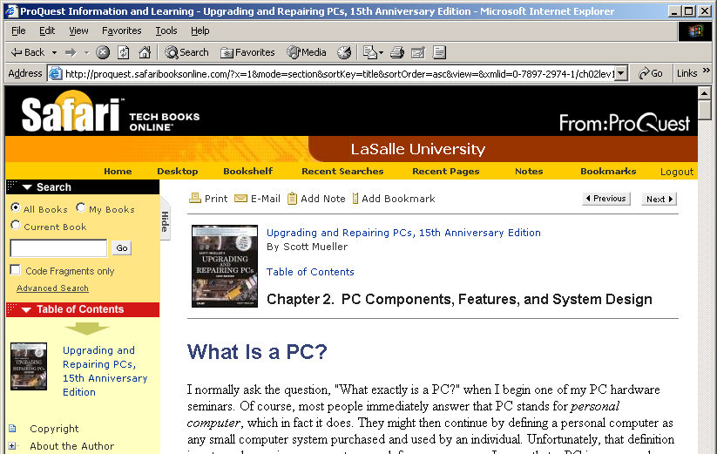

- Another way to search for topics in the book is to use the index. Click on the Index link found in the Table of Contents area.

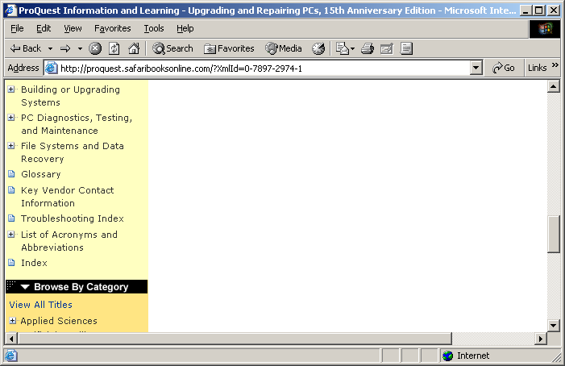

- The letters are hyperlinks to the items in the index that begin with that letter.

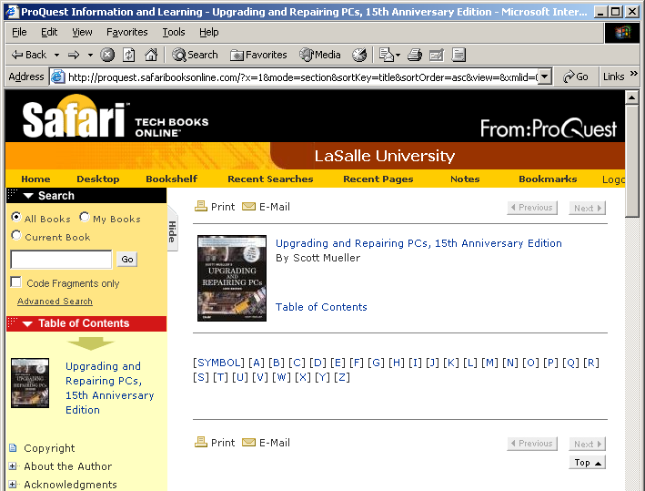
- Many of the items in the index are themselves hyperlinks. Click on one to be led to material on the selected subject.

