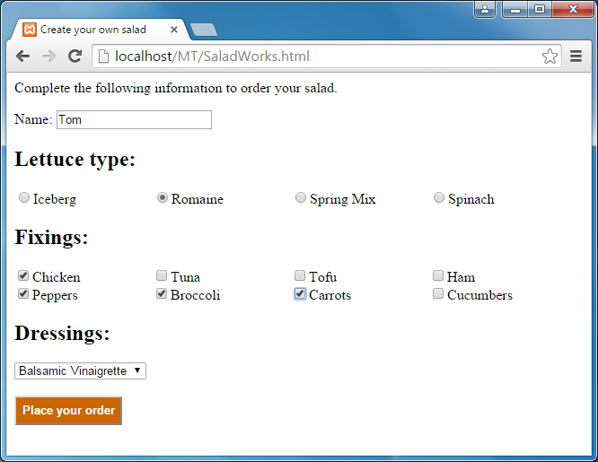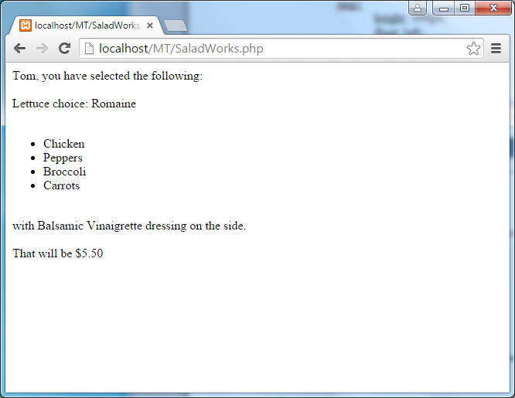
Salad Works
  - Using the file SaladWorks.html as a starting point, make it so the page is handled by a PHP page you make.
  - Add an HTML comment with your name to SaladWorks.html.
  - Add a PHP comment with your name to the handling page.
  - Make it so that only one of the Lettuce radio buttons can be selected and that the type of lettuce selected by the user is passed to the PHP page.
  - Make it so that all of the user-selected Fixings are passed to the PHP page.
  - Make it so that the user-selected Dressing is passed to the PHP page.
  - Have the PHP response page display the user’s name and the ingredients for his/her salad. The fixings should be in an unordered list.
  - Assuming that the base price (lettuce plus dressing) is $3.50 and each selected fixing is an additional $0.50, determine and display the price of the salad. The price should include a dollar sign and two decimal places.

