Dark Side of the Moon
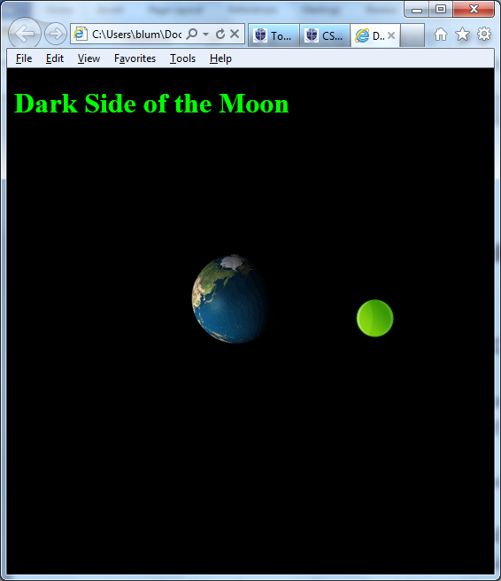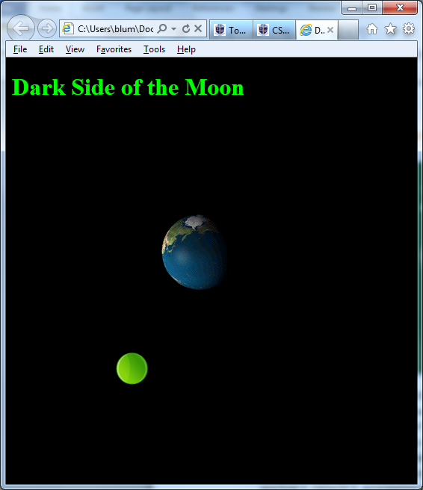
- Make a page with a title John Smith’s Dark Side of the Moon (with John Smith replaced by your name).
- Add an HTML comment with your name.
- Give the page’s body a black (#000000) background and a green (#00FF00) color (for the font).
- Put a header at the top of the page reading John Smith’s Dark Side of the Moon (with John Smith replaced by your name).
- Below that add a table with 3 rows and one column. If Visual Studio gave your table a style that makes the table’s width 100%, then eliminate the style attribute from the table tag.
- Give the top cell a style with a width of 400px and a height of 400px.
- Place two images in that cell. The first should use the image file planet_earth_rotating.gif and have a style with position absolute, top 200px and left 200px. The second should use the image file circle_green.png and have a style with position absolute, top 200px and left 400px.
- The second cell should contain only a non-breaking space.
- The third cell should have three buttons that say: Start, Reverse, and Stop. The Stop and Reverse buttons should be initially disabled.
- Start a script area and place a comment with your name at the top.
- Declare global variables x_cm, y_cm, x, y, R, w, t with the following initializations

x_cm =200; y_cm=200; R=200; w= 0.01047; t=0

- When the start button is clicked, start a (repeating) timer that calls a function every tenth of a second.
- Clicking the Start button should also enable the Reverse and Stop buttons and disable the Start button.
- That function should increment t by a delta_t of 1 and then calculate the following quantities

x = x_cm + R * Math.cos(w*t);
y = y_cm + R * Math.sin(w*t);

- Then set the second image’s top to y and left to x.
- The Reverse button should change the sign of delta_t (if delta_t is positive make it negative; if it is negative make it positive).
- The Stop button should stop the timer.
- The Stop button should also enable the Start button and disable the Reverse and Stop buttons.
- ZIP up your files and email them to me.

