Baked Potato
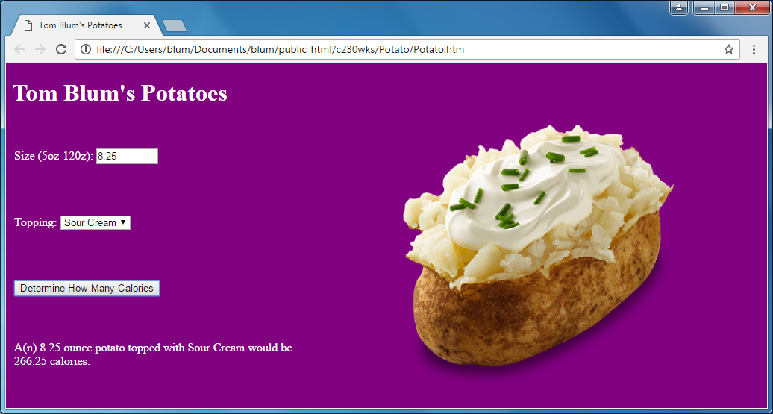
(https://www.verywell.com/how-many-calories-in-a-baked-potato-2506867)
You must use jQuery for this lab
- Make a page with a title John Smith’s Potatoes (with John Smith replaced by your name).
- Make the page any color other than the default white.
- Add an HTML comment with your name.
- Your HTML elements with ids cannot have default/meaningless ids such as Button1.
- Give the page a header John Smith’s Potatoes (with John Smith replaced by your name).
- Place on your page the code below. It makes a table with four rows and two columns with the cells in the second column merged into one cell
<table>
<tr>
<td>
&nbsp;</td>
<td rowspan="4">
&nbsp;</td>
</tr>
<tr>
<td>
&nbsp;</td>
</tr>
<tr>
<td>
&nbsp;</td>
</tr>
<tr>
<td>
&nbsp;</td>
</tr>
</table>
- Add the following style in between <style></style> tags
td
{
width: 400px;
height: 80px;
}

- In the second column place an image element in the merged cell. Give it a height of 350px. Use the image potato.png.
- The first row should have “Size (5oz-12oz)” followed by an input of the number type. It should have the following attributes: a min of 5, a max of 12, and a step of 0.05.
- The second row has the word Topping and a drop-down select (with choices nothing, butter, sour cream, and chili).
<select id="selTopping">
<option value="Something useful to the coder">Something the user sees</option>
</select>

- The third row has a button that says “Determine How Many Calories”.
- The fourth row is where the result will be placed.
- Add the link to the jQuery library.
- Start a script area and place a comment with your name at the top.
- When the user clicks the button, determine the user’s potato size.
- Determine the user’s topping choice
- The topping determines the “extra factor” in the calorie calculation.
Nothing 0
Butter 100
Sour Cream 60
Chili 75
- Determine how many calories using the formula

Calories = 25*Size + ExtraFactor

And display the result in the fourth row; it should be like the following

A(n) 8.25 ounce potato topped with Sour Cream would be 266.25 calories.

The underlining above indicates the parts that might change. The calories should be displayed with 2 decimal places, e.g. something like
… "would be " + calories.toFixed(2) + "calories.";

- If the size is not a number, alert the user to the problem and do no calculating. Something like:
size = parseFloat(size);

if (isNaN(size)) {
alert("Please enter a number (of ounces) for the size of your potato.");
return;
}

- If user entered a size less than 5, alert the user to the problem and do no calculating.
- If the user entered a size greater than 12, alert the user to the problem and do no calculating.
- When the user types a new size, clear out the calorie result. Something like:
$("#txtSize").keydown(function () {

});

- When the user uses the arrows of the number input (changes), clear out the calorie result. Something like:
$("#txtSize").change(function () {

});

- When the user changes the topping, clear out the calorie result. Something like:
$("#selTopping").change(function () {

});

- ZIP up your files and email them to me.
