CSC 349
October 12, 2017

Diamond Price Estimator App

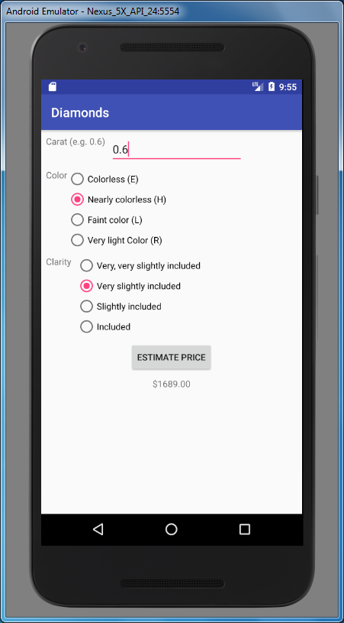

Remember to constrain to something that came earlier. Don't obsess on the app looking nice but items cannot fall on top of one another.

Comment out code that is not working that you wish to be considered for partial credit.

Design an app that has
- a TextView (label) and EditView for entering the number of carats, which is a decimal number
- a TextView (label) and set of RadioButtons for choosing the color
  - Colorless (E) use the value 1 in the formula below
  - Nearly colorless (H) use the value 2 in the formula below
  - Faint color (L) use the value 3 in the formula below
  - Very light color (R) use the value 4 in the formula below

- a TextView (label) and set of RadioButtons for choosing the clarity
  - Very, very slightly included use the value 1 in the formula below
  - Very slightly included use the value 2 in the formula below
  - Slightly included use the value 3 in the formula below
  - Included use the value 4 in the formula below
- A Button to click to begin the calculation
- A TextView for displaying the answer

  - When the user clicks on the Button, take in the values for Carat, Color and Clarity, and then perform the following calculation for price

Price = 137 + 4020*Carat -244*Clarity – 68*Color² -50*Color

And display the result.
  - If no value was entered for the Carat, Toast a message saying so.
  - If no value for the Color was selected, Toast a message saying so.
  - If no value for the Clarity was selected, Toast a message saying so.
  - If the user changes the Carat entry, clear out the displayed price result.
  - If the user changes the Color selection, clear out the displayed price result.
  - If the user changes the Clarity selection, clear out the displayed price result.

Send the files you edited, for example activity_main.xml and MainActivity.java

Based on http://guide.diamondpriceguru.com/diamond-and-ring-prices/diamond-prices/diamonds-and-regression-analysis-a-nerdy-way-of-analyzing-diamond-prices/

